



Akşehir Water Supply Project

Final Environmental and Social Management Plan

July 2022



Project | Details
Name | Akşehir Water Supply Project  Environmental and Social Management Plan
Reference | 19_1292_4-1.1
Submitted to | General Directorate of İLBANK
Prepared by | 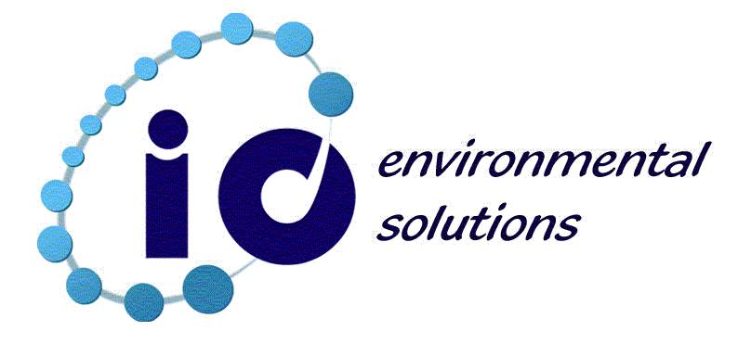  io Environmental Solutions Research Development Inc.  www.iocevre.com

This document has been prepared by io Environmental Solutions Research Development Inc. (io Environment) for sole use of our client (the “Client”) in accordance with generally accepted consultancy principles and the terms of reference agreed between io Environment and the Client. Any information provided by third parties and referred to herein has not been checked or verified by io Environment, unless otherwise explicitly stated in this document. No third party may rely upon this document without the prior and written agreement of io Environment.

Content
Content ii
List of Tables iv
List of Figures v
List of Annexes vi
Abbreviations vii
Executive Summary 1
1 Introduction 5
1.1 Background Information on the Project 5
1.2 Objective of Environmental and Social Management Plan for the Project 6
2 Project Description 8
2.1 Project Objective 8
2.2 Existing Infrastructure 8
2.3 Project Description 9
2.3.1 Land Use 12
2.3.2 Technical Specification 12
3 Baseline Data/Conditions 16
3.1 Geographical Location 16
3.2 Topographic and Geological Characteristics of Project Area 17
3.3 Population 19
3.4 Socio-Economic Baseline 21
3.4.1 Income and Production 21
3.4.2 Employment 23
3.4.3 Education 24
3.5 Climate 25
3.6 Protected Areas 25
4 Environmental and Social Management and Responsibilities 27
4.1 Environmental and Social Management 27
4.2 Roles and Responsibilities 27
4.3 Capacity Development and Training Requirements 29
4.4 Environmental and Social Monitoring Reports 31
4.4.1 Construction Phase 31
4.4.2 Operation Phase 32
4.5 Required Permits 32
5 Environment and Social Impacts 33
5.1 Area of Influence 33
5.2 Impacts on Physical Environment 35
5.2.1 Soil, Land Use and Landscape 35
5.2.2 Air Pollution 36
5.2.3 Noise Pollution and Vibration 36
5.2.4 Water Resources 38
5.2.5 Wastes 41
5.2.6 Protected Areas 42
5.2.7 Visual Impact and Landscape 42
5.3 Impacts on Biological Environment 42
5.3.1 Construction Phase 42
5.3.2 Operation Phase 43
5.4 Impacts on Socioeconomic Environment 43
5.4.1 Traffic Impact 46
5.4.2 Procurement 46
5.4.3 Occupational Health and Safety 46
5.4.4 Community Health and Safety 47
5.4.5 Land Acquisition 48
5.4.6 Working Conditions and Labor Management 49
5.5 Project Specific Environmental and Social Considerations 50
6 Environmental and Social Impact Management and Monitoring Plan 51
6.1 Pre-Construction and Construction Phases Environmental and Social Impact Management Plan 51
6.2 Pre-Construction and Construction Phases Environmental and Social Monitoring Plan 69
6.3 Operation Phase Environmental and Social Impact Management Plan 85
6.4 Operational Phase Environmental and Social Monitoring Plan 89
7 Stakeholder Consultation 94
8 References 97
ANNEXES 98
Annex 1: Photographs Taken in the Site Visit (27-29.11.2019)
Annex 2: Environmental and Social Legislations and Standards
Annex 3: Photographs, Minutes and Participant Lists from the Consultation Meetings dated February 24th, 2020, October 27th, 2021 and June 30th, 2022

List of Tables
Table 2.1 Present Transmission Line Information 8
Table 2.2 Present Water Reservoirs 9
Table 3.1 Population Results of Akşehir District 19
Table 3.2 Population Figure of Akşehir by Age 19
Table 3.3 Total Population Projection Results for Project Period 21
Table 3.4 Turkey and Konya, Gross Domestic Product (million TRY) in Current Prices 22
Table 3.5 Sectoral Percentages of GDP in Turkey 23
Table 3.6 Labor Force Participation, Employment and Unemployment Rates 23
Table 3.7 Education Level and Rates for Akşehir, Konya and Turkey for 2019 25
Table 3.8 Monthly Minimum and Maximum Temperatures and Average Precipitation in Akşehir 25
Table 4.1 Institutional Tasks of Relevant Authorities 28
Table 5.1 Noise Level Guidelines of WBG 37
Table 5.2 Regulation on Water Pollution Control, Table 19: Mixed Industrial Wastewater Discharge Standards 39
Table 5.3 WBG’s EHS Guidelines, Hydrotest Discharge Water Guideline Values 40
Table 5-4 Sensitive Settlements, Baseline Conditions and Possible Social Impacts 44
Table 6-1 Environmental and Social Impact Management Plan for the Pre-Construction and Construction Phases 51
Table 6-2 Environmental and Social Monitoring Plan for the Pre-Construction and Construction Phases 69
Table 6-3 Environmental and Social Impact Management Plan for the Operation Phase 85
Table 6-4 Environmental and Social Monitoring Plan for the Operation Phase 89

List of Figures
Figure 2-1 Satellite Map for Akşehir Water Supply Project 11
Figure 3-1 Konya Province and Akşehir District on Turkey Map 16
Figure 3-2 Neighborhoods of Akşehir District 17
Figure 3-3 Akşehir Centrum Topography 18
Figure 3-4 Turkey Earthquake Hazard Map 18
Figure 3-5 Map of Protected Areas 26
Figure 5-1 Area of Influence 34

List of Annexes
Annex 1 | Photographs Taken in the Site Visit (27-29.11.2019)
Annex 2 | Environmental and Social Legislation and Standards
Annex 3 | Photographs, Minutes and Participant Lists of February 24th, 2020, October 27th, 2021 and June 30th, 2022 Dated Stakeholder Consultation Meetings

Abbreviations
ABPRS | Address-Based Population Registration System
AC | Asbestos cement
AFAD | Disaster and Emergency Management Presidency
CITES | Convention on International Trade in Endangered Species of Wild Flora and Fauna
CoC | Code of Conduct
DM | Present water reservoir
DY | New Water Reservoir
DMAs | District Metered Areas
DSİ | General Directorate of State Hydraulic Works
EHSGs | Environmental, Health, and Safety Guidelines
EIA | Environmental Impact Assessment
ENPV | Economic Net Present Value
ESCP | Environmental and Social Commitment Plan
ESF | Environmental and Social Framework
ESHS | Environmental, Social, Health and Safety
ESMF | Environmental and Social Management Framework
ESMP | Environmental and Social Management Plan
ESMS | Environmental and Social Management System
ESS | Environmental and Social Standard
EU | European Union
EUR | Euro
FRIT | Facility for Refugees in Turkey
GBV | Gender Based Violence
GDP | Gross Domestic Product
GIIP | Good International Industry Practice
GRP | Glass Reinforced Polyester
HDPE | High Density Polyethylene
ILO | International Labor Organization
KOSKİ | Konya Water and Sewage Administration
LMP | Labor Management Procedures
LM Plan | Labor Management Plan
MoEUCC | Ministry of Environment, Urbanization and Climate Change
NRW | Non-revenue water
OHS | Occupational Health and Safety
PBV | Pressure Breaker Valve
PDoEUCC | Provincial Directorate of Environment, Urbanization and Climate Change
PIF | Project Information File
PIU | Project Implementation Unit
PVC | Polyvinyl Chloride
RMU | Regional Measurement Unit
SCADA | Supervisory Control and Data Acquisition
SEA/SH | Sexual Exploitation and Abuse/Sexual Harassment
SMS | Short Message Service
TD | Collection water reservoir
TurkStat | Turkish Statistical Institution
TRY | Turkish Lira
UN | United Nations
USD | United States Dollar
WB | World Bank
WBG | World Bank Group
WTP | Water Treatment Plant

Executive Summary
There are investments to be financed under the European Union (EU) Facility for Refugees in Turkey (FRIT) Municipal Services Improvement Project, financed both by EU and the World Bank (WB), implemented in the provinces impacted by refugee influx. These investments directly aim municipal services priorities, particularly through construction and rehabilitation of water supply, wastewater and solid waste facilities in targeted five provinces (Adana, Kahramanmaraş, Kayseri, Konya and Osmaniye) affected by the Syrian refugees in Turkey. Each investment is indicated as sub-project that will be financed under the Project.
Akşehir Water Supply Project is designed in order to increase the water quantity to be served to Akşehir and improve the quality of water supply system.
The specific objectives of the project are;
- to establish a modern water management system for Akşehir District to serve habitants healthier water through a sustainable water network, and to meet the EU and Turkish quality standards in water sector,
- to increase the overall effectiveness and efficiency of water management in the region,
- to ensure sustainable operation of project facilities through minimizing non-revenue water (NRW) rates to rehabilitate existing drinking water supply system and to construct a new water supply system, and
- to rehabilitate existing drinking water distribution system.
Approximately 125 km of secondary and main pipes will be renewed within the scope of the Project and these pipes are within the top network pressure level and higher-pressure level. Within the scope of the Project, regional measurement units (“RMU”) will also be constructed. The amount of water passing through each RMU will be recorded by flow meters at the network entrances of these RMUs. Data will also be transferred from these flow meters to the existing SCADA center.
Details about the sub-projects are provided in Section 2 of this Environmental and Social Management Plan (ESMP).
Baseline conditions of the sub-project area including geographical locations, topographical and geological characteristics, population, socio-economic conditions, climate and protected areas are detailed in Section 3 of this ESMP.
The environmental and social management system to be established in order to manage environmental and social impacts of the Project is defined under Section 4 of the ESMP. Roles and responsibilities, capacity development and training requirements, monitoring methods and permitting requirements for successful implementation of this ESMP are detailed in this Section.
Proposed environmental and social impacts of the sub-projects and mitigation measures are defined in Section 5 of this ESMP. The impacts to be discussed in this section are:
- Impacts on Physical Environment
- Soil, land use and landscape
The network lines to be constructed within the scope of project are designed as buried pipelines.

The permanent impact on land and soil will be observed at water reservoirs areas and service roads. As the water reservoir area is wider than a water reservoir and its construction impact area referring to the design documents, there is a possibility not to disturb whole topsoil on water reservoir areas. The topsoil having the potential of being disturbed should be stripped to a 15-30 cm depth before start of construction. A portion of spread topsoil could be stored on the water reservoir area to be used for landscape purposes. The excess topsoil stripped from water reservoir area and service road could be given to farmers after taking their written permissions or municipality for gardens.
- Air pollution
Dust generation is expected as a result of earthworks such as excavation, filling, backfilling, service road works and land preparation works etc.
In addition, exhaust emissions from construction machinery and equipment are expected. Periodical checks and maintenance of the construction machinery, equipment and vehicles to be used for the project shall be provided. Therefore, the effects are expected to be low.
- Noise pollution and vibration
The construction vehicle and machinery will generate noise during the construction phase. During the excavations and constructions of permanent facilities, vibrations may occur due to the operation of heavy machinery.
With the aim of minimizing the impact period, construction works will be carried out during daytime (08:30- 18:30). High-quality equipment will be selected with low noise levels and the adherence to speed limit will be ensured.
- Water resources
Potable and drinking water will be used for human consumption on working areas and at site offices. The wastewater generated could result in water pollution if it is discharged to water resources without any treatment. In addition, contamination of the water resources is a risk with the possibility of a chemical leak at the vicinity of a watercourse.
Another activity for drinking water project that could impact water resources is water pressure test which will be conducted in order to detect leaks and confirm the pipeline integrity.
Relevant measures will be taken for discharge of the wastewater and prevention of possible water pollution.
- Wastes
The construction activity will generate different kinds of wastes such as excess subsoil from excavation, domestic waste, recyclables, packing wastes that could not be recycled, hazardous waste, waste oil, medical waste etc. The disposal of this waste to the environment has an adverse impact on soil, water resources, community health and biodiversity features by resulting contamination.
The wastes will be collected separately, stored according to the relevant standards and disposed via the licensed companies.
- Protected areas
There are no protected areas defined in national legislations, key biodiversity areas recognized internationally and archaeological sites within the project area. Therefore, any hazard to protected areas and key biodiversity areas is not foreseen.
- Visual impacts and landscape
During the construction phase, a visual impact is foreseen because of the construction vehicles presence, earthworks, excavation works and relevant construction activities.
Proper reinstatement of pipeline route and landscaping of water reservoirs is critical to diminish visual impacts for the operational term.
- Impacts on Biological Environment
As there are no protected areas within the project area, it is concluded that there are no vulnerable species. With proper reinstatement and landscaping of the project areas, impact on the species will be diminished and species could be observed on project areas in one year after construction.
In the operation phase, any significant impact on biological environment is not expected.
- Impacts on Social Environment
- Traffic impact
An increase in traffic load is foreseen with the project vehicles access and ingress to the construction sites. The construction works could lead to road closures, which causes route changes and increased traffic load on the new routes. Furthermore, failure in full protection of the working sites and placement of the necessary warning signs may result in incidents/accidents that may threaten public health and safety.
- Procurement
Prioritizing local procurement will contribute local economy, which is noted as a positive impact. The contractor will pay attention to carry services and procure goods locally as much as possible in the course of construction phase.
- Occupational health and safety
Construction stage of the Project includes assembling works for equipment and the use of duty vehicles in this scope. As described in the sectoral World Bank Group (WBG) Environmental, Health and Safety (EHS) Guidelines Water and Sanitation; work at sanitation facilities is often physically demanding and may involve hazards such as open water, trenches, slippery walkways, working at heights, energized circuits, and heavy equipment. The nature of the work may also involve entry into confined spaces.
The repair and maintenance works are considered as construction works; therefore, the repair and maintenance crews will perform works by considering the construction phase impacts and comply with corresponding mitigation measures all the time.
- Community health and safety
Community access to construction sites will increase the likelihood of adverse community health and safety impacts such as accidents involving community members during the construction phase. Increase traffic load and restriction on access is another impact on community. In addition, disassembly, transport and disposal of asbestos pipes to be exposed during excavation lead to health problems.
Dissemination of cultural problems and annoyance of community because of workers and/or security personnel attitudes are avoided to be raised by provision of awareness campaigns for workers and security personnel.
The repair and maintenance works are considered as construction works; therefore, the repair and maintenance crews will perform works by considering the construction phase impacts and comply with corresponding mitigation measures all the time.
- Land acquisition
The land to be used for the construction of water reservoirs and other water structures is public land. Within the scope of the Project, any land acquisition activity that will cause livelihood loss is not expected during the construction works and rehabilitation of the existing infrastructure.
In case land acquisition is not avoidable, a sub-project specific Resettlement Plan (RP) in line with Resettlement Framework of the Project will be developed and implemented before commencement of any civil work. In addition, any unforeseen land impact, including damages to land and structure, crops, during project implementation, will be compensated/mitigated in accordance with the RF.
- Working conditions and labor management
Personnel shall be recruited during the construction phase of the project considering the requirements of Labor Management Procedures (LMP) of the project which is based on the Environmental and Social Standard-2 (ESS-2) of WB’s Environmental and Social Framework (ESF) and the national Labor Law. Local work force recruitment options will be considered as much as possible.
Labor related administrative works are critical to ensure compliant employment procedures and for protecting worker rights. Labor Management Procedures of the Project is in place and the contractor is required to prepare its own Labor Management Plan (LM Plan) by adopting it together with its specific Code of Conduct (CoC).
Child labor and forced labor will be prohibited. All Turkish Laws and International Labor Organization Conventions (ILO) related to child labor, forced labor, discrimination, freedom of association and collective bargaining shall be complied with.
Labor influx could be considered as part of the risks arising from long-term accommodation of the workers in the course of construction. However, the number of personnel working for the project will be limited due to the scope of the project. The work force will be recruited locally where labor influx is not a case.
Environmental and social impact management plan for pre-construction, construction and operation phases including proactive, preventive and mitigation measures about the above mentioned possible project impacts, responsible party and cost estimations are presented under Section 6, in Table 6-1 and Table 6-3. In addition, the monitoring plan is designed to control the implementation status of the measures. This designed monitoring scheme is presented including responsible parties in Table 6-2 and Table 6-4
The first round of stakeholder consultation meetings was held on February 24th, 2020 at Akşehir Cultural Center, in Akşehir district. Then following the approval of this ESMP’s draft version both by the WB and ILBANK, a second round of consultations was carried out on October 27th, 2021 again in Akşehir district. A third round of consultation is organized due to the revisions made on this ESMP in line with the changes in the project design (exclusion of the water transmission lines, reservoirs and water structures from the initial design of the project) on June 24th, 2022. in Akşehir district. Stakeholder engagement activities will continue during the Project’s construction and operation activities according to the Project SEP. If the public stakeholder meetings cannot be held physically due to the pandemic conditions, virtual consultations will be organized to inform the project stakeholders about ESMP. Requirements related to this public participation meetings are provided in Section 7 of this ESMP.

Introduction

Background Information on the Project
Following the protracted political crisis across Syria, Turkey has become the largest refugee hosting country, serving as a transit hub and a reception country for irregular migrants and refugees from the region. With almost 3.9 million refugees, more than 3.6 million are registered Syrian refugees under temporary protection. As of January 2021, only a small share (approximately 1.6 percent) resides in camps, while the rest (98.4 percent) lives outside camps, mostly in urban areas. Municipalities are among the primary responders in addressing the impact of the Syria crisis, and they have played an essential part in the development of more resilient capacities able to respond to the increase in demand for services. The refugee crisis has resulted in a substantial increase in the population of many municipalities across Turkey, especially in the South-Eastern Region as well as a number of other provinces across the country.
The provinces of Adana, Kahramanmaraş, Kayseri, Konya and Osmaniye are among several provinces in Turkey impacted by the influx of refugees. In January 2021, these five cities have a Syrian refugee population of about 589,904 people. The increased populations have put significant pressure on existing municipal infrastructure including water supply, wastewater and solid waste management services in affected host communities. As a result, urgent interventions in municipal infrastructure to augment existing systems are required. The Government of Turkey has requested grant financing from the European Union (EU) under its Facility for Refugees in Turkey (FRIT) for a project to support municipal services in refugee affected areas.
There are investments to be financed under the EU Facility for Refugees in Turkey (FRIT-II) Municipal Services Improvement Project (here after the Project), both financed by EU and WB, implemented in the provinces impacted by refugee influx. These investments directly target municipal services priorities, particularly through construction and rehabilitation of water supply, wastewater and solid waste facilities in targeted five provinces (Adana, Kahramanmaraş, Kayseri, Konya and Osmaniye) affected by the influx of Syrian refugee population in Turkey. Each investment that will be financed under Municipal Services Improvement Project is indicated as sub-project.
According to the EU Needs Assessment Report, water supply is likely to become a severe problem for Turkey in the near future. To counter this challenge, the Government has embarked on an extensive modernization and development process to improve water quality nationally, to ensure all rural and urban residential and industrial areas have access to drinking water and water treatment facilities. However, the sizeable population increase due to hosting refugees has caused an unexpected stress on this modernization program. The provinces have seen the greatest negative impact and facing water scarcity problems.
According to Municipal Water Statistics prepared by TurkStat in 2018, 99.8% of the population living in municipalities has access to piped water supply. However, non-revenue water (NRW) in utilities across the country is high, including physical losses averaging about 36 % country wide. In Akşehir district of Konya, NRW is indicated at around 55% in 2019 by the Akşehir Brach Office of Konya Water and Sewage Administration representatives.
Konya Water and Sewage Administration (KOSKİ) faces significant water supply service challenges and high unaccounted water due to ageing and poorly managed transmission and distribution infrastructure. These conditions have impacted the quality of services provided to the existing populations. The added pressure due to the refugee influx is further exacerbating the quality and quantity of services provided to the existing populations.
The priority issues have been identified by KOSKİ to improve the health standards and to protect natural resources in the region. These priority issues include increasing capacity and quality of water supply.
The Akşehir Water Supply Project (“the Project”) to be implemented in Akşehir district of Konya Province is one of the sub-projects that will be financed under Municipal Services Improvement Project to meet the demand for increasing infrastructure at Akşehir district.
KOSKİ which is established in accordance with the national law no 2560, is acting as a public legal entity of Konya Metropolitan Municipality.
As per the Regulation on Establishment, Authorization and Organization of General Directorate of KOSKİ, KOSKİ was established by 89/14524 numbered Cabinet Decision on 28/09/1989. The primary purpose of KOSKİ is to execute water and sewage services and establish required facilities, operate water and sewage systems and facilities.
İLBANK as the financial intermediary who will transfer the received grant from EU under the Improving Municipal Services in Refugee Affected Areas in Turkey Project to borrowing municipalities/utilities (such as KOSKİ). In this respect, KOSKİ is also named as sub-borrowers whereas the İLBANK is indicated as borrower.

Objective of Environmental and Social Management Plan for the Project
The objective of the Improving Municipal Services in Refugee Affected Areas in Turkey Project development is to enhance municipal services for water supply, storm water and sewerage, wastewater treatment and solid waste disposal services in Turkey’s municipalities which are subjected to significant Syrian refugee influx. Therefore, institutional capacity of municipalities is expected to be strengthened in terms of abovementioned municipal services to provide a sound, efficient, socially oriented and environmentally friendly management.
In order to examine overall risks and impacts of the Project and to outline the scope of the comprehensive environment and social management approach for project, an Environmental and Social Management Framework (ESMF) has been prepared in February 2020 in accordance with World Bank’s (WB) Environmental and Social Framework (ESF). An ESMF is an instrument that examines risks and impacts when a project is composed of a series of sub-projects, and then risks and impacts cannot be determined until the sub-project details have been identified. The ESMF is the key framework document committed by İLBANK to comply with national legislation and WB’s ESF. The ESMF has been shared with stakeholders in February 2020.
The environmental and social risk categorization of the Project has been determined by the WB and İLBANK team and it is classified as Moderate as per WB’s ESF. Thus, an Environmental and Social Management Plan (ESMP) is prepared for this sub-project on the basis of the principles, guidelines and procedure set out in the ESMF.
The ESMP is an instrument that details;
- The environmental and social risks and impacts that will or are likely to be encountered during project implementation and operation;
- The measures to be taken during the implementation and operation of a project to eliminate, reduce, mitigate or offset adverse environmental and social impacts, or to reduce them to acceptable levels; and
- The actions needed to implement and monitor these measures and the roles and responsibilities of parties that will undertake these actions.
The objective of the ESMP is to address environmental and social impacts specific to sub-project in accordance with mitigation hierarchy. The ESMP will provide a management and monitoring plan which includes specific measures and actions over a specified timeframe to avoid, minimize, reduce or mitigate specific risks and adverse impacts of the sub-project. These measures are designed in line with WB’s ESF and, applicable national regulations.
As this ESMP includes the requirements and monitoring scheme to be followed during the construction and operation phase of the sub-project, the ESMP will be incorporated as part of the construction contract between the Borrower and the construction contractors as well as shared with construction Supervision Consultant and KOSKİ who will work as a controller during construction phase. For the operational term, KOSKİ is obliged to follow the requirements set out in this ESMP to provide compliance with WB’s ESF and national regulations.
This ESMP is prepared by “io Environmental Solution” on behalf of KOSKİ conforming with the WB’s ESF, national regulatory requirements, WB’s Environmental Health and Safety Guidelines (EHSGs) and Good International Industry Practice (GIIP) in a comprehensive manner prioritizing being user friendly.

Project Description
In this section, the objective of Akşehir Water Supply Project along with existing infrastructure information, need analysis, description of project and its components are presented.

Project Objective
The objectives of Akşehir Water Supply Project are to;
- Minimize water losses (the non-revenue water (NRW) ratio is around 55%) to a level which is compatible with the standard limit of 30% as per “Regulation on Control of Water Loss in Water Supply and Distribution Systems”,
- Enhance the service quality of Akşehir water infrastructure in order to prevent system interruptions and issues related to high/low-pressure,
- Increase the capacity of water supplied and distributed to water system, and
- Improve the capacity of KOSKİ to better respond to increased demand resulting from refugee influx.
Within this context, Akşehir Water Supply Project designed in 2017 and approved on 28.07.2017 by General Directorate of İLBANK aims to renovate the present water resources piping system and connect additional resources to serve Akşehir water system along with renovation of centrum water network.

Existing Infrastructure
The construction of the water supply system in Akşehir was first started in 1938 by Akşehir Municipality. Projects of the existing drinking water network were approved in March 1985 by İLBANK. Construction of the system was completed in 1990 since then it has constantly been extended. Although some design maps are available, there are no as-built drawings (neither as software nor hardware) or operation plan for the water network.
Drinking water for Akşehir is supplied from three sources:
- Tekke springs with a total of nine springs having 116 liters per second average capacity,
- The Kuruçay Asbelles spring with an average flow of about 3 liters per second, and
- Seventeen wells within the developed area of the city with a total 221 liters per second capacity.
The present transmission lines and water reservoirs are presented in Table 2.1 and
Table 2.2 below.
Table 2.1 Present Transmission Line Information
 | Diameter (mm) | Length (m) | Material | Construction/  Renovation Year
Kuruçay Asbelles | 110 | 1,600 | PVC | 2009
Toptaş-Vişnelidere  (Double line) | 200  200 | 700  700 | PVC  PVC | 2009
Sultansuyu-Tekke  (Double line) | 280  280 | 4,000  4,000 | PVC  PVC | 2010
Tekke-Kürtemir  (Double line) | 280  280 | 1,000  1,000 | PVC  PVC | 2011
Kürtemir-Water Reservoir | 315  315 | 2,200  2,200 | PVC  PVC | 2011

Table 2.2 Present Water Reservoirs
No | Volume (m³) | Year of construction | Material
DM5 Kuruçay | 100 | 1986 | Concrete
DM4 | 800 | 1989 | Concrete
DM3 | 700 | 1940 | Stone
DM | 500 | 1989 | Concrete
DM1 | 2,500 | 1986 | Concrete
DM2 | 2,000 | 1986 | Concrete
*DM: Present Water Reservoir
In those periods when the output from the Tekke River basin source is reduced (June-November), additional water is supplied from the wells located within the town. The water from these wells is pumped directly into the distribution system and/or the service reservoirs (DM1 and DM2).
The present drinking water network is constructed in 1932 with 10,478 m cast iron pipe and extended in 1984 with 109,587 m asbestos cement pipe and 111,716 m PVC pipe.
Akşehir drinking water network currently consists of three pressure floors. The top mains pressure floor is in Kuruçay Neighbourhood, which is fed by an old reservoir with a volume of 100 mᶟ located at the 1,136.89 m elevation. 700 mᶟ and 800 mᶟ reservoirs located at elevation of 1,087.00 m also feed the higher-pressure level of the network located on both sides of the Akşehir Stream passing through northwest to southeast. The lower pressure level of the district is fed by reservoirs with a volume of 2.000 mᶟ and 2.500 mᶟ at an elevation of 1,054.09 m.

Project Description
Akşehir Water Supply Project is designed in order to increase the water quantity to be served to Akşehir and improve the quality of water supply system.
The specific objectives of the project are;
- to establish a modern water management system for Akşehir District to serve inhabitants healthier water through a sustainable water network, and to meet the EU and Turkish quality standards in water sector,
- to increase the overall effectiveness and efficiency of water management in the region,
- to ensure sustainable operation of project facilities through minimizing non-revenue water (NRW) rates to rehabilitate existing drinking water supply system and to construct a new water supply system, and
- to rehabilitate existing drinking water distribution system.
Approximately 125 km of secondary and main pipes will be renewed within the scope of the Project and these pipes are within the top network pressure level and higher-pressure level. Within the scope of the Project, regional measurement units (RMU) will also be constructed. The amount of water passing through each RMU will be recorded by flow meters at the network entrances of these RMUs. Data will also be transferred from these flow meters to the existing SCADA center.
Within the scope of the Project, a new 500 m³ water tank, named DY2 Kuruçay, will be constructed next to the 100 mᶟ water tank (DM5) that feeds the top network pressure level. The water supplied to the network by this tank, which will serve the top network pressure level, called RMU No. 1, will be measured by the flowmeter to be located in the maneuvering room. A total of 18 RMUs were designed in the higher network pressure floor.
In order to isolate the lower network pressure floor from the high network pressure floor, network main pipes coming out of the 2,000 mᶟ and 2.500 mᶟ reservoirs will also be constructed within the scope of the Project. The connection of any pipes in the lower pressure zone to the pipes of the upper pressure zone will be prevented.
The groundwater wells are located on both sides of the Akşehir Stream that directly feed the network in the regions where the pipes will be renewed within the scope of this Project. In order to transmit the groundwater to be taken from these wells to the 700 mᶟ and 800 mᶟ tanks, approximately 3 km of pumping lines will also be constructed within the scope of this Project.
The capacity of the 700 mᶟ and 800 mᶟ tanks which currently feed the higher-level network can meet the water requirement of the higher network region until 2030. After 2030, a new tank which 3,000 mᶟ volume is required to be built. This tank, which is not included in the scope of the project, is aimed to be built and commissioned by KOSKİ before 2030. With the construction of this tank, which is approximately 18 m higher than the existing tank, it will be required to construct a pressure breaker valve (PBV) in the network.
The satellite map of the Akşehir Water Supply Project with water reservoirs and network system is presented in Figure 2-1.

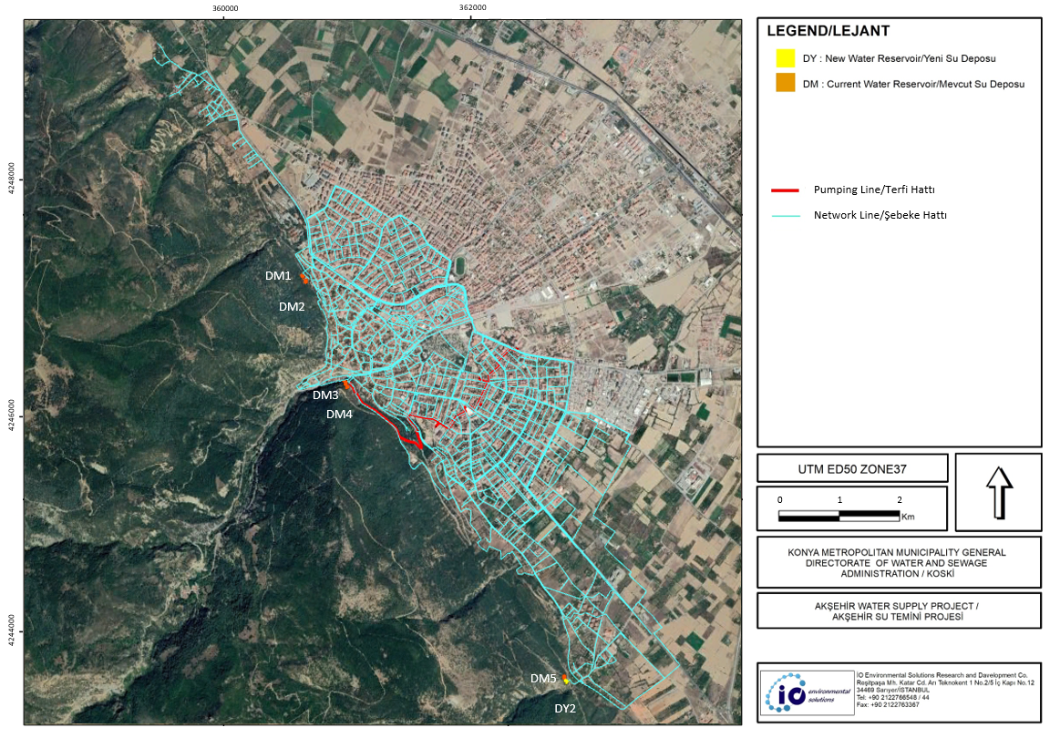
Figure 2-1 Satellite Map for Akşehir Water Supply Project
A site visit was conducted by the specialist of io Environmental Solutions between 27-29.11.2019 during the preparation of this ESMP. Pictures of the project components taken during the site visit are provided in Annex 1. The proposed network line includes rehabilitation of pipeline in Yıldırım, Çimenli, Anıt, Altunkalem, Selçuk, Eskikale, Ahicelal, Kuşcu, Nasrettin, Çay, Kileci, Meydan, Seyran, Gazi, Kuruçay, Yarenler and Yeni Neighborhoods, which are located in the centrum of Akşehir.
The construction of the project will be performed by construction company/companies who will be awarded contracts. The bidding process shall be managed in accordance with the World Bank Procurement Policy. The construction is expected to be finalized in 3 years and the economic life of the project is determined as 35 years. During the 12-month defects liability period, the construction contractor will be responsible for any repairs of the newly constructed facilities, in accordance with legal regulations as of provisional acceptance. Afterwards, KOSKİ will be responsible for operation, repairs and maintenance of the whole system. KOSKİ should ensure compliance of drinking water parameters with Regulation Concerning Water Intended for Human Consumption. Monthly analysis should be performed on samples drawn from the drinking water network as well as from the water resources.

Land Use
The New Water Reservoir-2 (DY2) is located on land without land registration. KOSKİ representatives refer to parcel no Savaş 113/1 for that land, indeed referred parcel is at the 670 m northwest of proposed DY2 land. Before the construction starts, KOSKİ should obtain required permits or obtain adequate information on the Forestry Land Delivery Receipt Reports (See Photo 2).
All network lines will be constructed along the present earth road alignment.

Technical Specification
Akşehir Water Supply Project contract packages is going to include İLBANK’s relevant technical specifications and its application project. The construction contractor should work complying with the contract package, technical specifications and application projects and controlling parties should control the construction contractor per subject requirements. The construction methodologies referring to the İLBANK’s technical specification and application project are presented below.

Material Certification and Documentation
The construction contractor shall provide the necessary documents related to the quality, production and tests of the equipment and materials to be used within the scope of the project from the manufacturer and submit the copies to the assigned representative of the supervision company for its approval.

Material Testing
The records of the relevant standards and test results of the equipment and materials procured under the project should be kept. All the tests necessary to verify the qualities and specifications of the material and its dimensional tolerances should be performed. Test results should be prepared at the intervals specified in the standards. If there is a conflict in the test results, the test could be repeated again by a different testing organization deemed appropriate by the supervision company. It is anticipated that the materials to be used in construction will be procured from local suppliers where available. Thus, it will contribute to the local economy.

Excavation Works
The trench excavation is excavations made by hand or any construction machinery for pipe lying. The excavations will be carried out by taking precautions so as not to disrupt the daily life. The local governmental institutions and community will be informed in advance about the time planning of the excavations. The excavated material will be removed from the site if it is not in suitable quality for backfilling.
The detailed construction programs will be prepared by construction contractor with the supervision of Supervision Consultant. This program includes details on how the excavated material will be managed whether it is stored to the edge of the trench or not, which storage areas will be used for storage or disposal and how much excavated material will be transferred to storage areas and methods of backfilling.
Setting vehicle tracking system and damper cover sensor to the excavation trucks to be integrated to the existing tracking system in Konya Metropolitan Municipality is mandatory and the excavation wastes should be transferred to the determined storage area/s of Konya Metropolitan Municipality. Receiving "Waste Transportation Permit Certificate" from Konya Metropolitan Municipality is required. All excavated waste, construction and demolition wastes must be disposed for a fee to the excavation storage areas and/or recreation areas determined by Konya Metropolitan Municipality.
The route of each trench or channel, grade elevation and similar measures shall be determined referring to the observations from witness points. The horizontal and vertical route and the maximum pipe decking and deflection used in conjunction with it shall comply with the requirements in the specification on pipe installation.
The depth and width of the trench will be opened in accordance with the application projects as it will allow sufficient working area for pipe lying, bedding and filling. Trench widths will not be reduced or increased unless pile-plank is required due to deep excavation or ground improvement or other infrastructure on the excavated route or for any other reason without permission of the Supervision Consultant. The excavation dimensions are determined taking such conditions into account within the typical drawings and the construction contractor is expected to work within the specified dimensions. If the construction contractor damages the roadways outside the specified widths, it will restore the damage.
The excavation will be arranged on the trench so that the distance between the right and left sides of the pipe to be laid will be equal and in each case the measurements given in the project drawings will be complied with.
During the trench excavation, the construction contractor shall take the necessary safety precautions. On areas where soil improvement is required, it will take necessary precautions such as pile-plank, etc. to ensure the safety of work and workers.
In the light of the studies, it is anticipated that there will be no need for provisional of new access roads other than the ones specified within the application project during the execution of the construction activities. During the construction, it is envisaged to form short distance traffic routing with different street alternatives.

The construction contractor shall comply with all requirements and recommendations of the Municipality, the Traffic Supervision Branch Directorate and the Highways Administration on road traffic regulations and road safety precautions. The construction contractor will submit traffic recommendations (if necessary) and permissions from the Traffic Supervision Branch Directorate and the Highways Administration to the approval of the Supervision Consultant before starting the activity on the site.

Pipe Bedding, Fill, Pressure Test and Backfill
The trench excavation will be performed to a depth depending on the bedding, filling and backfilling depths per typical drawings given in the application project. These depths change with respect to ground material. The bottom of the trench will be cleaned from large stones and graded. The bedding material will be spread over the trench bed as wide as the trench width. After the pipe lying on the bedding material in the trench, the water pressure test will be performed. The length of the pipe to be testes should not exceed 500 m. When the tests on pipes laid on the bedding material give positive results and after the Supervision Consultant’s approval is obtained, the fill material shall be placed around the pipe to the design height and compacted. Upon completion of the pipe encasing process, the backfill materials shall be placed, compacted and tested.

Properties of Materials for Bedding, Covering and Backfilling
For drinking water project, after lying the pipe in accordance with the requirements of TS 7397, it will be filled with nonaggressive soil grained from gravels having granules smaller than 20 mm or fine gravel or similar filling material and then compacted. The backfilling will be provided by excavation material or a standard filling material or stabilized material.
Due care and attention shall be paid to bedding, filling and backfilling. None of the pipes shall be embedded without the Supervision Consultant’s permission. Materials of specified quality shall be used by taking all related permissions.
The trench backfill material shall be levelled and compacted using tamping rods or any other equipment suitable to the purpose and then watered for adequate compaction. Bedding and filling material should not contain any ash and slag material which may cause corrosion of the pipe. Bedding and covering materials, their placement and compaction shall conform to the requirements given in the contractual documents.

Tests
All tests to ensure that bedding, covering and backfill materials and their placement should comply with specified requirements and all additional tests deemed required by the supervision company shall be made by the construction contractor.

Pavements
The detailed construction programs will be prepared by construction contractor with the supervision of Supervision Consultant. This program includes details on the damaged pavement amount and storage areas for damaged pavement as well as methods for repair of areas where pavements damaged. The repair and replacement of damaged pavements due to construction works will be under the responsibility of construction contractor.

Commissioning
The drinking water pipelines will be cleaned and disinfected in accordance with the İLBANK’s pre-operation disinfection instruction for drinking water supply systems. This will be documented with a disinfection report.
The temporary admission of facilities requires approval of İLBANK. The following list of documents will be submitted to İLBANK for temporary admission;
- Digital operational plans prepared by the construction contractor and approved by the İLBANK Regional Directorate,
- Leakage test reports for water reservoirs,
- Reports showing installation of protection fences for water catchments,
- Disinfection report of the system,
- Sufficient number photos of system components,
- Acceptance request document of physical, chemical and bacteriological analysis of supplied and chlorinated water samples taken from water reservoirs and from an appropriate point of the network.

Baseline Data/Conditions

Geographical Location
Akşehir is a District of Konya and is located in the Central Anatolian Region (See Figure 3-1, Figure 3-2). It is 15 km away from both Aegean Region and Mediterranean region and located at the crossing of the three regions, in the eastern lakes’ region.
The district is situated at 38º, 02’, 00 northern latitude and 31º, 24’, 45 eastern longitude and in the 109 km west of Konya Province. Konya is surrounded by Ankara and Eskişehir in the north, Afyonkarahisar in the northwest, Isparta in the west, Antalya and Karaman in the south and Aksaray and Niğde in the east. In the west of Akşehir district, Isparta Province is located. Akşehir district is surrounded by Akşehir Lake in the north. The district has an area of 1,142 km² and it is 1,050 m above sea level.
Akşehir Water Supply Project is planned to be constructed in Centrum of Akşehir District of Konya Province.
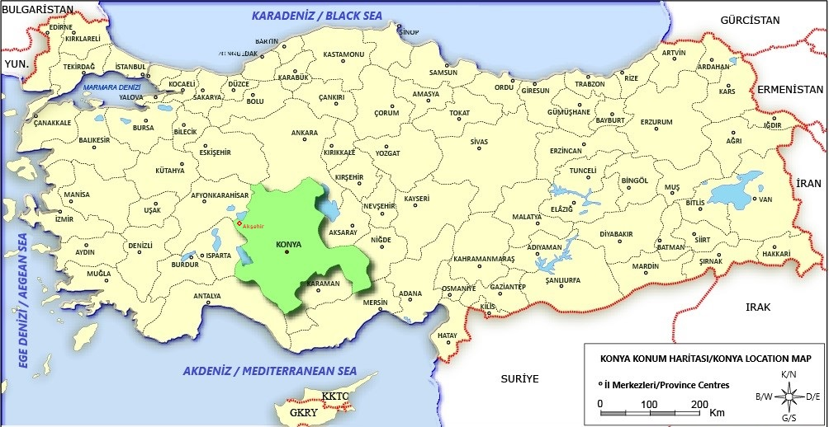
Figure 3-1 Konya Province and Akşehir District on Turkey Map
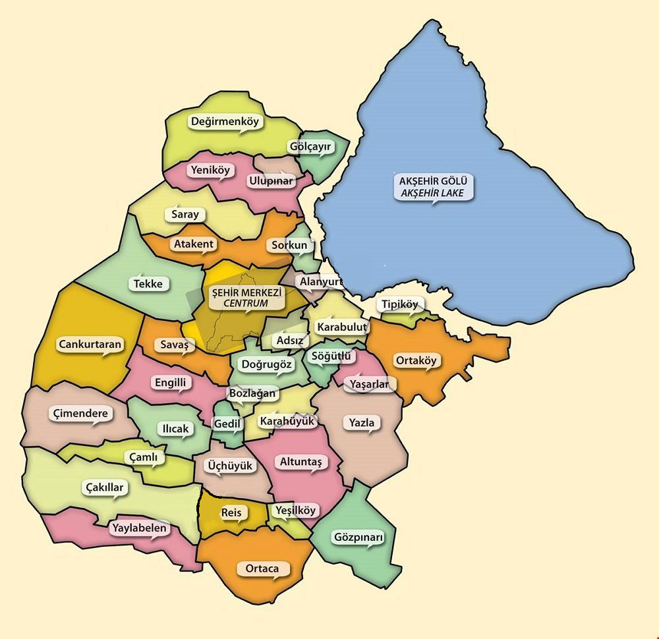
Figure 3-2 Neighborhoods of Akşehir District

Topographic and Geological Characteristics of Project Area
The Sultan Mountain chain at the south of the district and the water collection basin of Akşehir Lake on the North, determines the morphological structure of the region. The Sultan Mountain chain on the northwest-southwest direction, has Tekkale hill with an altitude of 1664 m, Çamlık hill 1731 m and Gelincikana hill 2610 m as its peak. Akşehir Lake is 958 m above sea level.
The most important stream is the Adıyan brook coming from Doğanhisar direction and joining Akşehir Lake at 5-6 km northwest of Akşehir. Akşehir brook starts from Sultan Mountains and flows through the town by separating it into two. In summer season the creek completely dries out.
Topography of Akşehir Centrum and the surrounding area is shown in Figure 3-3 below.
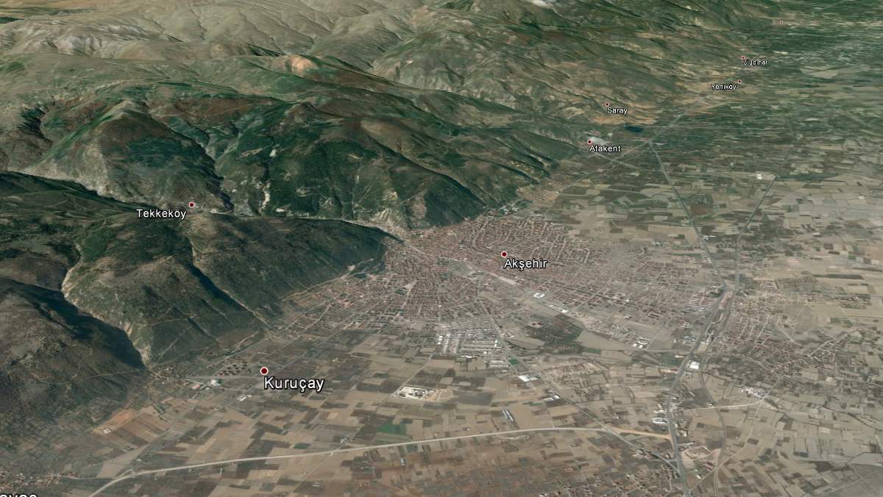
Figure 3-3 Akşehir Centrum Topography
Akşehir region is located on the northern part of the Western Taurus Mountains. In the region, Caledonian, hercynitian and alpine orogeny phases were effective and significant folds, drifts and many faults occurred. The Sultandağı fault is the biggest fault in the area and controls the Akşehir and Eber lakes from the south.
As per the Earthquake Hazard Map published by Disaster and Emergency Management Presidency (AFAD) (See Figure 3-4), the maximum ground acceleration of Akşehir District is around 0.3 g.
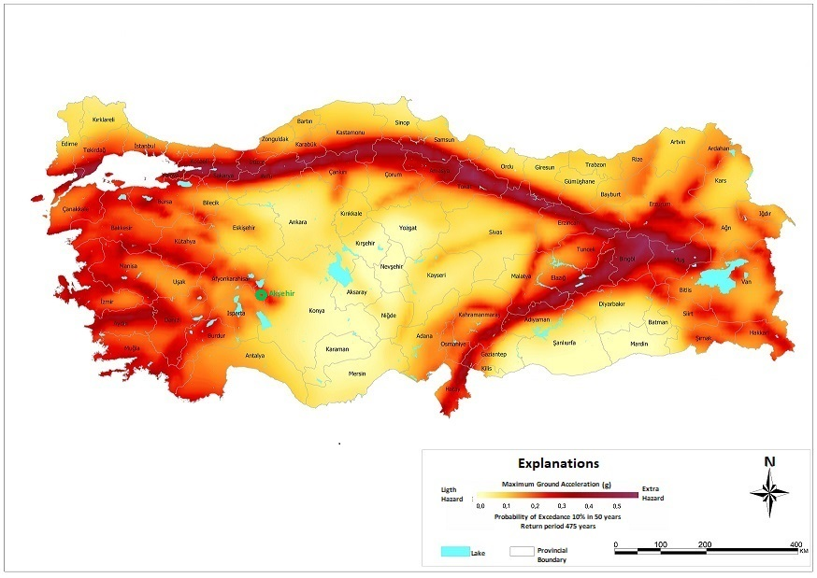
Figure 3-4 Turkey Earthquake Hazard Map
Source: Disaster and Emergency Management Presidency (AFAD), 2018, Earthquake Hazard Map

Population
Recent Turkish Statistical Institution (TurkStat) population results of Akşehir District which are based on Address-Based Population Registration System (ABPRS) is given in Table 3.1.
Table 3.1 Population Results of Akşehir District
 | Population |  | Active Population | Population | Yearly Increase Factor
Years | Male | Female | Aged Between 15-64 | Total | Yearly Increase Factor
2019 | 45,934 | 47,951 | 61,723 | 93,885 | 0.70%
2018 | 45,557 | 47,676 | 61,542 | 93,233 | -1.09%
2017 | 46,109 | 48,146 | 62,595 | 94,255 | 0.02%
2016 | 46,160 | 48,072 | 63,095 | 94,232 | 0.08%
2015 | 46,194 | 47,965 | 62,810 | 94,159 | 0.03%
2014 | 46,181 | 47,952 | 62,991 | 94,133 | 0.27%
2013 | 46,069 | 47,814 | 63,079 | 93,883 | -0.73%
2012 | 46,374 | 48,201 | 63,648 | 94,575 | -0.33%
2011 | 46,524 | 48,362 | 63,996 | 94,886 | -0.95%
2010 | 46,817 | 48,974 | 64,671 | 95,791 | -
Source: ABPRS, TurkStat
According to abovementioned data, it can be deduced that the population has decreased between years 2010-2014. The fact that there has been a significant population increase rate in year 2014 is due to Syrian refugee influx. Akşehir Water Supply Project is designed to feed the neighborhoods of Akşehir District, which are; Ahicelal, Altunkalem, Anıt, Çay, Çimenli, Eskikale, Gazi, Kileci, Kuruçay, Kuşçu, Meydan, Nasreddin, Selçuk, Seyran, Yarenler, Yeni, Yıldırım neighborhoods, respectively. The following Table 3.2 presents the population figures for Akşehir Water Supply system distribution area, by age.
Table 3.2 Population Figure of Akşehir by Age
Neighborhood | Total Population
Neighborhood | 2015 | 2016 | 2017 | 2018 | 2019
Ahicelal | 256 | 244 | 238 | 271 | 234
Altunkalem | 5,360 | 5,293 | 5,121 | 4,863 | 4,866
Anıt | 796 | 766 | 720 | 689 | 663
Çay | 209 | 207 | 204 | 195 | 183
Çimenli | 516 | 515 | 495 | 487 | 460
Eskikale | 301 | 286 | 292 | 289 | 265
Gazi | 5,599 | 5,791 | 5,874 | 5,926 | 6,148
Kileci | 5,023 | 5,045 | 4,967 | 4,903 | 4,964
Kuruçay | 971 | 968 | 1010 | 1,008 | 978
Kuşçu | 396 | 395 | 398 | 389 | 387
Meydan | 1,160 | 1,108 | 1,089 | 990 | 977
Nasreddin | 484 | 469 | 471 | 454 | 457
Selçuk | 2,310 | 2,164 | 2,189 | 2,075 | 1,991
Seyran | 4,011 | 4,027 | 3,814 | 3,899 | 3,872
Yarenler | 9,893 | 10,183 | 10,635 | 10,512 | 10,981
Yeni | 12,913 | 12,904 | 13,207 | 13,155 | 13,643
Yıldırım | 1,842 | 1,866 | 1,881 | 1,798 | 1,767
Akşehir | 52,040 | 52,231 | 52,605 | 51,903 | 53,836
Yearly Increase Factor | - | 0.37% | 0.71% | -1.34% | 1.78%
Source: ABPRS, TurkStat
Referring to the Akşehir Water Supply Project Design Report, the target year 2052 population for Akşehir Water Supply Project is calculated by taking the multiplication factor as 1 as instructed by Administration. The population is assumed in the project as given in Table 3.3.
It is estimated that there will be approximately 10,763 refugees living in Akşehir District in 2020 which includes the seasonal labor migrants who accommodate in seasonal agricultural labor camps during spring, summer and autumn period. The camps are established in neighborhoods where agricultural activity is dominant.
Total population projection results for Akşehir Water Supply Project is summarized in Table 3.3.

Table 3.3 Total Population Projection Results for Project Period
Year | Projected Population for Local Residents | Projected Population for Refugees | Total Population
2020 | 97,111 | 10,763 | 107,874
2025 | 102,064 | 17,679 | 119,743
2030 | 107,271 | 24,315 | 131,586
2035 | 112,742 | 30,677 | 143,419
2040 | 118,493 | 36,772 | 155,265
2045 | 124,538 | 42,602 | 167,140
2050 | 130,891 | 47,862 | 178,753
Source: Akşehir Water Supply Project, Project Identification Report, 2019
The projected population data in Akşehir Water Supply Project Design Report has no indication on inclusion of refugee population.

Socio-Economic Baseline
Akşehir is a district of Konya Province where approximately 35% of the population live in rural areas and mainly engage with agricultural activities. Within the socio-economy of the district, the sectorial ranking is in the form of agriculture and industry. Akşehir District agricultural lands are used for beet, wheat, poppy, cherry and sour cheery production. Cattle husbandry is dominant whereas goat and sheep husbandry is also common in Akşehir. Industrialization in Akşehir is mainly concentrated in the Akşehir Organized Industrial Zone and on industrialization of agricultural products and automotive.
Akşehir District likewise Konya has also its own specific problems regarding the migration to city centers.
Out-migration from the Province of Konya was mostly seen among young people between the ages of 20-24. TurkStat migration statistics show that in Konya the percentage of female migrants is higher than male migrants. While the female migration rate is 4% higher than male migrants for the ages of 20-24, it is 2% higher for all age groups.
According to TurkStat, the number of tourists overnight stays in Turkey is 450,561,752 people in 2017. Statistics show that this number increased by 8% in 2018 and 13% in 2019 reaching 505,608,959 people. In Konya Province, the total number of tourist overnight stays is measured as 5,962,386 people in 2017. Although this number increased 0.5% in 2018, it decreased 4% in 2019 to 5,744,025. KOSKİ representatives indicated that water supply should be ensured in Akşehir District in relation with it having a moderate to high tourism potential.

Income and Production
Gross Domestic Product (GDP) of Turkey and Konya
As per TurkStat and given in Table 3.4 and Table 3.5, Turkey’s GDP in current prices, has increased by 51.41% within 6 years between 2013 and 2018. The highest growth rate was in 2018 (16.48 %). The share of agricultural sector in GDP has dropped from 6.7% in 2013 to 5.8% in 2018. Industry sector share has increased from 27.7% in 2013 to 29.5% in 2018. Services sector remained relatively constant.

Konya’s GDP in current prices, has increased by 52.30% within 6 years between 2013 and 2018. The highest growth rate was observed in 2018 (16.30 %). The share of agricultural sector in GDP has dropped from 18.0 % in 2013 to 16.8% in 2018. Industry sector share has increased from 23.5% in 2013 to 27.2% in 2018.
Table 3.4 Turkey and Konya, Gross Domestic Product (million TRY) in Current Prices
 | Period | Agriculture | Industry | Services | Sectorial Total | Taxes-subsidies | GDP | Increase (%)
Turkey | 2013 | 121.71 | 501.22 | 962.40 | 1,585.33 | 224.39 | 1,809.71
Turkey | 2014 | 134.72 | 576.44 | 1,097.02 | 1,808.19 | 236.28 | 2,044.47 | 11.48%
Turkey | 2015 | 161.45 | 652.58 | 1,246.70 | 2,060.73 | 277.92 | 2,338.65 | 12.58%
Turkey | 2016 | 161.30 | 735.17 | 1,402.42 | 2,298.90 | 309.63 | 2,608.53 | 10.35%
Turkey | 2017 | 189.19 | 908.46 | 1,659.11 | 2,752.64 | 353.89 | 3,110.65 | 16.14%
Turkey | 2018 | 216.67 | 1,097.68 | 2,020.86 | 3,335.21 | 389.17 | 3,724.39 | 16.48%
Konya | 2013 | 6.76 | 8.83 | 17.33 | 32.91 | 4.66 | 37.57 | -
Konya | 2014 | 7.88 | 10.79 | 20.19 | 38.86 | 5.08 | 43.93 | 14.49%
Konya | 2015 | 8.96 | 12.63 | 22.59 | 44.19 | 5.96 | 50.15 | 12.39%
Konya | 2016 | 8.99 | 14.40 | 25.70 | 49.09 | 6.61 | 55.70 | 9.97%
Konya | 2017 | 10.78 | 17.77 | 29.87 | 58.43 | 7.50 | 65.93 | 15.51%
Konya | 2018 | 13.20 | 21.42 | 35.93 | 70.54 | 8.23 | 78.77 | 16.30%
Source: TurkStat

Table 3.5 Sectoral Percentages of GDP in Turkey
 | Period | Agriculture | Industry | Services | Sectorial Total | Taxes-subsidies
Turkey | 2013 | 6.7 | 27.7 | 53.2 | 87.6 | 12.4
Turkey | 2014 | 6.6 | 28.2 | 53.7 | 88.4 | 11.6
Turkey | 2015 | 6.9 | 27.9 | 53.3 | 88.1 | 11.9
Turkey | 2016 | 6.2 | 28.2 | 53.8 | 88.1 | 11.9
Turkey | 2017 | 6.1 | 29.2 | 53.4 | 88.6 | 11.4
Turkey | 2018 | 5.8 | 29.5 | 54.3 | 89.6 | 10.4
Konya | 2013 | 18.0 | 23.5 | 46.1 | 87.6 | 12.4
Konya | 2014 | 17.9 | 24.6 | 46.0 | 88.4 | 11.6
Konya | 2015 | 17.9 | 25.2 | 45.1 | 88.1 | 11.9
Konya | 2016 | 16.1 | 25.9 | 46.1 | 88.1 | 11.9
Konya | 2017 | 16.4 | 27.0 | 45.3 | 88.6 | 11.4
Konya | 2018 | 16.8 | 27.2 | 45.6 | 89.6 | 10.4
Source: TurkStat

Employment
Most actual, detailed statistics in terms of labor force participation and unemployment rates are available on the level of zones within the TurkStat statistics as there are no publicly available subject statistics on provincial level. Turkey has been divided into 26 zones to make it easier to conduct the statistical analysis. Konya is included in the 52nd Zone of Turkey together with Karaman. The unemployment rate as a whole in this zone compared to the unemployment rate in Turkey has been generally low. Labor Force Participation is also low in this zone as per Turkey ratio. Employment rate has been higher as compared to Turkey. Women participation in work force has been comparatively low in this region of Turkey showing lower employment figures for women when compared to national employment rates (See Table 3.6).
Table 3.6 Labor Force Participation, Employment and Unemployment Rates
Period | Turkey vs 52nd Zone Provinces | Labor Force Participation (%) | Employment - Men (%) | Employment – Women (%) | Employment (%) | Unemployment (%)
2014 | Konya and Karaman | 49.1 | 69.6 | 23.8 | 46.4 | 5.6
2014 | Turkey | 50.5 | 64.8 | 26.7 | 45.5 | 9.9
2015 | Konya and Karaman | 51.2 | 69.4 | 26.3 | 47.8 | 6.5
2015 | Turkey | 51.3 | 65 | 27.5 | 46.0 | 10.3
2016 | Konya and Karaman | 50.0 | 69.6 | 25.0 | 46.9 | 6.1
2016 | Turkey | 52.0 | 65.1 | 28 | 46.3 | 10.9
2017 | Konya and Karaman | 50.3 | 69.6 | 25.9 | 47.3 | 5.9
2017 | Turkey | 52.8 | 65.6 | 28.9 | 47.1 | 10.9
2018 | Konya and Karaman | 50.7 | 69.0 | 27.7 | 47.7 | 5.9
2018 | Turkey | 53.2 | 65.7 | 29.4 | 47.4 | 11
2019 | Konya and Karaman | 51.0 | 67.7 | 27.6 | 46.9 | 8.0
2019 | Turkey | 53 | 63.1 | 28.7 | 45.7 | 13.7
Source: TurkStat

Education
Literacy is a key measure of a population’s education in a country and affects the socio-economic conditions. Generally, in Turkey for 2019, the percentage of illiterate people among all over 15-year-olds (illiteracy rate) is 3.3%, while it is 2.3% in Konya Province and %3.3 in Akşehir District. While %0.8 of males is illiterate in the Akşehir District, this rate is %5.6 among the female population. This situation reveals gender inequality in education.
The Table 3.7 provides a detailed review on education levels for male and female over the age of 15 in Akşehir District, Konya province and Turkey for the year 2019. The education rates for females are increased in recent years for Turkey as well as for Konya province and Akşehir District. In both Konya and Akşehir, the education level for men after primary education is higher than the national level whereas the education level for females is significantly lower. The share of Akşehir’s female and male population having master degree rates in Konya represents in a range of 3.05-3.57% in 2019. While a slight increase is recorded on rates for college/faculty of both male and female in Turkey in last 5 years, this rate has slightly decreased in Konya but the share of women having a college or university degree has risen from 40.19% to 44.18%.

Table 3.7 Education Level and Rates for Akşehir, Konya and Turkey for 2019
 |  | Male (Over the age of 15) |  |  |  |  | Female (Over the age of 15)
Education Level | Akşehir | Akşehir’s Share in Province | Province Share in Turkey | Gender’s Share in Akşehir | Gender's Share in Province | Gender's Share in Turkey | Akşehir | Akşehir’s Share in Province | Province Share in Turkey | Gender’s Share in Akşehir | Gender's Share in Province | Gender's Share in Turkey
Doctor’s Degree | 59 | 1.59% | 2.97% | 62.77% | 65.15% | 59.06% | 35 | 1.76% | 2.30% | 37.23% | 34.85% | 40.94%
Master’s Degree | 574 | 3.57% | 2.66% | 64.35% | 60.70% | 55.93% | 318 | 3.05% | 2.18% | 35.65% | 39.30% | 44.07%
College or Faculty | 5715 | 4.36% | 2.40% | 58.16% | 55.82% | 53.18% | 4111 | 3.96% | 2.16% | 41.84% | 44.18% | 46.82%
High School | 11130 | 5.53% | 2.32% | 60.53% | 56.63% | 56.30% | 7258 | 4.71% | 2.29% | 39.47% | 43.37% | 43.70%
Secondary School | 6564 | 3.48% | 2.76% | 53.53% | 55.76% | 55.49% | 5698 | 3.81% | 2.73% | 46.47% | 44.24% | 44.51%
Primary Education | 2827 | 3.01% | 2.90% | 50.62% | 55.83% | 57.06% | 2758 | 3.71% | 3.05% | 49.38% | 44.17% | 42.94%
Primary School | 8618 | 5.18% | 3.28% | 38.02% | 38.16% | 40.61% | 14049 | 5.21% | 3.63% | 61.98% | 61.84% | 59.39%
Literate without any degree | 445 | 3.87% | 1.76% | 16.77% | 18.96% | 24.91% | 2208 | 4.49% | 2.49% | 83.23% | 81.04% | 75.09%
Illiterate | 295 | 5.95% | 1.73% | 11.95% | 12.53% | 14.15% | 2173 | 6.28% | 1.99% | 88.05% | 87.47% | 85.85%
Source: TurkStat

Climate
The region has a continental climate. In addition, it’s a transition zone between central Anatolia and west-central Anatolia. Summers are hot and dry, winters are cold and rainy. Yearly precipitation amount is 690 mm. Precipitation occur in winter and spring time. Akşehir and its surroundings is one of the rainiest regions of central Anatolian Region.
The following Table 3.8 provides data related to maximum and minimum temperatures and average precipitation on a monthly basis.
Table 3.8 Monthly Minimum and Maximum Temperatures and Average Precipitation in Akşehir
Parameter | Month
Parameter | Jan | Feb | Mar | Apr | May | Jun | Jul | Aug | Sep | Oct | Nov | Dec
Maximum temperature, ºC | 5 | 7 | 11 | 16 | 21 | 25 | 28 | 28 | 25 | 18 | 13 | 7
Minimum temperature, ºC | −2 | −1 | 1 | 5 | 9 | 12 | 14 | 14 | 10 | 6 | 2 | 0
Average Precipitation, mm | 71 | 66 | 69 | 69 | 56 | 46 | 18 | 13 | 18 | 48 | 56 | 80
Source: Weather base, 2011

Protected Areas
There are no national parks, nature parks, nature reserves, nature monuments, wildlife protection areas and wildlife development areas defined by the national legislation within the project area. The project does not fall on an archaeological site. There are no wetlands in and around the project area. The nearest wetland is the Akşehir lake which is located approximately 5 km north of the project components. The map of protected areas, key biodiversity areas and archaeological sites is given in Figure 3-5). It is concluded that no significant impact on these areas is expected after implementation of the mitigation measures provided in Table 6-1 and Table 6-3.
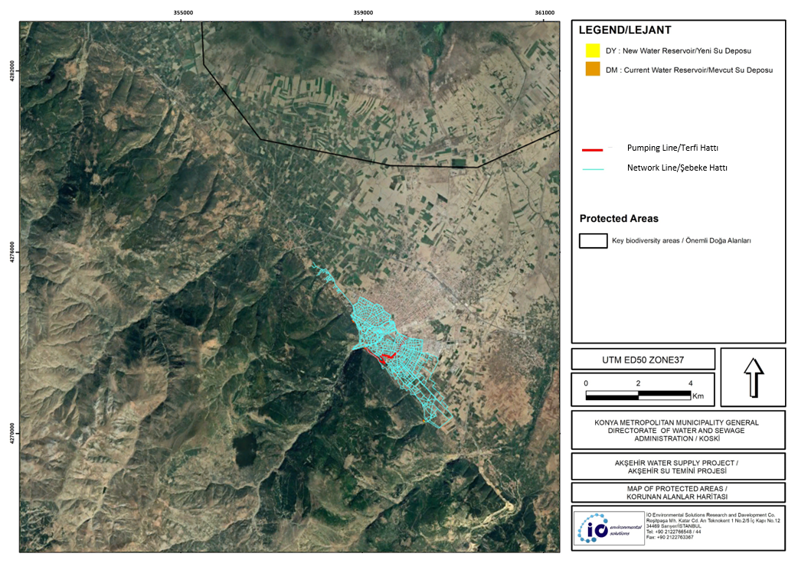
Figure 3-5 Map of Protected Areas

Environmental and Social Management and Responsibilities

Environmental and Social Management
Each project has environmental and social impacts. The environmental and social impacts of this project are detailed under Section 5. These impacts could be positive or adverse. There are ways to avoid, minimize, reduce and mitigate risks and adverse impacts. The WB’s Environmental and Social Framework (ESF) and the Project’s Environmental and Social Management Framework (ESMF) establishes objectives and requirements for reducing adverse impacts on environmental and social aspects. The national regulations also give regulatory references for the protection of environment and regarding health and safety.
The Environmental and Social Impact Management and Monitoring Plan provided under Section 6 gives the detailed proactive, preventive and mitigation measures along with monitoring measures, parameter and schemes. The monitoring schemes are designed to control the implementation status of the measures. This designed monitoring scheme is presented including responsible parties.
The effective and timely implementation of this Environmental and Social Management Plan (ESMP), along with effective and on the job monitoring by the monitoring agencies and institutions, will result in minimized and at some cases avoided environmental and social impacts.

Roles and Responsibilities
The construction of the project will be performed by construction company/companies who will be awarded contract(s). KOSKİ will be the main responsible party for ensuring the compliance of the Project with the requirements detailed in the ESMF, including Environmental, Social, Health and Safety (ESHS) measures.
The construction is expected to be finalized in 3 years and the economic life of the project is determined as 35 years. During the 12-month defects liability period, the construction contractor will be responsible for any repairs of the newly constructed facilities, in accordance with legal regulations as of provisional acceptance. Afterwards, KOSKİ will be responsible for operation, repairs and maintenance of the whole system.
The Supervision Consultant will be contracted by KOSKİ. The Supervision Consultant will review the Final Designs of the sub-project. In the event of any incompliant finding, the designs shall be revised or updated. The Supervision Consultant will work as controller and consultant during the construction phase of the sub-project.
The Supervision Consultant will identify and manage environmental, social and OHS related risks and initiate corrective actions where necessary, prepare the monthly and quarterly monitoring reports including the non-compliances and will submit to KOSKİ together with the Constructor’s monitoring reports.
The Supervision Consultant will have an Environmental and Social unit staffed with qualified environmental and social specialists (at least one environmental expert, one social expert and one occupational health and safety (OHS) expert) and number of experts will be increased if necessary, during project implementation. The unit will have environmental and social capacity to supervise the construction works according to the requirements of this ESMP, prepare monitoring reports and non-conformity forms, update the ESMP if required.
Constructor will prepare the monthly and quarterly monitoring reports including the corrective actions on environmental, social and OHS related issues addressed in ESMP and will submit to KOSKİ through the Supervision Consultant. KOSKİ will be responsible for timely submission of the quarterly monitoring reports of the Constructor and the Supervision Consultant to ILBANK.
The General Directorate of İLBANK is the main responsible party for the whole sub-project compliance as the financial intermediary. They should control the KOSKİ, and Supervision Consultant’s reports on the project and instruct them for compliance.
Detailed information on responsibilities of construction contractor, KOSKİ Project Implementation Unit, Supervision Consultant, and General Directorate of İLBANK is explained in the following table (Table 4.1).
Table 4.1 Institutional Tasks of Relevant Authorities
Company/Institution | Tasks
Construction Contractor | The construction contractor is contracted by KOSKİ to construct the project in line with the approved design documents and this ESMP. The contractor is the responsible body to develop, implement and apply the mitigation measures given in ESMP, particularly in Section 6.  The contractor shall adhere its responsibilities specified in this ESMP.  The contractor will prepare his/her sub-management plans and procedures such as OHS Plan and submit to KOSKİ/supervision contractor prior to the construction works.  The contractor should ensure that it is aware of its duties and responsibilities within this ESMP for compliance with national regulation and WB’s ESSs.  The construction contractor shall employ a full-time occupational health and safety (OHS) specialist and a full time environmental and social expert who will instruct and consult the workers on implementation of ESMP and LMP (including grievance mechanism and the applicable stakeholder engagement activities detailed in project SEP).  Furthermore, a competent ESHS manager of contractor should monitor implementation of measures given in the management plan.  The construction contractor should develop monthly and quarterly Environmental and Social Monitoring Reports in order to submit to the İLBANK though KOSKİ and Supervision Consultant.  During the construction phase, the contractor should train its workers on environmental and social aspects (including OHS) as per WB’s ESSs and national regulations in order to raise environmental and social awareness.  During the defects’ liability period, the construction contractor will be responsible for any repairs of the newly constructed facilities, in accordance with legal regulations as of provisional acceptance. Within the liability period, the contractor should implement measures given in Environmental and Social Management Plan for operation (Table 6.3)
KOSKİ PIU | The construction contract packages for these sub-projects will be managed by KOSKİ PIU.  The KOSKİ PIU will be responsible from the ESHS compliance of construction contractor and act as a controller within the scope of the sub-projects.  The KOSKİ PIU shall adhere its responsibilities specified in this ESMP.  The KOSKİ PIU will be responsible for management of sub-project level grievance mechanism and the stakeholder engagement activities set out in the project SEP.  Some of the measures and whole monitoring scheme which are defined under ESMP will be performed by KOSKİ PIU during the construction.  The KOSKİ PIU will examine the monthly and quarterly Environmental and Social Monitoring Reports of the contractor/s.  This unit requires trainings on WB’s ESSs in order to understand the compliance scheme and ESHS requirements of the project.
Supervision Consultant | The Supervision Consultant will serve as controller within the scope of the project and will control both the technical, including environment and social, and administrative progress of the contract packages and the implementation of the measures.  The Supervision Consultant shall be on site to conduct site inspections continuously.  The Supervision Consultant will examine the monthly and quarterly Environmental and Social Monitoring Reports of the contractor/s.  The Supervision Consultant has the responsibility to prepare non-conformity forms in the event of any non-conformity observed during the site inspections and within the reports.  The Supervision Consultant will reassess the water resources prior to construction and update this ESMP with KOSKİ in accordance with the final decision and water source.
General Directorate of İLBANK | The General Directorate of İLBANK is responsible for satisfactory implementation of all sub-project including the environmental and social performance. İLBANK will monitor the construction contractor’s, KOSKİ PIU’s, and Supervision Consultant’s performances relating with ESHS compliance with regular site visits.  They will instruct these parties for compliance.  They will review the quarterly reports of contractors during the construction phase. The General Directorate of İLBANK will inform the WB by providing regular semi-annual monitoring reports on the ESHS performance of the project.
World Bank | WB will periodically review the project development stages and regular semi-annual monitoring reports on the ESMP and ESHS performance of the project.

Capacity Development and Training Requirements
In order to raise awareness and develop responsible capacities, provision of a number of trainings is required for KOSKİ PIU and Contractor’s management and employees.
The Supervision Consultant will be responsible for the environmental and social trainings. Environmental and Social unit of Supervision Consultant will give necessary trainings to all personnel of KOSKİ PIU and Contractor’s management and employees before start of construction works. At the time of each employment for KOSKİ PIU, Supervision Consultant will train the new member of the unit.
Supervision Consultant will repeat its training to KOSKİ PIU and contractor representatives semi-annually and whenever it is deemed necessary.
Main subjects of the trainings for KOSKİ PIU are listed as;
- A brief information about content of Environmental and Social Management Plan and Monitoring Plan
- Responsibilities for implementation of environmental and social mitigation procedures and monitoring of implementation of measures
- Soil pollution control
- Waste management
- Water pollution control
- Air quality
- Noise control
- Protection of biological environment
- Community health and safety
- Grievance mechanism
- Requirements associated with land acquisition and involuntary (physical and economical) resettlement
- OHS measures and emergency preparedness and response (including Covid-19 precautions, how to be protected and what to do when symptoms appear)
Supervision Consultant will ensure that the Contractor will perform the same trainings for their personnel. Supervision Consultant is responsible for the monitoring of the Contractor’s actions on training. At the time of each employment for Contractor, the Contractor will train the new personnel.
Contractor will repeat its training to its personnel semi-annually and whenever it is deemed necessary by contractor itself or Supervision Consultant.
Main subjects of the trainings for Contractor’s are listed as;
- A brief information about content of Environmental and Social Management and Monitoring Plan
- Responsibilities on environmental and social mitigation procedures
- Soil pollution control
- Waste management
- Water pollution control
- Air quality
- Noise control
- Protection of biological environment
- Community health and safety
- Grievance mechanism
- Toolbox talks
- OHS measures and emergency preparedness and response (including Covid-19 symptoms, how to be protected and what to do when symptoms appear.)
- Work-specific talks
Furthermore, the contractor, KOSKİ and the Supervision Consultant should receive obligatory trainings as per national legislation. The provision of trainings will include but not be limited to the ones given in Table 6-1 which are provided in compliance with the national legislation and achieving compliance with ESHS requirements of the project.

Environmental and Social Monitoring Reports
The Environmental and Social Monitoring Report is one of the most important tools to record the project’s E&S impacts and the effect of the mitigation measures implemented. In that scope, Environmental and Social Monitoring Reports will be prepared in different frequencies, by different parties and having different scopes.

Construction Phase

Contractor’s Environmental and Social Monitoring Reports
The Contractor will prepare monthly Environmental and Social Monitoring Reports in Turkish for KOSKİ and Supervision Consultant. The monthly Monitoring Reports will at least include all issues defined in the ESMP as the Contractor is the main responsible body for implementation of the mitigation measures given in the ESMP. The Contractor’s practices will be included in the Monitoring Reports together with exemplary on-site photos, records sheets, logs and documents as required in the Environmental and Social Monitoring Plan. The Contractor’s internal non-compliance and non-compliance tracking and relevant preventive and corrective actions taken by Contractor should be listed with evidence in the Monitoring Reports. These reports should be brief and reader friendly. These will be submitted to KOSKİ and Supervision Consultant in the first week of each month and then KOSKİ, Supervision Consultant and Contractor will review the report and its findings in the Contractor’s office. Once KOSKİ and Supervision Consultant ask to see or check any document, the Contractor is obliged to provide this document at any time.
The Contractor will prepare quarterly Environmental and Social Monitoring Reports in Turkish and English and share it with İLBANK through KOSKİ and Supervision Consultant. This report will have the same scope with monthly reports but prepared with quarterly data. Any analysis/sampling/measurement report will be given as an annex of the report together with the relevant assessment and necessary remediation activities. These reports will be submitted to KOSKİ and Supervision Consultant in the first week of each quarter and then review the report with KOSKİ and Supervision Consultant before submission to İLBANK for adequacy. KOSKİ and Supervision Consultant can ask for revisions and update. The Contractor will complete these revisions in one week and submit the revised version to KOSKİ and Supervision Consultant. If the report is found satisfactory, KOSKİ will share the report with İLBANK.

İLBANK’s Environmental and Social Monitoring Reports
İLBANK will prepare semi-annual Environmental and Social Monitoring Reports for the WB. Results of assessments of issues given in Table 6-1 and evaluation of the monitoring parameters given in Table 6-2 will be presented in the monitoring report. The results shall be compared with the national legislative and WB’s ESF requirements. The non-conformities and incompliances of Contractor will be presented and remediation procedures, preventive and corrective actions, corrective actions defined will be included in the Monitoring Reports.

Operation Phase

KOSKİ’s Environmental and Social Monitoring Reports
KOSKİ will prepare quarterly Environmental and Social Monitoring Reports in Turkish and English. Monitoring report will at least include all the issues defined in the Environmental and Social Management Plan as KOSKİ is the main responsible for implementation of the mitigation measures given in the ESMP. Any analysis/sampling/measurement report will be given as an annex of the report together with the relevant assessment and necessary remediation activities. These reports will be submitted to İLBANK in the first week of each quarter.

İLBANK’s Environmental and Social Monitoring Reports
İLBANK will prepare semi-annual Environmental and Social Monitoring Reports for the WB. Results of assessments of issues given in Table 6-3 and evaluation of the monitoring parameters given in Table 6-4 will be presented in the monitoring report. The results shall be compared with the national legislative and WB’s ESF requirements. The non-conformities and incompliances of KOSKİ should be presented and remediation procedures, preventive and corrective actions defined will be included in the Monitoring Reports.

Required Permits
The construction contractor is required to obtain required permits from natural gas distribution company, Museum Directorate, Turkish Electricity Transmission Corporation, electricity distribution company, communication infrastructure companies such as Telekom, Motorways Regional Directorate and Brach Office of Transportation Coordination Center etc. before construction starts and should present it to the KOSKİ and Supervision Consultant through an official letter.
Before the construction starts, for the sub-project, it is recommended to obtain an opinion letter on EIA exemption status from Provincial Directorate of Environment, Urbanization and Climate Change in order to ease any national application processes.

Environment and Social Impacts

Area of Influence
The Turkish EIA Regulation defines the area of influence as “the area affected by planned project before operation, during operation and after operation”. The area of influence may be different for different types of impacts and different environmental components (physical, biological, social).
Area of influence is defined in the World Bank Group (WBG) International Finance Corporation (IFC) Performance Standard (PS) 1 Assessment and Management of Environmental and Social Risks and Impacts as follows:
“Where the project involves specifically identified physical elements, aspects, and facilities that are likely to generate impacts, environmental and social risks and impacts will be identified in the context of the project’s area of influence.
The Area of Influence (AoI) is to encompass the following as appropriate:
- The area likely to be affected by:
- the Project (e.g., Project sites, immediate air shed and watershed, or transport corridors) and the Project Sponsors’ activities and facilities that are directly owned, operated or managed (including by contractors) and that are a component of the project (e.g., tunnels, access roads, borrow and disposal areas construction camps);
- impacts from unplanned but predictable developments caused by the project that may occur later or at a different location; or
- indirect project impacts on biodiversity or on ecosystem services upon which Affected Communities’ livelihoods are dependent.
- Associated facilities, which are facilities that are not funded as part of the project and that would not have been constructed or expanded if the project did not exist and without which the project would not be viable.
- Cumulative impacts that result from the incremental impact, on areas or resources used or directly impacted by the project, from other existing, planned or reasonably defined developments at the time the risks and impacts identification process is conducted.”
The AoI for the environmental and social components described below includes the settlements within the zoning plan borders of the Akşehir Municipality. The AoI of the Project is shown in Figure 5-1.

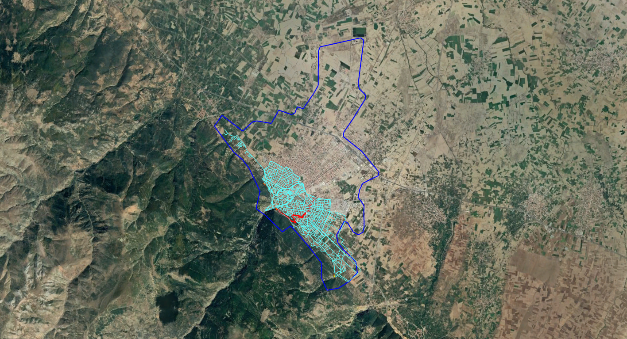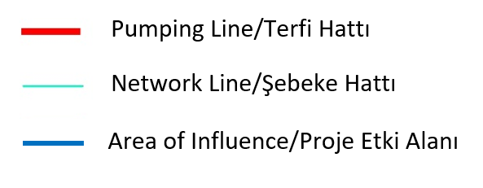
Figure 5-1 Area of Influence

Impacts on Physical Environment

Soil, Land Use and Landscape

Construction Phase
The network lines to be constructed within the scope of project are designed as buried pipelines. Topsoil on right of way (RoW) is going to be disturbed because of construction activities. In order to minimize this disturbance, the topsoil covering the whole RoW should be stripped to a 15-30 cm depth and collected on one side of the RoW during the construction works. Topsoil should be protected from vehicle movement, mixing and spreading. The subsoil excavated from trench excavations should be stored on the other side of the RoW to avoid mixing with topsoil.
After the bedding, pipe laying, covering and backfilling and pressure testing, and removal of excess subsoil from site, upon the approval of the Supervision Consultant, the topsoil should be spread over the RoW within the scope of reinstatement works. Thereby, the topsoil loss will be minimized at most and the impact on project affected people having rights on lands due to temporary and permanent will be reduced by handing back land having topsoil on it. Lands where pipeline passes should be restored to pre-project condition by an effective reinstatement approach.
Areas for storage of excess excavated material and backfilling material taken from quarries should be designated in advance to avoid unauthorized pouring/dumping on neighborhood lands.
The majority of network line pass through earth, stabilized or asphalted roads where no topsoil exists. In this case, providing that these are not going to be used as backfilling material, excavated earth and stabilized road material, subsoil and broken pavement should be transported to designated and permitted areas and/or licensed facilities for reuse and/or recycling. Roads is required to be restored to pre-project conditions.
All types of raw material used for construction will be provided from licensed quarries.
The permanent impact on land and soil will be observed at water reservoirs areas and service roads. As the water reservoir areas are wider than a water reservoir and its construction impact area referring to the design documents, there is a possibility not to disturb whole topsoil on water reservoir areas. The topsoil having the potential of being disturbed should be stripped to a 15-30 cm depth before start of construction. A portion of spread topsoil could be stored on the water reservoir area to be used for landscape purposes. The excess topsoil stripped from water reservoir areas and service road could be given to farmers after taking their written permissions or municipality for gardens.
The followings will be prohibited for the lifetime of the project;
- The use of any project vehicles out of RoW (unauthorized land) that can disturb soil environment,
- Any land disturbance out of RoW (if it is occurred, compensation will be paid).
There is a possibility of contamination of soil in the event of chemical i.e., oil, fuel, leakage due to accidents or faults of vehicles during construction works. The spill response should be applied, and spill response materials will be made available at the working areas.

Operation Phase
After the reinstatement of pipeline RoW is completed, any adverse impact on soil and land use is not expected for the operation phase.
The repair and maintenance works are considered as construction works; therefore, the repair and maintenance crews will perform works by considering the construction phase impacts and comply with corresponding mitigation measures all the time.

Air Pollution

Construction phase
Dust generation is expected as a result of earthworks such as excavation, filling, backfilling, service road works and land preparation works etc. Dust has an adverse effect on people from health perspective and on farmers by diminishing yield performance and on environmental features by clogging pores. It is foreseen that the project’s impacts are temporary and reducible. Necessary measures will be taken to avoid/minimize dust generation during earthworks, filling, emptying and transfer processes of the trucks. The top of trucks’ haulages will be covered to avoid air borne dust. Another important measure is water spraying by water tankers. Moistened soil will minimize the airborne dust. The storage areas of excavated material and construction materials (qualified sand and gravel) will be also moistened regularly to eliminate spread of dust.
In addition, exhaust emissions from construction machinery and equipment are expected. Periodical checks and maintenance of the construction machinery, equipment and vehicles to be used for the project shall be provided. Therefore, the effects are expected to be low.
For dust and exhaust emissions, additional measures shall be taken and a measurement campaign will be performed upon a complaint. The measurement results should comply with the standards given in WBG’s General EHS Guidelines.

Operation phase
In the operation phase, no adverse impact on air quality is anticipated.
The repair and maintenance works are considered as construction works; therefore, the repair and maintenance crews will perform works by considering the construction phase impacts and comply with corresponding mitigation measures all the time.

Noise Pollution and Vibration

Construction Phase
The construction vehicle and machinery will generate noise during the construction phase. The adverse effects of noise exposure on people could include interference with speech or other desired sounds, annoyance, sleep disturbance, anxiety, hearing damage and stress-related cardiovascular health problems. Recent studies show that the noise emission can interfere with animal communication hinder their foraging abilities and impact where they live.
During construction works, noise exposure due to working of 2-3 machinery for drinking waterline will last for 1 days for 100 m length. Therefore, the duration of the noise impact is assumed to be quite low and can be negligible.
With the aim of minimizing the impact period, construction works will be carried out during daytime (08:30- 18:30). High quality equipment will be selected with low noise levels and the adherence to speed limit will be ensured.
For noise pollution, additional measures will be taken and a measurement campaign will be performed on a quarterly basis. In addition to that, noise measurement will be conducted upon a complaint. The measurement results should comply with the standards given in national legislations and World Bank Group’s General EHS Guidelines,
Noise limit levels are described under, WBG’s General EHS Guidelines: Environmental Noise which one is stricter than national legislative limits; therefore, to be complied with within the scope of the Project. The noise limit values are based on World Health Organization Guidelines for Community Noise. Noise levels defined by WBG’s General EHS Guidelines are presented in Table 5.1.
Table 5.1 Noise Level Guidelines of WBG
Receptor | One Hour L_{Aeq} (dBA)
Receptor | Daytime 07:00 – 22:00 | Nighttime 22:00 – 07:00
Residential, institutional, educational | 55 | 45
Industrial, commercial | 70 | 70
During the excavations and constructions of permanent facilities, vibrations may occur due to the operation of heavy machinery. If there are houses or any assets at the close proximity of construction site, the vibration impact will be significant and pre-construction and post-construction checks are required. Compensation will be paid to all adversely affected community members for any damage caused. Some of the affected persons may also be considered as vulnerable when they are needy and could not have an opportunity to repair the damages a result of vibration. In such cases, they should be provided assistance in any repair/reconstruction of damaged structures.
Following mitigation measures will be taken in order to impacts of vibration:
- To ensuring speed limits are adhered by all construction vehicle,
- To work precisely at working area near the settlements,
- Under the control of KOSKİ or Supervision Consultant, to sign off a protocol under the control of KOSKİ or Supervision Consultant, indicating the damage caused by the construction activity comparing with the pre-condition report is going to be compensated by Contractor with the owner of the houses.

Operation Phase
In the operation phase, noise and vibration emissions are not anticipated.
The repair and maintenance works are considered as construction works; therefore, the repair and maintenance crews will perform works by considering the construction phase impacts and comply with respective mitigation measures all the time.

Water Resources

Construction Phase
Potable and drinking water will be used for human consumption on working areas and at site offices. The wastewater generated could result in water pollution if it is discharged to water resources without any treatment. Rather than that, wastewater at site offices will be collected and conveyed to municipality sewage system where it is possible and if it is not, septic tanks will be installed, and wastewater will be transferred to nearest wastewater treatment plant by vacuum tankers.
The contamination of water resources is a risk with the possibility of a chemical leak at the vicinity of a watercourse. To avoid this, all vehicles will be controlled periodically, chemical containers will be placed in chemical storage areas and the chemical containers that are used on site will have secondary containments and protective measures all the time.
During the excavations, there could be ponding in trenches, manholes and excavated areas with surface water, ground water or rainfall. The potential muddy water in such areas will be discharged to the receiving environment after eliminating the sand and sludge by adequate means. This water will not be directly discharged to the receiving environment.
The followings will be prohibited for the lifetime of the project;
- The use of any project vehicles out of RoW,
- Any land disturbance out of RoW (if it is occurred, compensation will be paid),
- Dumping any soil/material/waste and discharge of wastewater to watercourses.
The natural surface drainage system might deteriorate because of construction activities. The surface drainage will be restored after the construction works as soon as possible in order to prevent sediment flow and topsoil flow.
Another activity for drinking water project that could impact water resources is water pressure test which will be conducted in order to detect leaks and confirm the pipeline integrity. There are different options in terms of source of pressure test water and length of pipeline section to be tested depending upon primarily the construction plan, as well as topographical conditions, profiles and water resources distribution along the pipeline route.
In general, the pressure test water will be extracted from a surface water body if the water body is adjacent to the pipeline section to be tested. DSİ is the main responsible from water resources in Turkey; therefore, Regional Directorate of DSİ will be notified and its opinion will be obtained before extraction. Water sourcing for hydrotesting purposes should not adversely affect the water level or flow rate of a natural water body, and the test water withdrawal rate (or volume) should not exceed 10 percent of the stream flow (or volume) of the water source. Erosion control measures and fish-screening controls should be implemented as necessary during water withdrawals at the intake locations.
Another option is using water which is transported by water carrying trucks. This option is used when there is no water resource adjacent to pipeline section to be tested which is the case for the proposed drinking water project. In the case of that the water carrying trucks will extract water from a surface water body, DSİ Regional Directorate’s will be notified. If groundwater will be used, the groundwater wells having groundwater use permit will be selected. Water extracted from potable water network could also be used once it is billed formally.
Using the same hydrotest water for multiple tests is also considered to minimize the volume of water extracted and/or used.
In technical specification of İLBANK, it is recommended that the pressure test pipeline section should not exceed 500 m. The contractor will determine pipeline sections in advance and will prepare a Water Pressure Test Plan including the pipeline sections to be tested, its lengths and volumes, plans on source of water to be used, water intake points, discharge points, an estimated schedule of pressure test works and program to be followed for the determination of discharge water parameters and limits as well as requirement for notification.
Pollution by discharge pressure test water is possible and therefore, discharges are required to be managed adequately. In national legislation, specifically Regulation on Water Pollution Control refers to its Table 19 for discharge limits for mixed industrial wastes. Table 5.2represents this discharge limits.
Table 5.2 Regulation on Water Pollution Control, Table 19: Mixed Industrial Wastewater Discharge Standards
Parameter | Unit | Composite Sample  (2 hr) | Composite Sample  (24 hr)
Chemical Oxygen Demand (COD) | mg/L | 400 | 300
Total Suspended Solids | mg/L | 200 | 100
Oil & Grease | mg/L | 20 | 10
Total Phosphorus | mg/L | 2 | 1
Total Chromium | mg/L | 2 | 1
Chromium (Cr⁺⁶) | mg/L | 0.5 | 0.5
Lead (Pb) | mg/L | 2 | 1
Total Cyanide (CN⁻) | mg/L | 1 | 0.5
Cadmium (Cd) | mg/L | 0.1 | -
Iron (Fe) | mg/L | 10 | -
Fluoride (F⁻) | mg/L | 15 | -
Copper (Cu) | mg/L | 3 | -
Zinc (Zn) | mg/L | 5 | -
Mercury (Hg) | mg/L | - | 0.05
Sulfide (SO₄) | mg/L | 1500 | 1500
Total Kjeldalh Nitrogen | mg/L | 20 | 15
Fish Biotest (ZSF) | - | 10 | 10
pH | - | 6-9 | 6-9
Color | (Pt-Co) | 280 | 260
However, the Regulation also emphasizes in its clause 31(p) that the facilities out of scope of the tables of regulation will ask Provincial Directorate of Environment, Urbanization and Climate Change’s (PDoEUCC) opinion for discharge standards and obtain their approval. As pressure test discharge water is not deemed as industrial water, clause 31(p) requires to be applied. If any discharge criteria or monitoring requirement will not be requested by the authority, suspended solids, pH, conductivity and oil and grease will be monitored at minimum.
In addition to the national regulatory limits, WBG’s EHS Guidelines for Liquefied Natural Gas Facilities and Onshore Oil and Gas Development, both, give guideline values for water pressure test discharge water as follows. These guideline values will also be respected (See Table 5.3).
Table 5.3 WBG’s EHS Guidelines, Hydrotest Discharge Water Guideline Values
Parameter | Unit | Guideline Value
Total Hydrocarbon Content | mg/L | 10
pH | - | 6-9
BOD | mg/L | 25
COD | mg/L | 125
Total Suspended Solids (TSS) | mg/L | 35
Phenols | mg/L | 0.5
Sulfides | mg/L | 1
Heavy Metals (total) | mg/L | 5
Chlorides | mg/L | 600 (average)  1,200 (maximum)
If the defined suspended solid discharge standards will not be met; however, the other discharge standard is met the discharge water will be taken to a tank for settling a period of time and it will be discharged only once the suspended solid material limit is met. If the other defined discharge standards will not be met, the discharge water will be transported to a suitable wastewater treatment plant for treatment. The waste water will not be discharged if any above-mentioned discharge criteria is not met.
At the time of discharge to surface waters or land surface, the following pollution prevention and control measures should be considered.
- If discharged to water, the volume and composition of the test water, as well as the stream flow or volume of the receiving water body, will be considered in selection of an appropriate discharge site to ensure that water quality will not be adversely affected outside of the defined mixing zone.
- Break tanks or energy dissipaters (e.g., protective riprap, sheeting, tarpaulins) will be used for the discharge flow.
- Sediment control methods (e.g., silt fences, sandbags or hay bales) will be used to protect aquatic biota, water quality, and water users from the potential effect of discharge, such as increased sedimentation and reduced water quality.
- If discharged to land, the discharge site will be selected to prevent flooding, erosion, or lowered agriculture capability of the receiving land. Direct discharge on cultivated land and land immediately upstream of community / public water intakes will be avoided.
The volume of the process water required for the pressure tests will vary depending on the length of test sections determined considering the hydrostatic pressure profiles.

Operation Phase
In the operation phase, no impact on water resources is anticipated providing that the adequate measures for surface drainage will be maintained.
The repair and maintenance works are considered as construction works; therefore, the repair and maintenance crews will perform works by considering the construction phase impacts and comply with corresponding mitigation measures all the time.

Wastes

Construction Phase
The construction activity will generate different kinds of wastes such as excess subsoil from excavation, domestic waste, recyclables, packing wastes that could not be recycled, hazardous waste, waste oil, medical waste etc. The disposal of this waste to the environment has an adverse impact on soil, water resources, community health and biodiversity features by resulting contamination.
Such waste will be separately collected, temporarily stored in temporary waste collection containers at the site offices. Those are then transported and disposed of separately at licensed premises in accordance with the legislations.
Areas for storage of excess excavated material and backfilling material taken from quarries should be designated in advance under the control of Supervision Consultant to avoid any contamination.

Operation Phase
In the operation phase, the amount of waste generation will be lower than in the construction. Any kind of waste resulting from operational activities will be treated with the same procedures applied during construction phase.
The repair and maintenance works are considered as construction works; therefore, the repair and maintenance crews will perform works by considering the construction phase impacts and comply with corresponding mitigation measures all the time.

Protected Areas
Within the project area there are no areas which would be defined as protected by the national legislation, no internationally recognized key biodiversity areas and archaeological sites. Therefore, any hazard to protected areas and key biodiversity areas is not foreseen.
In the event of a chance find during the construction activities, the work should immediately be stopped, and the area should be demarcated. Provincial Museum Directorate will be notified promptly. It is important to act on the decision of Museum Directorate representatives and not to resume works until receiving a written approval of Museum Directorate.

Visual Impact and Landscape

Construction Phase
During the construction phase, a visual impact is foreseen because of the construction vehicles presence, earthworks, excavation works and relevant construction activities. Providing consecutive implementation of project’s construction lifecycle i.e., land clearing, topsoil stripping, excavation, pipe connection, pipe laying, backfilling and topsoil spreading without any time gaps in between, this visual impact will be short term and transient. Water reservoirs which are at the close proximity of houses/settlements will give rise to transient visual impacts limited to the duration of water reservoirs construction.

Operation Phase
Proper reinstatement of pipeline route and landscaping of water reservoirs is critical to diminish visual impacts for the operational term. The project’s visual impact is considered as negligible considering the buried pipes, and partially buried water reservoirs as long as adequate reinstatement and landscaping will be applied.

Impacts on Biological Environment

Construction Phase
The major impact of project on biological environment is topsoil stripping with that terrestrial flora species will be lost and fauna species moves if construction proceeds gradually or they are lost in the case of careless behavior. As there are no protected areas within the project area, it is concluded that there are no vulnerable species. With proper reinstatement and landscaping of the project areas, impact on the species will be diminished and species could be observed on project areas in one year after construction.
Pre-construction surveys are effective for identification of flora and fauna species in advance. The survey team will take notes of number of tress and species of trees, scrub density, preconstruction land status, and fauna features encountered etc. The aim here is to identify the preconstruction status of land and make reinstatement in accordance with the preconstruction phase conditions as well as protect/relocate the species observed during the survey in advance if it is deemed required by the competent expert attending the survey.

Operation Phase
In the operation phase, no significant impact on biological environment is expected.
The repair and maintenance works are considered as construction works; therefore, the repair and maintenance crews will perform works by considering the construction phase impacts and comply with corresponding mitigation measures all the time.

Impacts on Socioeconomic Environment
As it is explained in Section 5.1, the AoI of the Akşehir Water Supply Project is Akşehir District and its neighborhoods. The project will be constructed within the border of the district, therefore social impacts can be expected in the city center and its neighborhoods (Table 3.2) during both construction and operation phase of the Project. General baseline characteristics of the AoI is provided in Section 3.4, details of the baseline conditions of the neighborhoods and possible environmental and social impacts are provided in Table 5-4.
Table 5-4 Sensitive Settlements, Baseline Conditions and Possible Social Impacts
Project Section | Settlement | Baseline Conditions | The Closest Sensitive Building and Distance* | Potential Impacts
Network line and reservoir | Akşehir District Center | Population: 53,836  Economic activities: Animal husbandry, agriculture, industry, trade | Residential buildings: ~5 m  Schools: ~5 m  Mosques: ~5 m  Akşehir State Hospital: ~10 m | - Air pollution  - Landscape and visual impacts  - Noise and vibration  - Community health and safety  - Traffic  - Procurement
Network line | Atakent Neighbourhood / Akşehir District | Population: 1,062  Economic activities: Animal husbandry, agriculture, trade | Residential buildings: ~750 m  Secondary Schools: ~800 m  Family Health Center: ~1,000 m  Mosque: ~800 m | - Landscape and visual impacts  - Procurement
Network line and reservoir | Kuruçay Neighbourhood/ Akşehir District | Population: 971  Economic activities: Animal husbandry, agriculture, trade | Residential buildings: ~5 m  High school: ~5 m  Mosque: ~50 m | - Air pollution  - Landscape and visual impacts  - Noise and vibration  - Community health and safety  - Traffic  - Procurement
Network line and reservoir | Savaş Neighbourhood / Akşehir District | Population: 617  Economic activities: Animal husbandry, agriculture | Residential buildings: ~1,200 m | - Landscape and visual impacts  - Procurement
*Distances are calculated via Google Earth.

Information about possible social impacts during construction and operation phases is provided below.

Traffic Impact

Construction Phase
An increase in traffic load is foreseen with the project vehicles access and ingress to the construction sites. The construction works could lead to road closures, which causes route changes and increased traffic load on the new routes. Furthermore, failure in full protection of the working sites and placement of the necessary warning signs may result in incidents/accidents that may threaten public health and safety. In order to prevent those situations, the construction schedule and restrictions on traffic will be announced to the public on a timely basis and drivers and operators will be trained on the impact awareness and mitigation measures.

Operation Phase
In the operation phase, no traffic impact is anticipated.
The repair and maintenance works are considered as construction works; therefore, the repair and maintenance crews will perform works by considering the construction phase impacts and comply with corresponding mitigation measures all the time.

Procurement
Prioritizing local procurement will contribute local economy, which is noted as a positive impact. The contractor will pay attention to carry services and procure goods locally as much as possible in the course of construction phase.

Occupational Health and Safety

Construction Phase
The Construction stage of the Project includes assembling works for equipment and the use of duty vehicles. As described in the sectoral WBG EHS Guidelines Water and Sanitation, work at sanitation facilities is often physically demanding and may involve hazards such as open water, trenches, and slippery walkways, working at heights, energized circuits, and heavy equipment. The nature of the work may also involve entry into confined spaces.
Before the commencement of land preparation and construction works, the Contractor will prepare a site-specific Occupational Health and Safety Management Plan for the Project, which will comply with the Turkish Legislation, the Project ESMF and international standards. In order to track the project’s OHS performance by the Contractor itself and by the Supervision Consultant and KOSKİ, several records sheets were indicated under Table 6-1 and Table 6-2. A competent OHS engineer will be on site to advice on the OHS measures that shall be implemented. The project manager is the main responsible on the implementation of measures advised by the OHS staff to avoid any accident/incidents.
Disassembly, transport and disposal of asbestos pipes to be exposed during excavation lead to health problems. In case of encountering asbestos pipes during excavations, they will be left intact and will not be removed in any way. If removal is required or asbestos pipes are damaged due to construction activities, the work should stop and a competent expert should be consulted immediately. Besides, Provincial Directorate of Labor and Social Security and PDoEUCC will be notified about the incident. Regulation on Health and Safety Precautions for Works with Asbestos and Regulation on Management of Waste will be complied with. In the event of any asbestos waste to be formed, this waste will be stored and/or disposed in line with the competent expert’s recommendation as that will be handled differently than other excavation waste and disposed to an adequate disposal area for disposal.
“Occupational Health And Safety Guideline in Trench Excavation Works” published by the Ministry of Labor and Social Security will be followed during the construction works of the Project.
In addition, precaution plans/procedures including special measures provided below will be prepared in order to prevent any possible project impact related to Covid-19 pandemic and implemented during construction and operation phases of the project. During preparation of these plans and procedures, official announcements of the authorities and Interim Guidance on Covid-19 of WB will be considered and the plans and procedures will be updated regularly according to the updates of the documents and announcements.
- A pandemic protocol will be developed and applied during the project lifecycle.
- Single use masks and gloves will be provided to all staff and workers.
- Use of masks and gloves will be ensured for workers and visitors.
- Social distance between people will be ensured where possible.
- Regular trainings about the pandemic will be provided to workers.
- Banners and posters about the pandemic will be put at critical locations in the facility.
- If someone has a fever, cough or other symptoms of Covid-19, he/she will stop work, stay home and get away from others (except to get medical care or testing, if recommended).

Operation Phase
The repair and maintenance works are considered as construction works; therefore, the repair and maintenance crews will perform works by considering the construction phase impacts and comply with corresponding mitigation measures all the time.

Community Health and Safety

Construction Phase
Community access to construction sites will increase the likelihood of adverse community health and safety impacts such as accidents involving community members. The contractor shall take necessary measures to prevent the unauthorized access to construction sites such as perimeter fences surrounding working areas, safety guardrails, signs, announcements etc.
Increased traffic load and restrictions on access in the locality is another impact on the local community. Trainings will be conducted to the work force to prevent traffic related incidents and access to lands, bus stops etc. will be provided by provision of temporary crossing structures. Local information disclosure is important in advance.
Disassembly, transport and disposal of asbestos pipes to be exposed during excavation may lead to health problems. In case of encountering asbestos pipes during excavations, they will be left intact and will not be removed in any way. If removal is required or asbestos pipes are damaged, the work should stop and a competent expert should be consulted immediately.
To avoid social tensions and disturbance of local communities because of workers and/or security personnel behavior, an awareness campaigns for workers and security personnel will be conducted. In addition, both workers and security personnel will be signing a Code of Conduct when contracted.
In addition, precaution plans/procedures including special measures provided below will be prepared in order to prevent any possible project impact related to Covid-19 pandemic and implemented during construction and operation phases of the project. During preparation of these plans and procedures, official announcements of the local/international authorities and Interim Guidance on Covid-19 of WB will be considered and the plans and procedures will be updated regularly according to the updates of the documents and announcements.
- A pandemic protocol will be developed and applied during the project lifecycle.
- Single use masks and gloves will be provided to all staff and workers.
- Use of masks and gloves will be ensured for workers and visitors.
- Social distance between people will be ensured where possible.
- Regular trainings about the pandemic will be provided to workers.
- Banners and posters about the pandemic will be put at critical locations in the facility.
- If someone has a fever, cough or other symptoms of Covid-19, he/she will stop work, stay home and get away from others (except to get medical care or testing, if recommended).

Operation Phase
The repair and maintenance works are considered as construction works; therefore, the repair and maintenance crews will perform works by considering the construction phase impacts and comply with relevant mitigation measures all the time.

Land Acquisition

Pre-Construction Phase
The project related land acquisition may result in livelihood losses if the land is an agricultural land used by its owner, renter or any informal user or if the land is public land used for income generation by community members or used as a pastureland. The project land to be used within the scope of the Project for the construction of water reservoirs and other water structures is public land and any land acquisition that may result in livelihood loss is not expected during construction of new infrastructure or rehabilitation of the existing infrastructure.
In case of any need of land acquisition, the process will be completed in line with the requirements of the Expropriation Law and the Resettlement Framework prepared for the Project in line with the ESS5 of the WB’s ESF before commencement of any civil works. A Resettlement Plan (RP) will be prepared in line with the project’s RF by KOSKİ, which will then be approved by the Bank and implemented by KOSKİ (i.e. compensation and livelihood restoration paid to project affected people), before any physical works start.
In addition, any unforeseen land impact, including damages to land and structure, crops, unexpected damage to neighboring lands or assets during project implementation, then KOSKİ will consult with the affected parties and compensate/mitigate unintended damages to aggrieved parties in accordance with the RF and RP. Besides, KOSKİ will compensate losses from involuntary resettlement at full replacement cost by the compensation method defined in the RF or future RP prepared, for any land acquisition & involuntary resettlement under the project, in order to restore livelihood to at least pre-acquisition levels for both formal and informal land users. .

Operation Phase
Any further land acquisition will be subject to pre-assessment of land use status. In the operation phase, further land acquisition is not foreseen. In such an event, Expropriation Law, ESS 5 and Resettlement Framework of the Project should be complied with. If it is deemed required, a Resettlement Plan should be developed in accordance with ESS 5 and the national legal framework.

Working Conditions and Labor Management

Construction Phase
Personnel shall be recruited during the construction phase of the project considering the requirements of Labor Management Procedure of the Project which is based on the ESS2 and the national Labor Law. Local work force recruitment options will be considered as much as possible.
Labor related administrative works are critical to ensure compliant employment procedures and for protecting worker rights. Labor Management Procedure of the Project is in place and the contractor is required to prepare its own Labor Management Plan by adopting it together with its specific Code of Conduct (CoC).
Child labor or forced labor will be prohibited. All Turkish Laws and International Labor Organization Conventions (ILO) related to child labor, forced labor, discrimination, freedom of association and collective bargaining shall be complied with.
Labor influx could be considered as part of the risks arising from long-term accommodation of the workers in the course of construction. However, the number of personnel working for the project will be limited due to the scope of the project. The work force will be recruited locally where labor influx is not a case. Personnel who is specialized on a particular matter arriving from out of town could be employed. In this case, they will stay in hotels or rented houses during the construction phase. The contractor could build a construction camp site. The construction camp site should be located in project area premises. The contractor may require another land for camp site, yet, it is important to note that any new land acquisition is subject to a land acquisition impact assessment in advance. The requirements of workers’ accommodation are presented in Table 6-1.

Operation Phase
During the operation phase, it is not expected any impacts related with working conditions and labor management. OHS measures will be in place for the operational phase.

Project Specific Environmental and Social Considerations
Any beehives have not been observed at the time of site visit. The consultant team were informed that the beekeepers transport beehives to Aegean site during winter season and they come back to Akşehir during summer. During the construction period, KOSKİ should inform beekeepers on anticipated impacts and can inform and propose them new locations for beehives before they locate their beehives to avoid any impact to beekeepers.

Environmental and Social Impact Management and Monitoring Plan
Pre-construction, construction and operation phase environmental and social impact management plans and monitoring plans are provided in Table 6-1, Table 6-2, Table 6-3 and Table 6-4.

Pre-Construction and Construction Phases Environmental and Social Impact Management Plan
Table 6-1 Environmental and Social Impact Management Plan for the Pre-Construction and Construction Phases
Pre-Construction (PC) and Construction (C) Phase
No | Issue | Definition of Potential Impact | Mitigation Measures | Responsible Party | Cost | Key Performance Indicator
PC1 | Contractor’s awareness on Environmental and Social Management required for the Project | Lack of environmental and social competency of the contractor | This ESMP is included into the tender documents.  Construction Contractor will implement mitigation measured defined in this ESMP. The following plans and procedures are required to be prepared by Contractor for the approval of KOSKİ and Supervision Consultant and then implemented:  - Occupational Health and Safety (OHS) Plan including checklists and logs  - Accident/Incident Investigation and Reporting, Root Cause Analysis Procedure including accident/incident log contains determined corrective, preventive actions after root cause analysis for OHS and ES  - Non-conformity/Incompliance, Corrective/Preventive Action Procedure including Non-conformity/incompliance Log with corrective/preventive actions for OHS and ES  - Emergency Preparedness and Response Management Plan including community health and safety  - Labor Management Plan (including Worker Code of Conduct) (adopt from Project Labor Management Procedure)  - Grievance Mechanism Procedure including a Grievance Log | KOSKİ and/or İLBANK  Contractor | No cost  In construction cost | ESMP, Management Plans and Procedures
PC2 | Proactive and effective ESHS management | Failure in management of ES issues | Appoint a competent ESHS Manager/Team for the implementation of this ESMP and ESHS requirements | Contractor | In construction cost | Component ESHS manager/team
PC3 | Proactive and effective ESHS management | Failure in management of ES issues | Appoint a competent ESHS Manager for the close monitoring of the implementation of this ESMP by the construction contractor | KOSKİ PIU | Own resources | Component ESHS manager/team
PC4 | Permitting | Legal non-compliance | Obtain all legal permits/consents/approval required during the construction phase for the land use of new water reservoirs and for construction of other project components before construction starts | KOSKİ | Own resources | Permits/consents/approvals/official correspondences
PC5 | Land acquisition for the project facilities | Unsuccessful land acquisition implementation and non-compliance with legislation and ESS5 | In case land acquisition is not avoidable, develop a sub-project specific RP and implement before any physical work starts.  Compensate losses from involuntary resettlement in full replacement cost for any land acquisition performed or for any informal user determined.  Fully compensate/repair any unanticipated damage during construction to neighboring land/plot/structures/crops etc. as per guidance in Resettlement Framework | KOSKİ | Own resources | Resettlement Plan  Expropriation and compensation records
C1 | Reporting | Failure to monitor and report of ESHS issues | Develop monthly and quarterly progress reports on ESHS aspects | Contractor | In construction cost | Monitoring reports
C2 | Reporting for urgent information | Failure to monitor and report of urgent issues | In case of any significant environmental and social incidents (environmental spills, day loss accidents and accidents involving fatality etc.) on the construction area, İLBANK will be informed in 3 business days by the contractors through Supervision Consultant and KOSKİ and the incident report including root cause analysis, precautions and compensation measures taken will be submitted to İLBANK in 30 days | Contractor  Supervision Consultant and KOSKİ | In construction cost  In supervision cost and own resources | Urgent information reports
C3 | Permitting | Legal non-compliance | Obtain all legal permits/consents/approval required during the construction phase | Contractor | In construction cost | Permits/consents/approvals/official correspondences
C4 | Interruption of access | Insufficient information provided to stakeholders about the project actions | - Information disclosure by contractor on construction plan and interruption of access before 5 days of each interruption, trench excavation, areal construction to public by posts and informative labels  - Information disclosure by KOSKİ on construction plan and interruption of access before 5 days of each interruption, trench excavation, areal construction to public on KOSKİ’s web site | - Contractor  - KOSKİ | - In construction cost  - Own resources | Posters posted, verbal information delivered, stakeholder engagement conducted, announcements on KOSKİ’s web site
C5 | Procurement | Local procurement | - Contribute local economy through the use of local materials  - Pay attention to carry various goods and services locally | Contractor | In construction cost | Products procured from local and payment
C6 | Human resources and labor management | Insufficient human resources and labor management | - Contractor to prepare and implement Labor Management Plan (Adopted from Project Labor Management Procedure, including Code of Conduct)  - Issue contracts to workers upon recruitment including terms and conditions of employment and their rights as per national law  - Keep personnel data files including contracts, training records, signed off code of conducts, next of keen information and medical surveillance reports  - Keep records of database for employee, worker and subcontractor information such as contracts, identity card number, SSI numbers, age, gender, medical surveillance reports etc.  - Full and timely payment of contracted wages to workers | Contractor | In construction cost | Contractor’s LMP  Number of workers contracts  Number of personnel records  Number of employees  Number of records of payment of wages
C7 | OHS management | Incompliances and accidents/incidents related to OHS | - Implement the OHS Plan, prepared in line with national legislation and WB’s standards  - Provide Project Induction Training to workers on OHS aspects upon recruitment and before start to work  - Provide obligatory trainings for the workers in a timely and effective manner  - Implement Accident/Incident Investigation and Reporting, Root Cause Analysis Procedure including accident/incident log contains determined corrective, preventive actions after root cause analysis  - Implement Non-conformity/Incompliance, Corrective/Preventive Action Procedure including Non-conformity/incompliance Log with corrective preventive actions  - Ensure compliance with the applicable national OHS legislation by means of regularly filled up checklists, inspection forms, tracking logs  - Introduce procedures and mitigation measures as part of the OHS plan to ensure that subcontractors and primary suppliers within the supply chain are taking steps to prevent or to correct life-threatening situations and remedy. If it is not possible, shift the project’s primary supply chain over time to suppliers that can demonstrate that they are complying with WB’s ESSs. | Contractor | In construction cost | Number of personnel trained on OHS  Number of accidents and accident investigation reports  Number of corrective/preventive actions  Number of non-conformity/incompliances recorded  Number of checklist/inspection forms  Number of risk assessments  Number of conveying introductions on procedures to suppliers  Number of records of subcontractors and primary suppliers’ performance on OHS
C8 | OHS specific issues | Incompliances and accidents/incidents related to OHS | - Placing safety barriers and signs around the trench and other working areas  - Placing precautionary lighting around the trench  - Toolbox talks to workers before start of work each day  - Providing at least one set of firefighting equipment to each working zone  - Training to workers on firefighting measures  - Establishment of firefighting team from workers to each working zone  - Regulatory periodical control of work equipment on site by a competent specialist  - Daily controls of work equipment by its operator  - First aid boxes with each working team for the first aid intervention  - Certificate training to workers on first aid  - Establishment of first aid team from workers to each working zone  - Provision of Personnel Protective Equipment (PPE) to workers specific to their tasks  - Leave old asbestos pipes intact (if removal is required or asbestos pipes are damaged due to construction activities, stop the work and consult a competent expert immediately, complete an incident report and act as per expert’s opinion)  - Prepare Covid-19 precaution plans/procedures including following measures and implement in the work area such as construction camps, eating areas, construction site, office areas  - A pandemic protocol will be developed and applied during the project lifecycle.  - Single use masks and gloves will be provided to all staff and workers.  - Use of masks and gloves will be ensured for workers and visitors.  - Social distance between people will be ensured where possible.  - Regular trainings about the pandemic will be provided to workers. | Contractor | In construction cost | Number of safety barriers  Number of precautionary lightings  Number of toolbox talks  Number of checklists for firefighting equipment  Number of personnel trained on firefighting  Number of assigned personnel to firefighting team  Number of periodical control forms  Number of daily control forms  Number of personnel trained on diseases including Covid-19 measures  Number of personnel having Covid-19 infection  Number of personnel having certificate on first aid  Number of PPE provision records  Number of incident reports
C9 | Emergency | Incidents and hazards due to insufficient management of emergency situations | - Implement Emergency Preparedness and Response Plan  - Establish an emergency response team  - Train the team  - Provide an Emergency Information Sheet to each worker, operator etc. upon employment showing the contact person communication numbers, ambulance numbers etc. to be contacted at the time of emergency  - Locate Emergency Information Sheet to working zones  - Designate muster points at each working zone  - Develop and implement a pandemic protocol and apply during the project lifecycle:  - Provide single use masks and gloves to all staff and workers  - Ensure use of masks and gloves for workers and visitors  - Ensure social distance between people where possible  - Provide regular trainings about the pandemic to workers  - Put banners and posters about the pandemic at critical locations  - If someone has a fever, cough or other symptoms of Covid-19, ensure that he/she will stop work, stay home and get away from others (except to get medical care or testing, if recommended) | Contractor | In construction cost | Number of designated muster points  Number of assigned personnel for emergency response team  Number of trainings to emergency team  Number of personnel attended emergency response trainings  Revision number of the Emergency Information Sheet
C10 | Workers’ grievance mechanism | Unsuitable working conditions, unhappy workers and insufficient feedback from workers | - Implement the Grievance Mechanism Procedure for workers  - Record all verbal and written grievances  - Respond to the grievances in a timely manner and take corrective actions if required  - Provide Project Induction Training to workers on grievance mechanism upon recruitment and before start to work  - Publicize the grievance mechanism for the workers | Contractor | In construction cost | Number of grievances received (decrease in number grievances is targeted)  Number of corrective actions completed  Number of open grievances  Number of employees trained on grievance mechanism
C11 | Workers’ accommodation | - Unsuitable accommodation conditions, unhappy workers and insufficient feedback from workers | - If a prefabricated or container type of workers’ accommodation is established, a Construction Camp Management Procedure should be developed by Contractor in line with “Workers' Accommodation: Processes and Standards (IFC, EBRD, 2009) including checklists and inspection forms | Contractor | In construction cost | Number of internal inspection forms  Number of checklists  Number of inspections with the attendance of KOSKİ and Supervision Consultant
C12 | Subcontractors | - Unsuccessful subcontractor ESHS performance | - Prepare subcontractors list approved by KOSKİ  - Ensure the subcontractors are performing in line with this ESMP, OHS Plan, Labor Management Procedure and implementing Workers’ Grievance Mechanism | Contractor | In construction cost | Number of contracts with subcontractors  Number of subcontractors  Number subcontractor personnel  Number of subcontractor personnel attended ESHS trainings
C13 | Material supply | - Inadequate management of material supply | - Prepare a supplier list approved by KOSKİ  - Supply material from suppliers at as close as possible distances  - Ensure materials are supplied from permitted/licensed/certified suppliers as per national regulations  - Introduce procedures and mitigation measures as part of the Labor Management Procedure to ensure that subcontractors and primary suppliers within the supply chain are taking steps to prevent or to correct child labor, forced labor and safety issues and remedy. If it is not possible, shift the project’s primary supply chain over time to suppliers that can demonstrate that they are complying with WB’s ESSs.  - Prefer as practical as possible the materials certified as green and low carbon | Contractor | In construction cost | Number of suppliers  Number of permits/licenses/certificates of suppliers  Number of conveying introductions on procedures to suppliers
C14 | Energy use | Consumption of resources | - Perform periodical inspections of work equipment  - Avoid unnecessary idling of work equipment  - Lighting will be kept in optimum and unnecessary lighting will be avoided. | Contractor | In construction cost | Number of internal periodical inspection record sheets  Number of periodical maintenance records
C15 | Water use for human consumption | Consumption of resources | - Site office should be connected to the existing drinking water network (or if there is not an existing network for connection, install temporary isolated impermeable water tank and fill it with potable water  - Designate the water resource for potable water and analyze it as per Regulation Concerning Water Intended for Human Consumption before first use  - In the event of change of the water resource, analyze it again before use  - If the water resource is a water body, obtain the relevant permit to extract  - Ensure use of bottled and authorized drinking water by the personnel  - Water needed will not compete with any other water users in the area | Contractor | In construction cost | Number of water analyses for parameters defined by Regulation on Water Consumption Concerning Human Annex 2
C16 | Water Use for water spraying against dust | Consumption of resources | - Designate the water resource for spraying water  - If the water resource is a water body, obtain the relevant permit for extraction  - Water needed will not compete with any other water users in the area | Contractor | In construction cost | Number of water spraying vehicles
C17 | Water use for pressure test | Consumption of resources  Contamination due to wastewater discharge | - Designate the source of water for pressure test for each designated section in advance and obtain required permits from DSİ  - Designate the discharge point of hydro test water in advance and obtain required permits  - Inform community who share this source 5 days before hydro test start in case of any interruption  - If the source is a water body, avoid receiving water in dry season or leave at least 30% of water for the habitat of the water body  - Consult with the PDoEUCC on the discharge water classification by an official letter referring to Regulation on Water Pollution Control since within the regulation there is no specific information on the subject discharge water.  - Analyze at minimum suspended solids, pH, conductivity and oil and grease  - If the discharge point is a water body, analyze the hydro test water before discharge to avoid any contaminated water discharge to receiving water body  - If the defined discharge suspended solid standards will not meet, the discharge water will be taken to a tank for settling a period of time. It will be discharged only once the suspended solid material standard is meet  - If the defined discharge standards will not meet, the discharge water will be transport to a suitable wastewater treatment plant for treatment  - Water needed will not compete with any other water users in the area | Contractor | In construction cost | Total kilometers of water spraying vehicles/day
C18 | Raw materials | Consumption of resources | - Provide bedding, covering and back filling material from licensed quarry in accordance with the specific trench cross section  - Provide all raw materials and materials from licensed and approved suppliers | Contractor | In construction cost | Licenses/permits of quarry selected
C19 | Air pollution | Environmental and health impacts due to air emissions | - Perform periodical inspections of exhaust emissions of work equipment  - Provide trainings to workforce on air quality impacts and measures  - Avoid unnecessary idling of work equipment  - Covering of the transport trucks with canvas during their arrival and departure to the construction site and on the public highway  - Careful loading and unloading trucks and preventing the material from being thrown out  - Application of speed limit for trucks  - Cleaning truck tires to prevent mud transport on roads  - Storage of daily backfilling, bedding and covering materials at designated storage areas, moistening and compacting materials to prevent the materials transported by wind  - Provide systematic water spraying to working areas | Contractor | In construction cost | Number of grievances on dust emission (decrease in number grievances is targeted)  Number of exhaust emission inspections performed (decrease in number grievances is targeted)  Number of periodical maintenance records  Number of trainings on air pollution management  Number of corrective/preventive actions as a response to grievances  Number of open grievances on dust emission  Number of PM10 and settled dust measurements
C20 | Waste water | Contamination due to wastewater discharge | Site office should be connected to the existing sewage network (or if there is not an existing network for connection, install temporary isolated impermeable septic tank pits and transfer the collected wastewater to the nearest wastewater treatment plant by licensed vacuum tankers) | Contractor | In construction cost | Wastewater connection permit  Number of official wastewater delivery logs
C21 | Management of non-hazardous waste – Excavated material | Inadequate management/disposal of excavated material and environmental pollution | - Avoid accumulation of excavated material on site  - Removal of excavated material which is not being utilized in backfilling at regular intervals  - Use licensed excavation trucks for transportation of excavated waste  - Disposed of removed excavated material to permitted excavation material storage area of Konya Metropolitan Municipality | Contractor | In construction cost | Number of licensed trucks used of excavation transportation  Consent of Municipality  Number of delivery forms
C22 | Management of non-hazardous waste – Domestic and Recyclable Wastes (including packaging wastes) | Unproper management/disposal of wastes and environmental pollution | - Provide separate waste containers at offices, water reservoirs construction areas and bags at temporary working zones for domestic and recyclable waste  - Train workers on non-hazardous waste management and use of separate waste containers  - Dispose domestic waste through municipality’s domestic waste collection system  - Dispose recyclable waste through municipality’s recyclable waste collection system  - Record a domestic waste and recyclable waste delivery log and obtain delivery tickets for recyclables from municipality recyclable collection truck | Contractor | In construction cost | Number of waste containers for non-hazardous wastes on working sites  Number of personnel received training on waste management  Number of delivery records for domestic and recycle waste by type of waste
C23 | Management of hazardous wastes, medical waste and waste oil (as per Regulation of Waste Management) | Inadequate management/disposal of wastes and environmental pollution | - Establish a secured, covered, impermeable temporary hazardous waste storage area with adequate ventilation  - Submit Annual Waste Declaration (for all kinds of wastes) from Integrated Environmental Information System  - Provide secondary containments for each type of waste in adequate size  - Provide impermeable separate waste containers for each type of hazardous waste (drums for waste oils) and label them  - Lock the storage area and assign a competent worker as responsible of the area who is specifically trained on hazardous waste management  - Do not mix hazardous wastes  - Do not mix hazardous wastes and non-hazardous waste  - Treat contaminated non-hazardous waste as hazardous waste and dispose accordingly  - Collect all hazardous wastes from working areas at the end of the working day and transport to hazardous waste storage area  - Put the hazardous waste into secondary containments at the working zone until the end of the day  - Collect medical waste in red bags and red containers writing medical waste on it  - Collect sharp medical objects in sharp boxes  - Train workers on hazardous waste management and use of separate waste containers  - Record all received hazardous waste into the hazardous waste collection area on a hazardous waste log  - Dispose hazardous wastes by types to licensed facilities through using national waste system  - Take the records of disposal of each hazardous waste  - Put precautionary signs, labels, fire extinguisher in adequate size and type  - Dispose of waste oil to licensed recycling facilities in accordance with the classification and obtain a form from recycling facility  - Leave old asbestos pipes intact (if removal is required or asbestos pipes are damaged due to construction activities, stop the work and consult a competent expert immediately, complete an incident report and act as per expert’s opinion) | Contractor | In construction cost | Number of temporary hazardous waste storage area  Number of secondary containments used for hazardous wastes storage  Number of waste containers for hazardous wastes at storage area  Number of waste containers for hazardous wastes at working areas  Number of fire extinguishers at storage area  Number of personnel trained on hazardous material management  Number of assigned personnel for hazardous waste management  Number of records on hazardous waste disposal  Number of records on medical waste disposal  Number of waste oil recycling form
C24 | Management of chemicals and hazardous materials | Inadequate management of hazardous materials, OHS incidents and environmental pollution | - Establish a secured, covered, impermeable chemicals and hazardous material storage area with adequate ventilation  - Provide secondary containments for each type of hazardous material in adequate size  - Provide labelling for each type of hazardous material  - Provide safety data sheets for each type of hazardous material  - Lock the storage area and assign a competent worker as responsible of the area who is specifically trained on hazardous material management  - Do not mix hazardous materials  - Treat contaminated materials with hazardous material as hazardous waste and dispose accordingly  - Collect all hazardous materials working areas at the end of the working day and transport to hazardous material storage area  - Put the hazardous material into secondary containments at the working zone until the end of the day  - Train workers on hazardous material management  - Record all received hazardous materials into the hazardous material storage area on a hazardous material log  - Dispose empty hazardous material containers as hazardous waste to licensed facilities through using national waste system  - Put precautionary signs, labels, fire extinguisher in adequate size and type to the hazardous material storage area | Contractor | In construction cost | Number of chemical and hazardous material storage area  Number of secondary containments used for chemical and hazardous material containers  Number of chemical and hazardous material containers  Number of safety data sheets  Number of fire extinguishers at storage area  Number of personnel trained on hazardous material management  Number of assigned personnel for hazardous material storage  Number of accidents and accident investigation reports  Number of corrective actions taken
C25 | Repair and maintenance | Inefficient performance of the equipment, OHS incidents and environmental pollution | - List the work equipment and vehicles used  - List repair and maintenance records of each equipment and vehicles used  - Do repair and maintenance at services as much as practical  - In case of repair and maintenance at working zone, take secondary containment in adequate size for machinery oil drum as well as for waste oil to avoid any leakage  - Ensure only competent repairmen is performing repair and maintenance  - Provide list of competent repairmen | Contractor | In construction cost | Number of assigned repair people who are also trained  Number of work equipment and vehicle  Number of repair and maintenance records  Number of secondary containments given to the repair team
C26 | Soil, surface water, groundwater protection | Environmental pollution | - Ensure topsoil is stripped and protected during the construction  - Designate a storage area in the working zone for stripped topsoil  - Ensure topsoil and subsoil are not mixed in any case  - Spread topsoil on subsoil for reinstatement and landscaping purposes  - Ensure adequate spill response at the time of a spill incident  - Ensure spill kits are available at site for response to spill.  - Ensure trained spill response personnel are available for each working team  - Train the workers on the use of spill kits, response to emergency spillages  - Prepare accident/incident investigation reports for spill incident  - Record the spill incidents into Accident/Incident Log  - Rehabilitate and restore deteriorated surface water drainage system on construction site to avoid sediment and topsoil flow | Contractor | In construction cost | Number of designated topsoil storage areas  Number of topsoil storage areas whose topsoil is re-used  Number of spill kits at working zones  Number of personnel trained on spill response  Number of spill response personnel trained and assigned  Number of accident investigation reports for spills  Number of method statement for restoration of surface drainage system  Number of restored surface drainage  Parameters to be monitored on soil in the event of a major spill incident (>10 liter): TOX, TPH, As, Cd, Cr, Cu, Hg, Ni, Pb, Zn
C27 | Noise | Environmental and health impacts due to noise generation | - Arrangement of working hours as 8.30-18.30  - Select quality equipment with low noise level  - Ensure speed limits are adhered | Contractor | In construction cost | Number of project vehicles violating speed limits  Number of work equipment and vehicle  Number of grievances on noise  Number of corrective actions taken against noise grievances  Number of open grievances on noise (decrease in number grievances is targeted)  Number of noise measurement conducted
C28 | Vibration | Environmental and health impacts due to vibration | - Ensure speed limits are adhered by all construction vehicle  - Work precisely at working area near the settlements  - Under the control of KOSKİ or Supervision Consultant, sign off a protocol indicating the damage caused by the construction activity comparing with the pre-condition report is going to be compensated by Contractor with the owner of the houses | Contractor | In construction cost | Number of project vehicles violating speed limits  Number of reports on the condition of houses  Number of signed-off protocols between owner and contractor
C29 | Community health and safety regarding construction works | Potential negative impacts on community health and safety due to project works | - Ensure measures are in place for the control of air and noise emissions and vibration as defined in this ESMP  - Perform emergency drills as required by the legislation and the Emergency Preparedness and Response Plan with the participation of community members  - Provide training to the workforce on the importance of community health and safety and relevant measures  - Inform community at the working zone before 5 days of start of work by positioning information signs  - Prepare traffic plans showing alternative routes, warning, information and direction signs and position them before the start of the work for each working zone, if needed  - Place warning signs at least 500 m before the work area  - Carry out transportation works in areas with heavy traffic at times when traffic is off-peak time  - Locate safety barriers, signs and lighting around the trench and material deposition area  - Provide pedestrian crossing structure on construction site for safe access of pedestrian  - Ensure pedestrian walkways and bus stops are reachable and safe for use of pedestrians  - Schedule interruption in water supply in corporation with KOSKİ and inform community in advance  - Prepare Covid-19 precaution plans/procedures including following measures and implement in the work area such as construction camps, eating areas, construction site, office areas  - A pandemic protocol will be developed and applied during the project lifecycle.  - Single use masks and gloves will be provided to all staff and workers.  - Use of masks and gloves will be ensured for workers and visitors.  - Social distance between people will be ensured where possible.  - Regular trainings about the pandemic will be provided to workers.  - Banners and posters about the pandemic will be put at critical locations in the facility.  - If someone has a fever, cough or other symptoms of Covid-19, he/she will stop work, stay home and get away from others (except to get medical care or testing, if recommended). | Contractor | In construction cost | Number of signs located  Number of lighting system around working areas  Number of safety barriers around working areas  Number of transportation work schedule produced  Number of emergency drills  Number of personnel trained on community health and safety including Covid-19 measures  Number of activities on information delivery to community  Number of personnel having Covid-19 infection
C30 | Community health and safety regarding workers’ attitude | Potential negative impacts on community health and safety due to project works | - Train workers on adequate communication ways and social aspects of the project in order to ensure respectful behavior towards local communities and provide those cultural problems do no arise and community is not annoyed | Contractor | In construction cost | Number of personnel trained on code of conduct with community members  Number of grievances from locals on workers’ attitude (decrease in number grievances is targeted)
C31 | Security | Insecure conditions during the project works | - Ensure adequate number of competent security personnel without previous records of abuses  - Ensure avoidance of any use of force  - Train security personnel on project requirement and avoidance of use of force | Contractor | In construction cost | Number of security personnel with credentials  Number of security personnel trained on use of force and code of conduct
C32 | Restrictions on land use | Negative impacts on land use of the communities | - Ensure the construction activities not to restrict/prevent the social and economic life of the people in the region  - Ensure community members access and ingress do not be limited during the construction by different means such as providing portable bridges on trenches for human use or designate a maximum trench length as 200 m to ease the husbandry move | Contractor | In construction cost | Number of realized restriction on land use and access recorded  Number of community grievances on restriction on land use and access (decrease in number grievances is targeted)  Number of closed and open grievances on restriction on land use and access
C33 | Biodiversity | Negative impacts of the project works on flora and fauna species | - Designate the vegetation and trees at the construction area by pre-construction surveys under the control of Supervision Consultant and KOSKİ on the areas where water reservoirs will be placed for the network project  - Ensure a mapping surveyor, a biologist and an archaeologist will attend the pre-construction surveys  - Report the finding of the pre-construction survey for the approval of Supervision Consultant and KOSKİ  - Protect vegetation cover as much as possible  - Strip and store topsoil to designated area  - Do not mix topsoil with subsoil  - If cut of trees are required, plant identical number of trees at the vicinity of the subjected area  - Take required permits for the arrangement of a warehouse for equipment and vehicles  - Ensure equipment and vehicles do not disturb present habitat  - Ensure there is no waste on bare ground left by workers  - Ensure proper reinstatement and landscaping is implemented | Contractor | In construction cost | Number of topsoil storage areas  Number of pre-construction survey reports
C34 | Cultural Heritage | - Damage to cultural heritage in case of potential chance finds | - Assign an archaeologist for inspection of undisturbed lands  - Implement an Archaeological Chance Find Procedure detailed below;  - Train workers on measures related with archaeological findings  - Stop the work in the event of a chance find immediately and demarcate the area until an official notification is received  - Contact the Provincial Museum Directorate and notify its representatives about the chance find  - Inform KOSKİ and Supervision Consultant about the chance find  - Museums Directorate will assess findings and determine the significance of the find and give information on the scope of the resulting investigation  - Inform KOSKİ and Supervision Consultant about the potential delay in accordance with information taken from Museum Directorate representatives  - Act on the decision of Museum Directorate representatives and do not start work until receiving a written approval of Museum Directorate  - Report the chance find incident and procedures | Contractor | In construction cost | Number of archaeologists on site  Number of trainings on cultural heritage protection  Number of official letters on a chance find
C35 | Stakeholder Engagement and Information Disclosure | - Insufficient information provided to stakeholders about the project actions | - Implement Stakeholder Engagement Plan  - Disclose the stakeholder grievance mechanism to the public including the details on how to contact the responsible personnel for handling grievances  - Keep records for all stakeholder grievances and disclosures in a grievance log  - Design the grievance mechanism to receive Gender Based Violence (GBV) Sexual Exploitation and Abuse (SEA/SH) grievances anonymously  - Ensure the grievances are responded in a timely manner and take corrective actions if required  - Keep records of stakeholder consultation and information disclosure to a stakeholder engagement log  - Disclose the Stakeholder Engagement Plan (SEP) and ESMP to the public and ensure it is in the public domain throughout the lifetime of the Project  - Inform community at the working zone before 5 days of start of work  - Ensure that the temporary measures for accessibility is put in place for the vulnerable who are negatively impacted from the project | KOSKİ | Own resources | Number of stakeholder engagement activities  Number of activities on disclosure of grievance mechanism  Number of grievances received (decrease in number grievances is targeted)  Number of corrective actions completed  Number of open grievances

Pre-Construction and Construction Phases Environmental and Social Monitoring Plan
Table 6-2 Environmental and Social Monitoring Plan for the Pre-Construction and Construction Phases
Pre-Construction (PC) and Construction (C) Phase
No | Topic | Which parameter be monitored? | Where the parameter be monitored? | How the parameter be monitored/Type of monitoring equipment? | When the parameter be monitored? | Why the parameter be monitored? | Cost/Source of Financing |  | Institutional Responsibility
PC1 | ESHS Management | ESMP, Management Plans and Procedures | Site offices of contractor | KOSKİ and Supervision Consultant review the copies of this ESMP, Management Plans and Procedures developed by the contractor. | Before construction starts | To ensure they are in place | Own resources  In supervision cost |  | KOSKİ  Supervision Consultant
PC2 | ESHS Management | Assignment and employment records of ESHS Manager/Team | Site offices of contractor | KOSKİ and Supervision Consultant review and check assignment and employment records of ESHS Manager/Team. | Before construction starts | To ensure they are assigned | Own resources  In supervision cost |  | KOSKİ  Supervision Consultant
PC3 | ESHS Management | Assignment and employment records of KOSKİ PIU ESHS Manager | Offices of KOSKİ | Supervision Consultant reviews the assignment and employment records of KOSKİ PIU ESHS Manager. | Before construction starts | To ensure he/she is assigned | In supervision cost |  | Supervision Consultant
PC4 | Permitting | Permits/consents/approvals/official correspondences | Offices of KOSKİ | Supervision Consultant reviews and controls the permits/consents/approvals/official correspondences and similar obtained by KOSKİ. | Before construction starts | To ensure the documents are in place and valid | In supervision cost |  | Supervision Consultant
PC5 | Implementation of RP measures | Number of acquired land protocols  Total payments | Offices of KOSKİ and on project affected areas | Supervision Consultant controls the implementation of listed measures in RP by reviews of acquired land protocols, expropriation procedures and associated payments. | Before the construction starts  Before and after each land acquisition during the construction | To ensure RP is implemented | In supervision cost |  | Supervision Consultant
C1 | Reporting | Number of quarterly progress reports | Site offices of contractor  Offices of İLBANK | KOSKİ and Supervision Consultant review and control monthly and quarterly progress reports prepared by construction contractor.  İLBANK review quarterly reports of Contractor controlled by KOSKİ and Supervision Consultant.  İLBANK submit Semi-annual Monitoring Reports on ESHS aspects to WB. | In the first week of each month during construction  Quarterly  Semi-annually | To ensure the reports are in place and adequately prepared | Own resources  In supervision cost  Own resources |  | KOSKİ  Supervision Consultant  General Directorate of İLBANK
C2 | Urgent information system | Number of urgent information reports | Site offices of contractor | KOSKİ and Supervision Consultant review and control the urgent information process and reports of contractor. | Right after the accident/incident and in the first week of each month during the construction | To ensure the reports are in place | Own resources  In supervision cost |  | KOSKİ  Supervision Consultant
C3 | Permitting | Permits/consents/approvals/official correspondences | Site offices of contractor | KOSKİ and Supervision Consultant reviews and controls the permits/consents/approvals/official correspondences and similar obtained by Contractor. | In the first week of each month during construction | To ensure the documents are in place and valid | Own resources  In supervision cost |  | KOSKİ  Supervision Consultant
C4 | Interruption of access | Number of posters posted  Number of verbal information delivered  Number of stakeholder engagement conducted  Number of announcements on KOSKİ’s web site | On construction sites  Site offices of contractor  On KOSKİ’s web page | KOSKİ and Supervision Consultant visually check  - Posters on the future construction area posted by contractor.  KOSKİ and Supervision Consultant communicate with mukhtars  - Whether verbal information on interruption to access is received or not from contractor.  KOSKİ and Supervision Consultant review  - The stakeholder engagement log recorded by the contractor.  Supervision Consultant review  - KOSKİ’s web site for the announcements under the responsibility of KOSKİ. | Before 5 days of each interruption, trench excavation and areal construction | To ensure information on construction plan and interruption of access due to trench excavation and areal construction is disclosed. | Own resources  In supervision cost |  | KOSKİ  Supervision Consultant
C5 | Contribution to local economy | Number of procured products from local  Total payment for procured products from local | Site offices of contractor | Contractor records the parameters and archives a copy of those as an evidence.  KOSKİ and Supervision Consultant check contractor's list of procured products from local and associated payments. | In the first week of each month during construction | To contribute local economy through the use of local materials, goods and services locally | In construction cost  Own resources  In supervision cost |  | Construction Contractor  KOSKİ  Supervision Consultant
C6 | Human resources and labor management | Contractor’s LMP  Number of workers contracts  Number of personnel records  Number of employees  Number of records of payment of wages | Site offices of contractor | KOSKİ and Supervision Consultant check  - Contractor’s LMP  - Implementation of LMP  - Worker contracts  - Personnel records  - Employee Database  - Payment of wages records | In the first week of each month during construction | To ensure employment records of contractor are in place and compliant. | Own resources  In supervision cost |  | KOSKİ  Supervision Consultant
C7 | OHS management | Number of personnel trained on OHS  Number of accidents and accident investigation reports  Number of corrective/preventive actions  Number of non-conformity/incompliances recorded  Number of checklist/inspection forms  Number of risk assessments  Number of conveying introductions on procedures to suppliers  Number of records of subcontractors and primary suppliers’ performance on OHS | Site offices of contractor | KOSKİ and Supervision Consultant check  - OHS Plan  - Records of trainings and training realization log  - Accident/Incident Investigation Reports including root cause analysis and determined actions  - Accident/Incident Log with corrective/preventive actions  - Non-conformity/incompliance Log with corrective preventive actions  - Records of checklists, inspections forms, tracking logs  - Records of corrective/preventive actions  - Records of risk assessments  - Records of initiations of introductions on procedures to suppliers  - Records of subcontractors and primary suppliers’ performance on OHS  for presence and review the documents whether they are logically filled and comprehensive as well as carefully recorded or not. | In the first week of each month during construction | To ensure OHS records of contractor are in place and compliant. | Own resources  In supervision cost |  | KOSKİ  Supervision Consultant
C8 | OHS specific measures | Number of safety barriers  Number of precautionary lightings  Number of toolbox talks  Number of checklists for firefighting equipment  Number of personnel trained on firefighting  Number of assigned personnel to firefighting team  Number of periodical control forms  Number of daily control forms  Number of personnel trained on diseases including Covid-19 measures  Number of personnel having Covid-19 infection  Number of personnel having certificate on first aid  Number of PPE provision records  Number of incident reports | On construction sites  Site offices of contractor | KOSKİ and Supervision Consultant visually check  - Provision of safety barriers and precautionary lighting  KOSKİ and Supervision Consultant review  - Attendance sheets of toolbox talks showing the toolbox subject  - Monthly firefighting equipment checklist showing the working crew of which it belongs  - Training records on firefighting  - Assignment records of firefighting team  - Signed periodical control forms  - Signed daily control forms  - Certificates on first aid  - Assignment records of first aid teams  - Signed off records on PPE provision  - Training records and training log  - Incident reports in the event of a damage to or removal of any asbestos pipe and records of precautionary and corrective actions signed off by competent expert | Visual inspection continuously  Review in the first week of each month during the construction | To ensure  - Presence of safety barriers and lighting and  - OHS specific records of contractor are in place and compliant. | Own resources  In supervision cost |  | KOSKİ  Supervision Consultant
C9 | Emergency | Number of designated muster points  Number of assigned personnel for emergency response team  Number of trainings to emergency team  Number of personnel attended emergency response trainings  Revision number of the Emergency Information Sheet | On construction sites  Site offices of contractor | KOSKİ and Supervision Consultant visually check  - Designation of muster points  KOSKİ and Supervision Consultant review  - Emergency Preparedness and Response Plan  - Assignment sheet of emergency response team members  - Training records of emergency team members  - Trainings records provided for employees  - Up to date Emergency Information Sheet | Visual inspection continuously  Review in the first week of each month during the construction | To ensure  - Presence of muster points, and  - Emergency measures are in place and compliant. | Own resources  In supervision cost |  | KOSKİ  Supervision Consultant
C10 | Workers’ grievance mechanism | Number of grievances received  Number of corrective actions completed  Number of open grievances  Number of employees trained on grievance mechanism | Site offices of contractor | KOSKİ and Supervision Consultant review  - Grievance Log with respond details, timing and the corrective actions  - Training Records and Training Realization Log | Review in the first week of each month during the construction | To ensure  - Grievances are logged, and  - Grievance mechanism trainings are realized. | Own resources  In supervision cost |  | KOSKİ  Supervision Consultant
C11 | Workers’ Accommodation | Number of internal inspection forms  Number of checklists  Number of inspections with the attendance of KOSKİ and Supervision Consultant | Contractor camp sites | Contractor performs  - Internal inspections to camp sites on monthly basis.  KOSKİ and Supervision Consultant check and review  - Construction Camp Management Procedure, checklist and inspection forms whether they are logically filled and comprehensive as well as carefully recorded or not  - KOSKİ and Supervision Consultant attend Contactor’s camp inspections bimonthly | Inspection by monthly by Contractor  Review in the first week of each month during the construction  Attendance bi-monthly by KOSKİ and Supervision Consultant | To ensure  - Construction camp sites are internally and externally inspected, and  - Checklists and inspections forms are filled adequately. | In construction cost  Own resources  In supervision cost |  | Constructor  KOSKİ  Supervision Consultant
C12 | Subcontractors | Number of contracts with subcontractors  Number of subcontractors  Number subcontractor personnel  Number of subcontractor personnel attended ESHS trainings  Number of subcontractor personnel attended grievance mechanism training  Number of subcontractor accident investigation reports  Number of subcontractor non-conformity and incompliance forms  Number of subcontractor corrective/preventive action forms | Site offices of contractor | KOSKİ and Supervision Consultant review  - Contracts with subcontractors  - Approved subcontractors list  - Subcontractor personnel files  - Records of subcontractor ESHS and grievance mechanism trainings and training log  - Records of subcontractor’s incidents, accidents, non-conformities, incompliances with associated corrective/preventive actions | Review in the first week of each month during the construction | To ensure  - Records related with subcontractor management are in place, and  - Subcontractors work in accordance with this ESMP. | Own resources  In supervision cost |  | KOSKİ  Supervision Consultant
C13 | Material Supply | Number of suppliers  Number of permits/licenses/certificates of suppliers  Number of conveying introductions on procedures to suppliers | Site offices of contractor | KOSKİ and Supervision Consultant review  - Approved supplier list showing the location of production facilities  - Records of supply and supplier permits/licenses/certificates  - Records of initiations of introductions on procedures to suppliers | Review in the first week of each month during the construction | To ensure  - Records related with supplier management are in place, and | Own resources  In supervision cost |  | KOSKİ  Supervision Consultant
C14 | Energy use | Number of internal periodical inspection record sheets  Number of periodical maintenance records | On construction sites  Site offices of contractor | KOSKİ and Supervision Consultant visually check  - Idling at the working area, which should be avoided  KOSKİ and Supervision Consultant review  - Periodical internal inspection records sheet of each equipment/vehicle  - Periodical records of maintenance for all vehicles and machinery | Visual inspection continuously  Review in the first week of each month during the construction | To ensure  - Energy use of the constructor is under control. | Own resources  In supervision cost |  | KOSKİ  Supervision Consultant
C15 | Water use for human consumption | Number of water analyses for parameters defined by Regulation on Water Consumption Concerning Human Annex 2 | Site offices of contractor  On construction sites | KOSKİ and Supervision Consultant check the analyses results for potable water, permit/s of extraction if the water resource is a water body and use of bottled water. | In the first week of each month during the construction for records. | To ensure  - Safe potable and drinking water is supplied for human consumption. | Own resources  In supervision cost |  | KOSKİ  Supervision Consultant
C16 | Water use for water spraying against dust | Number of water spraying vehicles  Total kilometers of water spraying vehicles/day | On construction sites | KOSKİ and Supervision Consultant check the construction sites are frequently sprayed against dust also the records. | Visual inspection  In the first week of each month during the construction | To ensure  - Water spraying is conducted against air borne dust generation. | Own resources  In supervision cost |  | KOSKİ  Supervision Consultant
C17 | Water use for pressure test  Discharge water quality | Number of official permits  Number of community information activities performed  Number of analysis results for hydro test water | Site offices of contractor  On construction sites | KOSKİ and Supervision Consultant check whether;  - Official permit and information sheet regarding the source and discharge point of hydro test water  - Evidences on informing community in advance  - Analysis result of hydro test water in accordance with the parameters to be requested by the PDoEUCC (if any discharge criteria or monitoring requirement will not be requested by the authority, suspended solids, pH, conductivity and oil and grease will be monitored at minimum) at the beginning (filling) and at the discharge point to see any variation whether adequacy for discharge is in place and indication of a possible impact that needs to be mitigated. | 10 days before each pressure test | To ensure  - Hydro test water is under control. | Own resources  In supervision cost |  | KOSKİ  Supervision Consultant
C18 | Raw materials supply | Licenses/permits of quarry selected | Site offices of contractor | KOSKİ and Supervision Consultant check licenses of permitted quarry. | In the first week of each month during the construction | To ensure  - Raw materials are supplied from licensed suppliers. | Own resources  In supervision cost |  | KOSKİ  Supervision Consultant
C19 | Air Pollution | Number of grievances on dust emission  Number of exhaust emission inspections performed  Number of periodical maintenance records  Number of trainings on air pollution management  Number of corrective/preventive actions as a response to grievances  Number of open grievances on dust emission  Number of PM10 and settled dust measurements | On construction sites  At the complaint area | KOSKİ and Supervision Consultant monitor dust generation visually.  KOSKİ and Supervision Consultant review  - Exhaust emission inspection records of each vehicle  - Periodical maintenance records for all vehicle and machinery  - Training records on air pollution management for employees  PM10 and settled dust measurements are conducted upon a compliant by the contractor. | Visual inspection continuously  Upon a complaint | To ensure  - Generated dust emission is not adversely impacted environment and community. | Own resources  In supervision cost  In construction cost |  | KOSKİ  Supervision Consultant  Contractor
C20 | Wastewater | Wastewater connection permit  Number of official wastewater delivery logs | Site offices of contractor  On construction sites | KOSKİ and Supervision Consultant check  - Wastewater connection permit from KOSKİ if connection is performed  - Official wastewater delivery logs from septic tanks | In the first week of each month during the construction | To ensure  - Wastewater is managed without and hazard to environment. | Own resources  In supervision cost |  | KOSKİ  Supervision Consultant
C21 | Non-hazardous waste – Excavated material | Number of licensed trucks used of excavation transportation  Consent of Municipality  Number of delivery forms | On construction sites  Site offices of contractor | KOSKİ and Supervision Consultant visually check  - Accumulation level of excavated material on site to avoid  KOSKİ and Supervision Consultant review  - List of licensed trucks used for excavation transportation  - Official consent from Municipality on the disposal of excavation  - Delivery forms obtained from permitted excavation storage area | Visual inspection continuously  Review in the first week of each month during the construction | To ensure  - Excavated material is managed without and hazard to environment and community. | Own resources  In supervision cost |  | KOSKİ  Supervision Consultant
C22 | Non-hazardous waste – Domestic and Recyclable Wastes (including packaging wastes) | Number of waste containers for non-hazardous wastes on working sites  Number of personnel received training on waste management  Number of delivery records for domestic and recycle waste by type of waste | On construction sites  Site offices of contractor | KOSKİ and Supervision Consultant visually check  - Separate waste containers use on site.  KOSKİ and Supervision Consultant review  - Training records and training log  - Domestic and Recyclable waste delivery log  - Recyclable delivery tickets | Visual inspection continuously  Review in the first week of each month during the construction | To ensure  - Domestic and recyclable wastes are managed without and hazard to environment and community. | Own resources  In supervision cost |  | KOSKİ  Supervision Consultant
C23 | Hazardous wastes, medical waste and waste oil | Number of temporary hazardous waste storage area  Number of secondary containments used for hazardous wastes storage  Number of waste containers for hazardous wastes at storage area  Number of waste containers for hazardous wastes at working areas  Number of fire extinguishers at storage area  Number of personnel trained on hazardous material management  Number of assigned personnel for hazardous waste management  Number of records on hazardous waste disposal  Number of records on medical waste disposal  Number of waste oil recycling form | On construction sites  Site offices of contractor | KOSKİ and Supervision Consultant visually check  - Temporary hazardous waste storage area, secondary containments, separate waste containers and labels on site, signs, labels, fire extinguishers,  - Mixing of wastes, presence secondary containments at the working zones and any hazardous waste at the working zone at the end of the working day, and medical waste management.  KOSKİ and Supervision Consultant review  - Training records of assigned personnel  - Waste management training records and training log  - Hazardous Waste Log of received hazardous waste to hazardous waste storage area  - Records of disposal of hazardous waste to licensed facilities  - Waste oil recycling form from recycling facility | Visual inspection continuously  Review in the first week of each month during the construction | To ensure  - Hazardous wastes, medical waste and waste oil are managed without and hazard to environment and community. | Own resources  In supervision cost |  | KOSKİ  Supervision Consultant
C24 | Chemicals and Hazardous Materials | Number of chemical and hazardous material storage area  Number of secondary containments used for chemical and hazardous material containers  Number of chemical and hazardous material containers  Number of safety data sheets  Number of fire extinguishers at storage area  Number of personnel trained on hazardous material management  Number of assigned personnel for hazardous material storage  Number of accidents and accident investigation reports  Number of corrective actions taken | On construction sites  Site offices of contractor | KOSKİ and Supervision Consultant visually check  - Chemicals and hazardous material storage area, secondary containments, labels and safety data sheets, signs, labels, fire extinguishers.  KOSKİ and Supervision Consultant review  - Training records of assigned personnel  - Hazardous material management training records and training log  - Hazardous Material Log of received hazardous material to hazardous material storage area  - Accident investigation reports and Accident/Incident log | Visual inspection continuously  Review in the first week of each month during the construction | To ensure  - Chemicals and hazardous materials are managed without and hazard to environment and community. | Own resources  In supervision cost |  | KOSKİ  Supervision Consultant
C25 | Repair and Maintenance | Number of assigned repair people who are also trained  Number of work equipment and vehicle  Number of repair and maintenance records  Number of secondary containments given to the repair team | On construction sites  Site offices of contractor | KOSKİ and Supervision Consultant visually check  - Provision of secondary containments for machinery oil and waste oil during repair and maintenance.  KOSKİ and Supervision Consultant crosscheck  - The repair people encountered is in the repair people lists or not.  KOSKİ and Supervision Consultant review  - Work equipment and vehicle list  - List of repair people  - Repair and Maintenance records and relevant list | Visual inspection continuously  Review in the first week of each month during the construction | To ensure  - Repair and maintenance are managed without and hazard to environment and community. | Own resources  In supervision cost |  | KOSKİ  Supervision Consultant
C26 | Soil, surface water, groundwater | Number of designated topsoil storage areas  Number of topsoil storage areas whose topsoil is re-used  Number of spill kits at working zones  Number of personnel trained on spill response  Number of spill response personnel trained and assigned  Number of accident investigation reports for spills  Number of method statement for restoration of surface drainage system  Number of restored surface drainage  Parameters to be monitored on soil in the event of a major spill incident (>10 liter): TOX, TPH, As, Cd, Cr, Cu, Hg, Ni, Pb, Zn | On construction sites  Site offices of contractor | KOSKİ and Supervision Consultant visually check  - Topsoil at the storage areas is not mixed with subsoil,  - Re-use of topsoil during reinstatement and landscaping,  - Presence of spill kits at working zones,  - Restored surface drainage system.  KOSKİ and Supervision Consultant review  - Training records and logs of spill response personnel  - Assignment sheets of spill response personnel for each work team  - Accident/Incident investigation reports for spills  - Accident/Incident Log  - Area specific method statement for restoration of surface drainage system  - Soil quality analysis | Visual inspection continuously  Review in the first week of each month during the construction | To ensure  - Soil, surface water and groundwater are not contaminated as a result of project works. | Own resources  In supervision cost |  | KOSKİ  Supervision Consultant
C27 | Noise | Number of project vehicles violating speed limits  Number of work equipment and vehicle  Number of grievances on noise  Number of corrective actions taken against noise grievances  Number of open grievances on noise  Number of noise measurement conducted | On construction sites  Site offices of contractor  At the complaint area | KOSKİ and Supervision Consultant monitor working hours of contractor and adherence to speed limits by project vehicles.  KOSKİ and Supervision Consultant review list of work equipment and vehicle.  Noise measurement is conducted quarterly and upon a complaint by the contractor. | Visual inspection continuously  Review in the first week of each month during the construction  Measurement on quarterly basis and upon a complaint | To ensure  - Generated noise emission is not adversely impacted environment and community. | Own resources  In supervision cost  In construction cost |  | KOSKİ  Supervision Consultant  Contractor
C28 | Vibration | Number of project vehicles violating speed limits  Number of reports on the condition of houses  Number of signed-off protocols between owner and contractor | On construction sites  Site offices of contractor | Vibration measurement is conducted upon a complaint by the contractor.  KOSKİ and Supervision Consultant visually check  - Speed limit adherence of vehicles and precise work approach of contractor near the settlements  KOSKİ and Supervision Consultant control and participate  - Visit to the close settlements and check, control on condition house performed by the Contractor.  KOSKİ and Supervision Consultant review and control  - Reports on the condition of the houses and assets near the working areas and signed off protocol between owner and contractor. | Upon a complaint  Visual inspection continuously  At least one month before beginning of construction at the working zone close to the settlement | To ensure  - Vibration does not adversely affect the assets of community. | Own resources  In supervision cost |  | KOSKİ  Supervision Consultant
C29 | Community Health and Safety regarding construction works | Number of signs located  Number of lighting system around working areas  Number of safety barriers around working areas  Number of transportation work schedule produced  Number of emergency drills  Number of personnel trained on community health and safety including Covid-19 measures  Number of activities on information delivery to community  Number of personnel having Covid-19 infection | On construction sites  Site offices of contractor | KOSKİ and Supervision Consultant visually check  - Traffic plans, signs, safety barriers, lighting around working areas, transportation works schedule, availability of pedestrian crossing and access to walkways and bus stops  KOSKİ and Supervision Consultant review  - Emergency drill reports  - Training records and training log  - Evidences on information delivered to community | Visual inspection continuously  Review in the first week of each month during the construction | To ensure  - Community health and safety is not adversely affected due to the project works. | Own resources  In supervision cost |  | KOSKİ  Supervision Consultant
C30 | Community Health and Safety regarding workers attitude | Number of personnel trained on code of conduct with community members  Number of grievances from locals on workers’ attitude | On construction sites  Site offices of contractor | KOSKİ and Supervision Consultant visually check  - Workers attitudes on community members.  KOSKİ and Supervision Consultant review  - Training records, training log and grievance forms and log | Visual inspection continuously  Review in the first week of each month during the construction | To ensure  - Community health and safety is not adversely affected due to the project works. | Own resources  In supervision cost |  | KOSKİ  Supervision Consultant
C31 | Security | Number of security personnel with credentials  Number of security personnel trained on use of force and code of conduct | On construction sites  Site offices of contractor | KOSKİ and Supervision Consultant visually check  - Security personnel attitude on workers and community members.  KOSKİ and Supervision Consultant review  - Records of credentials of the security personnel  - Training records and training log | Visual inspection continuously  Review in the first week of each month during the construction | To ensure  - Security patrols do not adversely affect the workers and community members. | Own resources  In supervision cost |  | KOSKİ  Supervision Consultant
C32 | Restrictions on Land Use | Number of realized restriction on land use and access recorded  Number of community grievances on restriction on land use and access  Number of closed and open grievances on restriction on land use and access | On construction sites  Site offices of contractor | KOSKİ and Supervision Consultant visually check  - Realized and potential restriction on land use and access.  KOSKİ and Supervision Consultant review  - Restriction on land use and access record sheet  - Community grievances and log | Visual inspection continuously  Review in the first week of each month during the construction | To ensure  - Restriction on land use is avoided during the construction. | Own resources  In supervision cost |  | KOSKİ  Supervision Consultant
C33 | Biodiversity | Number of topsoil storage areas  Number of pre-construction survey reports | On construction sites  Site offices of contractor | KOSKİ and Supervision Consultant visually check  - Presence of designated topsoil storage area  KOSKİ and Supervision Consultant review  - Pre-construction survey reports | Visual inspection continuously  Review in the first week of each month during the construction | To ensure  - Minimum disturbance to biodiversity during the construction phase. | Own resources  In supervision cost |  | KOSKİ  Supervision Consultant
C34 | Cultural Heritage | Number of archaeologists on site  Number of trainings on cultural heritage protection  Number of official letters on a chance find | On construction sites  Site offices of contractor | KOSKİ and Supervision Consultant visually check  - Presence of an archaeologist on site.  KOSKİ and Supervision Consultant review  - Training records and training log  - Official letters to relevant authority at the time of a chance find. | Visual inspection continuously  Review in the first week of each month during the construction | To ensure  - Minimum disturbance to cultural heritage and adherence to chance find procedure during the construction phase. | Own resources  In supervision cost |  | KOSKİ  Supervision Consultant
C35 | Stakeholder Engagement and Information Disclosure | Number of stakeholder engagement activities  Number of activities on disclosure of grievance mechanism  Number of grievances received  Number of corrective actions completed  Number of open grievances | On construction sites  Site offices of contractor | KOSKİ and Supervision Consultant visually check  - Community information system (signs, verbal information etc.) is in place before work starts  KOSKİ and Supervision Consultant review  - Disclosure of grievance mechanism  - Grievance log showing responding activity, timing and corrective actions  - Stakeholder engagement log  - Disclosure of SEP and ESMP to public. | Visual inspection continuously  Review in the first week of each month during the construction | To ensure  - Effective and sound stakeholder engagement and information disclosure during the construction phase. | Own resources  In supervision cost |  | KOSKİ  Supervision Consultant

Operation Phase Environmental and Social Impact Management Plan
Table 6-3 Environmental and Social Impact Management Plan for the Operation Phase
Operation (O) Phase for the Reimbursement Period
No | Issue | Definition of Potential Impact | Mitigation Measures | Responsible Party | Cost | Key Performance Indicator
O1 | Reporting | Failure to monitor and report on ESHS issues | Develop quarterly reports on ESHS aspects | KOSKİ | Own resources | Number of quarterly monitoring reports
O2 | Reporting for urgent information | Failure to monitor and report on urgent issues | In case of any significant accident (environmental spills, day loss and accidents involving fatality etc.) relating with the Project, İLBANK will be informed in 3 business days by KOSKİ and the incident report including root cause analysis, precautions and compensation measures taken will be submitted to İLBANK in 30 days for the reimbursement period. | KOSKİ | Own resources | Number of urgent information reports
O3 | OHS Management | Incompliances and accidents/incidents related to OHS | - Implement the OHS Plan, prepared in line with national legislation and WB’s standards  - Develop risk assessment report specific to project operational term risks  - Provide regulatory OHS trainings to repair and maintenance crews  - Fill up accident/incident forms after any accident/incident and perform a root cause analysis  - Ensure compliance with the applicable national OHS legislation by means of regularly filled up checklists, inspection forms, tracking logs  - Prepare Covid-19 precaution plans/procedures including following measures and implement in the work area such as construction camps, eating areas, construction site, office areas  - A pandemic protocol will be developed and applied during the project lifecycle.  - Single use masks and gloves will be provided to all staff and workers.  - Use of masks and gloves will be ensured for workers and visitors.  - Social distance between people will be ensured where possible.  - Regular trainings about the pandemic will be provided to workers.  - Banners and posters about the pandemic will be put at critical locations in the facility.  - If someone has a fever, cough or other symptoms of Covid-19, he/she will stop work, stay home and get away from others (except to get medical care or testing, if recommended). | KOSKİ | Own resources | Number of personnel trained on OHS  Number of personnel trained on diseases including Covid-19 measures  Number of risk assessments  Number of accident/incident form  Number of checklist/inspection forms  Number of personnel having Covid-19 infection
O4 | OHS Specific for repair and maintenance | Incompliances and accidents/incidents related to OHS | - Placing safety barriers and signs around the area of repair  - Placing precautionary lighting around the area of repair  - Toolbox talks to workers before start of work each day  - Providing at least one set of firefighting equipment to each area of repair  - Training to workers on firefighting measures  - Assign a fire fighter to each area of repair zone  - Regulatory periodical control of work equipment on site by a competent specialist  - Daily controls of work equipment by its operator  - First aid boxes with each repair and maintenance team for the first aid intervention  - Certificate training to workers on first aid  - Provision of Personnel Protective Equipment (PPE) to workers specific to their tasks | KOSKİ | Own resources | Number of safety barriers  Number of precautionary lightings  Number of toolbox talks  Number of checklists for firefighting equipment  Number of personnel trained on firefighting  Number of assigned personnel to firefighting team  Number of periodical control forms  Number of daily control forms  Number of personnel having certificate on first aid  Number of PPE provision records
O5 | Emergency | Incidents and hazards due to insufficient management of emergency situations | - Develop and implement Emergency Preparedness and Response Plan  - Establish an emergency response team  - Train the team  - Provide an Emergency Information Sheet to each worker, operator etc. upon employment showing the contact person communication numbers, ambulance numbers etc. to be contacted at the time of emergency  - Locate Emergency Information Sheet to the service areas | KOSKİ | Own resources | Number of designated muster points  Number of assigned personnel for emergency response team  Number of trainings to emergency team  Number of personnel attended emergency response trainings  Revision number of the Emergency Information Sheet
O6 | Workers’ grievance mechanism | Unsuitable working conditions, unhappy workers and insufficient feedback from workers | - Implement the Grievance Mechanism Procedure for workers  - Record all verbal and written grievances  - Respond to the grievances in a timely manner and take corrective actions if required  - Provide Project Induction Training to workers on grievance mechanism upon recruitment and before start to work  - Publicize the grievance mechanism for the workers | KOSKİ | Own resources | Number of grievances received (decrease in number grievances is targeted)  Number of corrective actions completed  Number of open grievances  Number of employees trained on grievance mechanism
O7 | Water quality - Chlorination | Poor water quality and health impacts | - Establish continuous chlorination control and monitoring  - Develop and implement chlorination equipment maintenance procedures, storage procedures, and emergency response procedures  - Ensure having continuous monitoring at chlorination plant  - Ensure that the chlorination plants/systems are secured with an access only to authorized staff | KOSKİ | Own resources | Number of chlorination control sheets  Number of procedures for maintenance, storage and emergency response  Number of assigned personnel for water quality control and management  Number of personnel trained on water quality control
O8 | Management of Chemicals and Hazardous Materials | Inadequate management of hazardous materials, OHS incidents and environmental pollution | - Develop and implement safe delivery, storage, handling and spill response procedures for chemicals including chlorine in accordance with safety data sheets  - Contain and clean-up any spilled material immediately  - Prepare an accident/incident investigation report for each spill incident and record the incident into accident/incident log  - Train relevant KOSKİ staff on safe delivery, storage, handling and spill response procedures  - Record the trainings by an attendance sheet and through a log | KOSKİ | Own resources | Number of chemical and hazardous material storage area  Number of secondary containments used for chemical and hazardous material containers  Number of chemical and hazardous material containers  Number of safety data sheets  Number of fire extinguishers at storage area  Number of personnel trained on hazardous material management
O9 | Water quality - Analyses | Poor water quality and health impacts | - Monthly water analysis from drinking water system end points (i.e., 5 points at minimum) to meet Regulation Concerning Human Consumption standards  - Quarterly water analysis from each drinking water resources where there are no analysis to meet Regulation Concerning Human Consumption standards  - Ensure sealed and stamped water containers taken by relevant authority  - Develop Emergency Procedure relating with incompliant water standard for notification and alerting the public | KOSKİ | Own resources | Number of water analyses for parameters defined by Regulation on Water Consumption Concerning Human Annex 2  Number of notifications in an incompliance  Emergency Procedure
O10 | Community Health and Safety for repair and maintenance | Potential negative impacts on community health and safety due to project works | - Provide training to the workforce on the importance of community health and safety and relevant measures  - Locate safety barriers, signs and lighting around the area of repair  - Provide pedestrian crossing equipment on area of repair for safe access of pedestrian  - Ensure pedestrian walkways and bus stops are reachable and safe for use of pedestrians  - Schedule interruption in water supply if there is a maintenance/repair and inform community in advance  - Prepare Covid-19 precaution plans/procedures including following measures and implement in the work area such as construction camps, eating areas, construction site, office areas  - A pandemic protocol will be developed and applied during the project lifecycle.  - Single use masks and gloves will be provided to all staff and workers.  - Use of masks and gloves will be ensured for workers and visitors.  - Social distance between people will be ensured where possible.  - Regular trainings about the pandemic will be provided to workers.  - Banners and posters about the pandemic will be put at critical locations in the facility.  - If someone has a fever, cough or other symptoms of Covid-19, he/she will stop work, stay home and get away from others (except to get medical care or testing, if recommended). | KOSKİ | Own resources | Number of signs located  Number of lighting system around working areas  Number of safety barriers around working areas  Number of emergency drills  Number of personnel trained on community health and safety including Covid-19 measures  Number of activities on information delivery to community  Number of personnel having Covid-19 infection

Operational Phase Environmental and Social Monitoring Plan
Table 6-4 Environmental and Social Monitoring Plan for the Operation Phase
Operation (O) Phase
No | Topic | Which parameter be monitored? | Where the parameter be monitored? | How the parameter be monitored/Type of monitoring equipment | When the parameter be monitored | Why the parameter be monitored | Cost/Source of Financing | Institutional Responsibility
O1 | Reporting | Number of quarterly progress reports | İLBANK offices | İLBANK review quarterly reports prepared by KOSKİ.  İLBANK submit Semi-annual Monitoring Reports on ESHS aspects to WB. | Quarterly during the reimbursement period  Semi-annually | To ensure the reports are in place and adequately prepared | Own resources | KOSKİ  General Directorate of İLBANK
O2 | Reporting for urgent information | Number of urgent information reports | KOSKİ offices | KOSKİ review and control the urgent information process and reports | Right after the accident/incident and quarterly during the reimbursement period | To ensure the reports are in place | Own resources | KOSKİ
O3 | OHS Management | Number of personnel trained on OHS  Number of personnel trained on diseases including Covid-19 measures  Number of risk assessments  Number of accident/incident form  Number of checklist/inspection forms  Number of personnel having Covid-19 infection | KOSKİ offices | KOSKİ check and review  - OHS Plan  - Risk assessment report  - Records of trainings and training realization log  - Accident/incident forms  - Records of checklists, inspections forms, tracking logs | Quarterly during the reimbursement period | To ensure OHS records of contractor are in place and compliant | Own resources | KOSKİ
O4 | OHS Specific for repair and maintenance | Number of safety barriers  Number of precautionary lightings  Number of toolbox talks  Number of checklists for firefighting equipment  Number of personnel trained on firefighting  Number of assigned personnel to firefighting team  Number of periodical control forms  Number of daily control forms  Number of personnel having certificate on first aid  Number of PPE provision records | On site  KOSKİ offices | KOSKİ visually check  - Provision of safety barriers and precautionary lighting around the area of repair  KOSKİ review  - Attendance sheets of toolbox talks showing the toolbox subject  - Firefighting equipment checklist showing the repair crew of which it belongs  - Training records on firefighting  - Assignment records of firefighters  - Signed periodical control forms  - Signed daily control forms  - Certificates on first aid  - Assignment records of first aid teams  - Signed off records on PPE provision | Visual inspection when it is deemed necessary  Review quarterly during the reimbursement period | To ensure  - Presence of safety barriers and lighting and  - OHS specific records of contractor are in place and compliant | Own resources | KOSKİ
O5 | Emergency | Number of designated muster points  Number of assigned personnel for emergency response team  Number of trainings to emergency team  Number of personnel attended emergency response trainings  Revision number of the Emergency Information Sheet | KOSKİ offices | KOSKİ review  - Emergency Preparedness and Response Plan  - Assignment sheet of emergency response team members  - Training records of emergency team members  - Trainings records provided for employees  - Up to date Emergency Information Sheet | Quarterly during the reimbursement period | To ensure  - Emergency measures are in place and compliant | Own resources | KOSKİ
O6 | Workers’ grievance mechanism | Number of grievances received  Number of corrective actions completed  Number of open grievances  Number of employees trained on grievance mechanism | KOSKİ offices | KOSKİ review  - Grievance Log with respond details, timing and the corrective actions  - Training Records and Training Realization Log | Quarterly during the reimbursement period | To ensure  - Grievances are logged, and  - Grievance mechanism trainings are realized | Own resources | KOSKİ
O7 | Water quality - Chlorination | Number of chlorination control sheets  Number of procedures for maintenance, storage and emergency response  Number of assigned personnel for water quality control and management  Number of personnel trained on water quality control | On site  KOSKİ offices | KOSKİ visually check  - Chlorination plants’ locks  KOSKİ review  - Chlorination control and monitoring record sheets  - Maintenance procedures  - Storage procedures  - Emergency response procedures  - Assignment sheets of authorized personnel  - Trainings for authorized personnel on water quality control | Visual inspection when it is deemed necessary  Review quarterly during the reimbursement period | To ensure  - Continuous and safe chlorination is in place | Own resources | KOSKİ
O8 | Chemicals and hazardous materials | Number of chemical and hazardous material storage area  Number of secondary containments used for chemical and hazardous material containers  Number of chemical and hazardous material containers  Number of safety data sheets  Number of fire extinguishers at storage area  Number of personnel trained on hazardous material management  Number of assigned personnel for hazardous material storage  Number of accidents and accident investigation reports  Number of corrective/preventive actions taken | On site  KOSKİ offices | KOSKİ visually check  - Chemicals and hazardous material storage area, secondary containments, labels and safety data sheets, signs, labels, fire extinguishers.  KOSKİ review  - Training records of assigned personnel  - Hazardous material management training records and training log  - Hazardous Material Log of received hazardous material to hazardous material storage area  - Accident investigation reports and Accident/Incident log | Visual inspection when it is deemed necessary  Review quarterly during the reimbursement period | To ensure  - Chemicals and hazardous materials are managed without and hazard to environment and community | Own resources | KOSKİ
O9 | Water quality - Analyses | Number of water analyses for parameters defined by Regulation on Water Consumption Concerning Human Annex 2  Number of notifications in an incompliance  Emergency Procedure | KOSKİ offices | KOSKİ review  - Monthly water analysis reports  - Quarterly analysis reports  - Analyses reports showing seal and stamp status  - Emergency Procedure  - Notifications in accordance with procedure in the event of an incompliance | Quarterly during the reimbursement period | To ensure  - Safe drinking water is supplied to community | Own resources | KOSKİ
O10 | Community Health and Safety for repair and maintenance | Number of signs located  Number of lighting system around working areas  Number of safety barriers around working areas  Number of emergency drills  Number of personnel trained on community health and safety including Covid-19 measures  Number of activities on information delivery to community  Number of personnel having Covid-19 infection | On site  KOSKİ offices | KOSKİ visually check  - Signs, safety barriers, lighting around working areas, availability of pedestrian crossing and access to walkways and bus stops around area of repair  KOSKİ review  - Training records and training log  - Emergency drill reports  - Evidences on information delivered to community | Visual inspection when it is deemed necessary  Review quarterly during the reimbursement period | To ensure  - Community health and safety is not adversely affected due to the project works | Own resources | KOSKİ

Stakeholder Consultation
The first stakeholder consultation meeting for the project was conducted on February 24th, 2020 at Akşehir Cultural Center. With this meeting, the KOSKİ’s Stakeholder Engagement Plan was introduced to the participants together with its aim, scope, relevant practices and grievance mechanism.
The meeting minutes was recorded by KOSKİ representatives and integrated to the KOSKİ’s final Stakeholder Engagement Plan which is publicly available on KOSKİ’s web site as per its commitments. Detailed information about the meeting is presented within the KOSKİ’s Stakeholder Engagement Plan. Stakeholder consultation meeting materials (announcement, participation list, photographs, minutes of the meeting) are provided in Annex 3 of this ESMP.
A second round of stakeholder consultation meeting was held in Akşehir district on October 27th, 2021after the approval of the draft version of this ESMP by the WB and İLBANK. The purpose of the meeting was to inform the stakeholders on the project details, its anticipated environmental and social impacts, proposed proactive, preventive and mitigation measures as well as roles and responsibilities of different parties involved in the project management. Moreover, another purpose of the meeting was to engage and consult the project affected people who will be affected from the project directly or indirectly on their expectation, observation and comments.
In Turkey, the mukhtars are one of the key informants to reach out the community members. In this respect, specific phone calls were made with the mukhtars to ensure an effective announcement and invitation process before the meeting. During the discussions with the mukhtars, it has been requested by the mukhtars to make announcements to the local communities through appropriate methods. Accordingly, KOSKİ invited the public institutions via official letters. These official letters included a copy of the announcement note to make it publicly available. This announcement note was published on the KOSKİ’s website, and the meeting announcement note was also published on a local newspaper. Stakeholder consultation meeting materials (announcement, participation list, photographs, minutes of the meeting) are provided in Annex 3 of this ESMP. The meeting was organized at Akşehir Culture Center. Approximately 30 attendees were present from different level of interest. Some of the key participants were:
- Local residents from Akşehir (including the refugees);
- Heads (mukhtars) of the neighborhoods;
- KOSKİ representatives;
- Representatives of Akşehir Municipality;
- Representative of branch of Turkish Employment Agency
A presentation that covers project’s description, its objectives and potential environmental and social impacts, supported with figures and photographs was presented and made during the meeting. The construction and operation phase impacts of the Project were presented separately.
During the meeting, following questions were raised by the participants and the questions were answered by the representatives of KOSKİ and io Environmental Solutions.
- Director of branch of Turkish Employment Agency: Will the white-collar and blue-collar workers be employed from Akşehir?
io Environmental Solutions representative: Employment will be done from Akşehir to the extent possible. The agency will be contacted during recruitment period.
- Mukhtar of Gazi Neighbourhood: When will the construction works start?
KOSKİ representative: According to the proposed schedule, tender processes will start at the end of 2021 after completion of the Project works. The construction works are proposed to be started during spring 2022 period.
- Mukhtar of Kileci Neighbourhood: Water network of Gazi, Kileci, Kızılca and Seyran Neighbourhoods are connected. Therefore, water cuts happen in all neighborhoods. Will this situation change with the Project?
KOSKİ representative: Pressure measurement points will be created, and pressures will be decreased at nights via flowmeters. In this way, fails at the network will be prevented and time required for control and repairment will be shortened.
During the meetings, Covid-19 measures (social distancing, wearing masks, air conditioning, hand sanitizers etc.) were taken in order to avoid potential spread of the viruses.
A third round of stakeholder consultation meeting was held due to the revisions made on this ESMP in line with the changes in the project design (exclusion of the water transmission lines, reservoirs and water structures from the initial design of the project) in Akşehir district on June 30th, 2022. Similar to the previous meetings, the purpose of the meeting was to inform the stakeholders on the project details, its anticipated environmental and social impacts, proposed proactive, preventive and mitigation measures as well as roles and responsibilities. Moreover, another purpose of the meeting was to engage and consult the project affected people who are affected from the project directly or indirectly on their expectation, observation and comments.
For the third round of consultation meeting, KOSKİ again invited the Project stakeholders (including representatives of government institutions, mukhtars, etc.) via official letters, announcements on KOSKİ’s website, Project brochures and SMS notification. Stakeholder consultation meeting materials (announcement, participation list, photographs, minutes of the meeting) are provided in Annex 3 of this ESMP. The meeting was organized at Akşehir Culture Center. Approximately 40 attendees were present from different level of interest. Some of the key participants were:
- Local residents from Akşehir (including refugees);
- Heads (mukhtars) of the neighborhoods;
- KOSKİ representatives;
- Representatives of Akşehir Municipality;
A presentation that covers project’s description, its objectives and potential environmental and social impacts, supported with figures and photographs was made during the meeting. The construction and operation phase impacts of the Project were presented separately.
During the meeting, following questions were raised by the participants and the questions were answered by KOSKİ representatives.
- Akşehir Municipality Council Member: When will the tender of the Project will be held? When will the construction works start?
KOSKİ representative: It is aimed to share the relevant documents with the World Bank until July and to make the tender at the end of July or the beginning of August. The project is planned to start in September.
- Mukhtar of Çimenli Neighbourhood: Will there be a water cut while the work is being done?
Planned water cuts that may occur during Project works will be notified to the public via SMS
During the organization and execution of all consultation meetings, the measures provided in Interim Guidance on Covid-19 of WB including the following Covid-19 measures has been taken, where applicable. For the upcoming consultation meetings or any type of stakeholder engagement activities, the measures those will be updated in line with the official announcements of the Ministry of Health and other related national/international authorities during the project implementation will be taken.
- Space of the meeting room, number of participants and positions of the chairs will meet the social distancing requirements.
- Air conditioning system of the meeting room will be adequate.
- In order to circulate fresh air into the room, some breaks will be provided during the meeting, so that the doors and windows can be opened to allow the meeting room to ventilate naturally for a short period of time
- HES code and body temperature of the participants will be checked at the entrance of the meeting room. If any Covid-19 risk is detected or any symptoms of Covid-19 is observed for someone, attendance of him/her to the meeting will not be allowed.
- Individual bottles of water and plates of foods will be placed on the meeting tables.
- Use of single use masks or face coverings will be mandatory for attending the meeting.
- Online connection of some stakeholders to the meeting can be preferable if it is applicable.
- If any stakeholder cannot participate the meeting, a separate consultation program will be organized.
- Hand sanitizers will be available in the meeting room.
If the stakeholder consultation activities including the meetings cannot be executed due to the pandemic conditions, virtual consultations will be organized in order to inform project stakeholders about this ESMP. Online meetings via easily accessible software (i.e., Zoom, Microsoft Teams) will be used. Project stakeholders including community leaders (mukhtars) and representatives of sub-provincial institutions and provincial instructions will be invited to the online meeting. If any stakeholder will not be able to attend the meeting, individual meetings or phone calls will be arranged to achieve a successful stakeholder engagement process in line with the project’s SEP.

References
- Akşehir Water Supply Project, Design Report, 2017, Approved on 28.07.2017 by Regional Directorate of İLBANK
- Akşehir Water Supply Project, Project Identification Document, 2019
- Directorate General of Migration Management, www.goc.gov.tr/gecici-koruma5638
- European Commission, October 2018. Technical Assistance to the EU Facility for Refugees in Turkey – Final Report
- FRIT II - Municipal Services Improvement Project Environmental and Social Commitment Plan, İLBANK, February 2020
- FRIT II - Municipal Services Improvement Project Environmental and Social Management Framework, İLBANK, February 2020
- FRIT II - Municipal Services Improvement Project Labor Management Procedures, İLBANK, February 2020
- FRIT II - Municipal Services Improvement Project Resettlement Framework, İLBANK, February 2020
- FRIT II - Municipal Services Improvement Project Stakeholder Engagement Framework, İLBANK, February 2020
- http://www.koski.gov.tr/mevzuat/yonetmelikler
- Kunc, H. P. (November 1st, 2019). The effects of anthropogenic noise on animals: a meta-analysis. Biology Letters, Volume 15 Issue 11. Retrieved from https://doi.org/10.1098/rsbl.2019.0649
- National Legislation
- Occupational Health And Safety Guideline in Trench Excavation Works, Ministry of Labor and Social Security, March 2018
- Strengthening Municipal Resilience in Response to the Impact of the Syria Crisis in Turkey, 3RP, UNDP, October 2018,
https://www.tr.undp.org/content/turkey/en/home/library/syria_programme/tuerkiye-boelgesel-muelteci-ve-dayankllk-plan--3rp--kapsamnda-ka.html
- Turkish Statistical Institute Statistics
- World Bank Group’s General Environmental, Health and Safety Guidelines
- World Banks’s Environmental and Social Framework
s

ANNEXES

Annex 1: Photographs Taken in the Site Visit (27-29.11.2019)

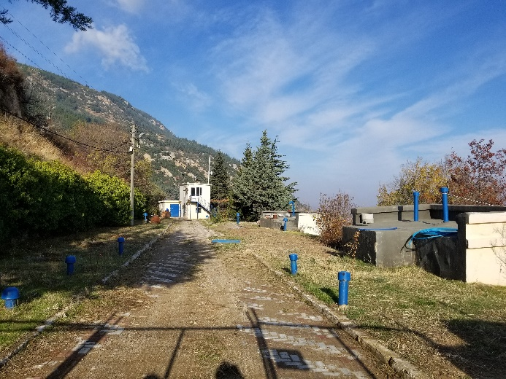
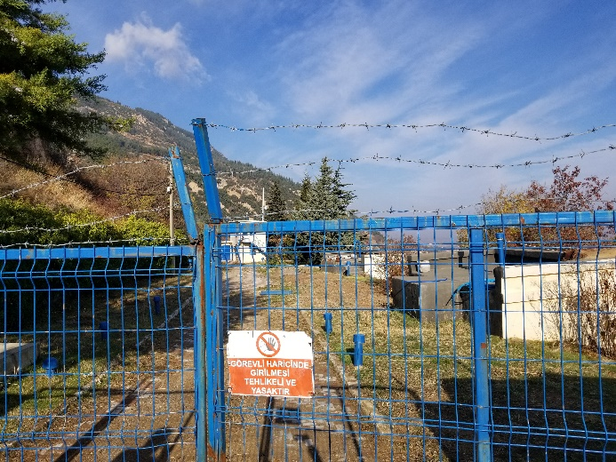
Photo 1 Present Water Reservoir-3 and 4 (DM3 and DM4)

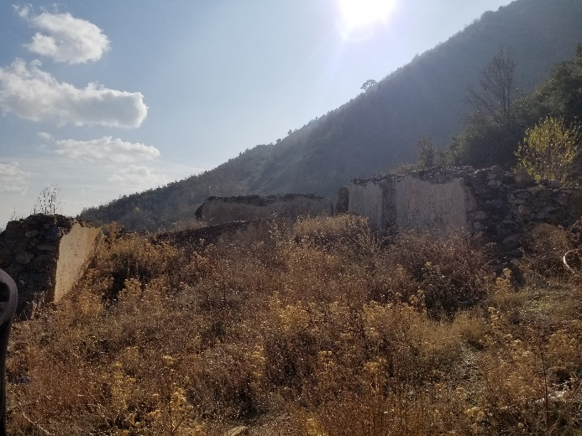
Photo 2 Land of New Water Reservoir-2 (DY2)

Annex 2: Environmental and Social Legislations and Standards
NATIONAL LEGISLATIONS
Institutional and Legal Framework in Turkey
Prior to accession of Turkey’s European Union, Turkish Environmental regulations are being made compatible with EU Directives. The Ministry of Environment, Urbanization and Climate Change (MoEUCC) is the responsible organization for the implementation of policies adopted protection and conservation of the environment, and for sustainable development and management of natural resources. MoEUCC also prepares the legislation on environment, public works, identifies the principles and policies on environmental protection, pollution, develops standards and criteria for implementation and monitoring, assesses the impacts and performs the measurements/analyses and monitoring studies.
Turkish Environmental Law had come into force in 1983. Throughout years, other laws have been entered into force which fulfills requirements of environmental issues such as Conservation of Cultural and Natural Assets Law (Law No: 2863, Date of Ratification: 1983), Energy Efficiency Law (Law No: 5627 , Date of Ratification: 2007), Forestry Law (Law No: 6831 , Date of Ratification: 1956), Groundwater Law (Law No: 167 , Date of Ratification: 1960), Labor Law (Law No: 4857, Date of Ratification: 2003), Law on Soil Protection and Land Use (Law No: 5403; Date of Ratification 2005), Amendment on Law on Soil Protection and Land Use (Law No: 6537; Date of Ratification 2014), Municipality Law (Law No: 5393 , Date of Ratification: 2005), Metropolitan Municipality Law (Law No: 5216, Date of Ratification: 2004), Occupational Health and Safety Law (Law No: 6331, Date of Ratification: 2012), Public Health Law (Law No: 1593, Date of Ratification: 1930) and Social Insurances and General Health Insurance Law (Law No: 5510, Date of Ratification: 2006).
National Environmental Legislation and Regulatory Requirements
The sub-projects planned to be financed under the Project should comply with several regulations which are in line with Environmental Law. The regulations grouped by their impact context are listed below.
Environmental Management, Permitting and Planning
Environmental Impact Assessment Regulation, Official Gazette date: November 25, 2014 and No: 29186
Environmental Permitting and Licenses Regulation, Official Gazette date: September 10, 2014 and No: 29115
Regulation Concerning Environmental Land Use Plans, Official Gazette date: November 11, 2008 and No: 27051
Environmental Auditing Regulation, Official Gazette date: November 21, 2008 and No: 27061
Regulation for Starting up and Operating a Work Place, Official Gazette date: August 10, 2005, No: 25902
Air Quality Control and Management
Regulation Concerning Follow up of Greenhouse Gas Emissions, Official Gazette date: May 31, 2017, No: 30082
Regulation on the Control of Air Pollution from Heating, Official Gazette date: January 13, 2005, No: 25699
Regulation on the Control of Exhaust Emissions, Official Gazette date: March 11, 2017, No: 30004
Industrial Air Pollution Control Regulation, Official Gazette date: December 20, 2014, No: 29211
Regulation on Assessment and Management of Air Quality, Official Gazette date: June 6, 2008, No: 26898
Health and Safety
Communiqué on Hazard Classes List related to Occupational Health and Safety, Official Gazette date: March 29, 2013, No: 28602
First Aid Regulation, Official Gazette date: July 29, 2015, No: 29429
Heavy and Hazardous Works Regulation, Official Gazette date: June 16, 2004, No: 25494
Health and Safety Signs Regulation, Official Gazette date: September 11, 2013, No: 28762 (based on EU Council Directive 92/58/EEC dated June 24, 1992)
Regulation Concerning the Use of Personal Protection Equipment at Workplaces, Official Gazette date: July 2, 2013, No: 28695 (based on EU Council Directive 89/656/EEC dated November 11, 1989)
Regulation on Health and Safety in Fixed Term and Temporary Employment, Official Gazette date August 23, 2013, No: 28744
Regulation on Health and Safety Measures in the Use of Work Equipment, Official Gazette date: April 25, 2013, No: 28628
Regulation on Health and Safety Measures to be taken at Works Involving Chemicals, Official Gazette date: August 12, 2013, No: 28733
Regulation on Methods and Essentials of Work Health and Safety Training for Workers, Official Gazette date: May 15, 2013, No: 28648
Regulation on Occupational Health and Safety, Official Gazette date: December 9, 2003, No: 25311) (based on EU Council Directive 89/391/EEC dated June 6, 1989)
Regulation on Radiation Safety, Official Gazette date: March 24, 2000, No: 23999
Management of Chemicals and Other Dangerous Substances
Regulation Concerning the Classification, Packaging, and Labeling of Dangerous Substances and Preparations, Official Gazette date: December 11, 2013, No: 28848
Regulation Concerning the Material Safety Data Sheets for the Dangerous Substances and Preparations, Official Gazette date: December 3, 2014, No: 29204
Regulation on the Inventory and Control of Chemicals, Official Gazette date: December 26, 2008, No: 27092
Nature Protection
Regulation on Pastures, Official Gazette date: July 31, 1998, No: 23419
Regulation on the Protection of Wetlands, Official Gazette date: April 4, 2014, No: 28962
Regulation on Procedures and Principles Concerning the Protection of Game and Wild Animals and their Habitats and Combat with their Pests, Official Gazette date: October 24, 2005, No: 25976
Noise Control and Management
Regulation on the Assessment and Management of Environmental Noise, Official Gazette date: June 4, 2010, No: 27601
Regulation on the Environmental Noise Emission caused by Equipment used Outdoors, Official Gazette date: June 30, 2016, No: 29758
Soil Quality Control and Management
Implementation Regulation on Soil Protection and Land Use, Official Gazette date: December 15, 2005, No: 26024
Regulation on the Control of Soil Pollution and Polluted Areas by Point Sources, Official Gazette date: June 8, 2010, No: 27605
Waste Management
Regulation of Waste Management, Official Gazette date: April 2, 2015, No: 29314
Regulation Concerning the Landfill of Wastes, Official Gazette date: March 26, 2010, No: 27533
Regulation on the Control of Excavation Materials, Construction and Demolition Wastes, Official Gazette date: March 18, 2004, No: 25406
Regulation on the Control of Medical Wastes, Official Gazette date: January 25, 2017, No: 29959
Regulation on the Control of Packaging Wastes, Official Gazette date: December27, 2017, No: 30283
Regulation on the Control of Waste Batteries and Accumulators, Official Gazette date: August 31, 2004, No: 25569
Waste Oils Management Regulation, Official Gazette date: December 21, 2019, No: 30985
Zero Waste Regulation, Official Gazette date: July 12, 2019, No: 30829
Regulation on the Control of Waste Tires, Official Gazette date: March 11, 2015, No: 29292
Water Quality Control and Management
Ordinance on Groundwater Resources, Official Gazette date: August 8, 1961, No: 10875
Regulation Concerning Protection of Ground Waters against Pollution and Deterioration, Official Gazette date: May 22, 2015, No: 29363
Regulation Concerning Quality of Surface Waters Planned or Used as Drinking Water Supply, Official Gazette date: June 29, 2012, No: 28338
Regulation Concerning Water for Human Consumption, Official Gazette date: March 7, 2013, No: 28580
Regulation on the Control of Pollution Caused by Dangerous Substances in Water Environment, Official Gazette date: November 26, 2005, No: 26005
Regulation on Pit Opening Where Sewer System Construction is not Applicable, Official Gazette date: March 19, 1971, No: 13783
Surface Water Quality Management Regulation, Official Gazette date: April 15, 2015, No: 29327
Urban Wastewater Treatment Regulation, Official Gazette date: January 8, 2006, No: 26047
Regulation Concerning Wastewater Collection and Disposal Systems, Official Gazette date: January 6, 2017, No: 29940
Water Pollution Control Regulation, Official Gazette date: December 31, 2004, No: 25687
Other Related Regulations
Turkey Building Earthquake Regulation, Official Gazette date: March 18, 2018, No: 30364
Regulation Concerning the Decrease of Ozone Depleting Substances, Official Gazette date: April 7, 2017, No: 30031
Regulation Concerning the Increase of Efficiency in the Usage of Energy and Energy Resources, Official Gazette date: October 27, 2011, No: 28097
Regulation on Control of Large-Scale Industrial Accidents, Official Gazette date: August 18, 2010, No: 27676
Regulation on the Implementation of the Law Concerning Private Security Services, Official Gazette date: September 26, 2009, No: 27358
National Regulation of Environmental Impact Assessment
The objective of National Regulation on Environmental Impact Assessment (EIA) is to arrange administrative and technical procedure that will be implemented during environmental impact assessment process. The Regulation of EIA has first been put into force in February 1993. Since then, there had been several amendments in the first regulation and new EIA regulations were published in 2008 and 2013 repealing the former regulations in force. The latest EIA Regulation has been published in the Official Gazette dated November 25, 2014 and numbered 29186, which repealed the 2013 EIA Regulation.
The EIA Regulation is largely in line with the EU Directive on EIA. The key relevant steps of the Turkish EIA procedure namely screening, public consultation, scoping, disclosure and supervision are briefly reviewed below in the order they are prescribed to occur.
The scope of EIA procedure in Turkey has been set out under Environmental Law with an indication that all agencies and establishments leading to environmental problems obliged to prepare an EIA report or Project Information File (PIF) depending on their classification.
The Regulation on EIA classifies project into two categories as Annex I and Annex II. While the projects listed in Annex I of Regulation are described as project that have potential significant effects and requires an EIA to be submitted to MoEUCC, the projects in Annex II covers the projects that may or may not yield significant effects on environment. For this kind of projects, a PIF which is briefer than a full EIA should be submitted to Provincial Directorate of Environment, Urbanization and Climate Change. Upon submittal of PIF, the directorate decides whether EIA is necessary or not. It should be noted that social impacts of projects are not reviewed in either in EIA or PIF in a comprehensive manner.
Projects that require the preparation of EIA, the Governorate and MoEUCC should inform public about initiation of EIA process and the project. A formal public consultation meeting occurs for projects that are subject to an EIA after the screening process and prior to scoping. The project proponent organizes a “public participation meeting” chaired by Provincial Directorate of Environment, Urbanization and Climate Chance (PDoEUCC) in a location that affected local groups can access easily. During the meeting, it should be ensured that the public is informed about the project, and its comments and suggestions regarding the project are either obtained verbally or written. Minutes of the meeting are kept and submitted to MoEUCC and the Governorate. It is required to inform the public about the timeframe for submission of public comments and suggestions. Such comments and suggestions are submitted to the EIA commission and presented within the EIA Report with clarifications.
For the scoping, the project proponent presents a project dossier to a commission, which comprises representatives of MoEUCC and relevant organizations as identified by MoEUCC. Based on the information submitted within the dossier, the commission determines the scope of the EIA and the “project specific format”. Furthermore, the commission may exclude or include some items depending on the specific characteristics of the proposed project. The commission also determines the level of detail under each heading depending on the special project’s environmental impacts. In this process, the commission also takes into consideration of the opinions expressed during the public participation meeting.
After the review of the draft EIA Report by commission for adequacy, the commission either request revision or accept the EIA report as final with incorporating commission’s assessments. The final report is submitted to MoEUCC for final review and the MoEUCC determines whether the “EIA is positive” in which case the project proponent may implement the project or “EIA is negative” in which case the project may not go any forward.
It should be noted that Turkish EIA does not cover costs, institutional responsibilities of mitigation measures. Neither does the EIA include a monitoring plan.
The draft EIA report is made publicly available at MoEUCC or provincial directorate. After MoEUCC’s final evaluation of the EIA report, MoEUCC’s final decision is announced to public. Disclosure of the final EIA document is not foreseen in the EIA Regulation.
It should also be underlined that MoEUCC monitors and inspect projects that has a positive EIA or the ones that does not require EIA. This monitoring is made by consultancy companies that is contracted by the project proponent.
The proposed sub-projects are neither in Annex-I nor in Annex-II of Regulation on EIA. For Elbistan Drinking Water Network Project, an EIA Exemption Letter was obtained from Kahramanmaraş Provincial Director of Environment and Urbanization on October 16th, 2019 (Annex 1). For Afşin - Elbistan Transmission Line Project, obtainment of an opinion letter from Provincial Directorate of Environmental and Urbanization is recommended in order to ease any national application processes.
National Laws on Social Impacts
Despite the fact that Turkish EIA Regulation does not entirely meet the requirements of international standards in terms of social impacts and stakeholder engagement, some legal arrangements (laws and regulations) are present in the management of various social impacts. These can be exemplified as: Labor Law, Law on Occupational Health and Safety, Regulation on Contractors and Sub-Contractors, Law on Right to Information, Regulation on the EIA, Expropriation Law and Amendment on Expropriation Law.
National Laws on Labor and Working Conditions
Labor and Working Conditions
Turkey is party to a multitude of International Labor Organization (ILO) conventions, including but not limited to conventions on equal treatment of employees, gender equality, child labor, forced labor, OHS, right of association and minimum wage. Accordingly, the current Turkish Labor Law (No.4857) is to large extent consistent with Environmental and Social Standard (ESS) 2 requirements.
There are also secondary legislation that may apply to the project, which include regulations on annual leave, working hours, overtime work, minimum wage, female and child employees. The Ministry of Family Labor and Social Services has published various communiques and circulars that set ground for the implementation of the Labor Law, which may also be referenced during project implementation.
Occupational Health and Safety
In recent years, Turkey has undergone a reform to improve its national Occupational Health and Safety (OHS) system through adapting a set of international and regional standards into its national level requirements for the prevention occupational risks as defined in the ILO Occupational Safety and Health Convention, 1981 (No. 155). The convention, along with the Occupational Health Services Convention, 1985 (No. 161) were both ratified by Turkey in 2005. Turkey is also party to the Labor Inspection Convention, 1945 (No. 81) since 1951. In 2014, Turkey ratified the Promotional Framework for Occupational Safety and Health Convention, 2006 (No. 187).
During 2012, a stand-alone Law on OHS (No. 6331) was put into force (20 June 2012). The OHS Law governs workplace environments and industries (both public and private) as well as virtually all classes of employees including part-time workers, interns, and apprentices. The legislation is comprehensive and is generally applicable across all sectors and many industries.
Right to Information
Right to information refers to the right of access to information held by public bodies also known as access to public information. Access to public information is considered of fundamental importance for the effective functioning of democratic systems, as it enhances governments' and public officials' accountability, boosting people participation and allowing their informed participation into public life. The fundamental premise of the right of access to public information is that the information held by governmental institutions is in principle public and may be concealed only on the basis of legitimate reasons which should be detailed in the law.
Access to public information is regulated by the Law on Right to Information that has been published in the Official Gazette in Turkey on October 24th, 2003. The law was introduced in the framework of the negotiations for accession to the European Union. The purpose of this law is to regulate the procedure and the basis of the right to information according to the principles of equality, impartiality and openness that are the necessities of a democratic and transparent government. This law is applied to the activities of the public institutions and the professional organizations, which qualify as public institutions.
National Laws on Land Acquisition
In the scope of the Turkish legal framework, land acquisition/expropriation related issues are handled through the Expropriation Law No: 2942 (amended by Law No: 4650 in 2001).
Compensation for the subject property/assets to be expropriated is determined according to procedures and principles outlined in Articles 8, 10 and 11 of the Law. Article 27 authorizes the expropriation agency to confiscate the assets required by the project earlier than the time needed in normal expropriation procedure. This process does not prevent challenges of the property owners against the determined valuation.
INTERNATIONAL AGREEMENTS AND CONVENTIONS
Turkish national policy on protection of environment, cultural heritage and conservation of biological resources has been formulated on the basis of relevant international agreements signed or ratified by Turkey. Relevant environmental, OHS and international labor agreements and conventions ratified by Turkey are listed below:
Basel Convention on the Control of Transboundary Movements of Hazardous Wastes and Their Disposal
Bern Convention on Protection of Europe’s Wild Life and Living Environment
Convention on International Trade in Endangered Species of Wild Flora and Fauna (CITES)
Convention on Long-range Transboundary Air Pollution
European Monitoring and Evaluation Programme (EMEP)
European Convention on the Protection of the Archaeological Heritage
European Landscape Convention
International Convention for the Protection of Birds
Montreal Protocol on Substances that Deplete the Ozone Layer
Paris Convention on the Protection of the World Cultural and Natural Heritage
RAMSAR Convention on Wetlands of International Importance Especially as Wildfowl Habitat
Stockholm Convention on Persistent Organic Pollutants
United Nations Convention to Combat Desertification in Countries Experiencing Serious Drought and/or Desertification, Particularly in Africa
United Nations (UN) Framework Convention on Climate Change (Kyoto Protocol)
UN (Rio) Convention on Biological Diversity
Vienna Convention or the Protection of the Ozone Layer
ILO Occupational Safety and Health Convention
Occupational Health Services Convention
Labor Inspection Convention
Promotional Framework for Occupational Safety and Health Convention
Worst Forms of Child Labor Convention
WORLD BANK’S ENVIRONMENTAL AND SOCIAL FRAMEWORK AND STANDARDS
The WB’s ESF sets out the WB’s commitment to sustainable development, through a Bank Policy and a set of Environmental and Social Standards (ESS) that are designed to support Borrowers’ projects, with the aim of ending extreme poverty and promoting shared prosperity. It was launched on October 1th, 2018.
The WB ESSs set the requirements to be met by Borrowers with respect to the identification, evaluation and mitigation of social and environmental risks and impacts associated with projects supported by the WB through Investment Project Financing. Nine (as ESS 7 is not relevant) out of the ten ESSs establish the standards that the Borrower and the project will meet through the project life cycle, as follows:
ESS1: Assessment and Management of Environmental and Social Risks and Impacts;
ESS2: Labor and Working Conditions;
ESS3: Resource Efficiency and Pollution Prevention and Management;
ESS4: Community Health and Safety;
ESS5: Land Acquisition, Restrictions on Land Use and Involuntary Resettlement;
ESS6: Biodiversity Conservation and Sustainable Management of Living Natural Resources;
ESS8: Cultural Heritage;
ESS9: Financial Intermediaries; and
ESS10: Stakeholder Engagement and Information Disclosure.
In accordance with the ESSs, the requirements of EHSGs should be apply to the sub-projects. In cases where the Turkish requirements differ from the levels and measures presented in the EHSGs, the more stringent one (such as the most stringent discharge and emission standards) will be applied in the sub-project’s specifications.
The applicable EHSGs for these sub-projects are as follows:
World Bank Group’s EHS General Guidelines; and
World Bank Group’s EHS Guidelines for Water and Sanitation.
The details of WB’s Environmental and Social Standards are provided in the Environmental and Social Management Framework of the Project.
KEY DIFFERENCES BETWEEN THE NATIONAL EIA REGULATION AND THE WB ESSS
The National EIA procedures are, with some exceptions, in line with the WB’s ESSs. The primary exceptions between WB ESSs and National EIA Regulation on in project categorization, scope of environmental and social assessment and public consultation and disclosure. In cases where the Turkish legislation differ from the ESSs, the more stringent one will be applied to the project implementation. A detailed comparison of WB ESSs and National EIA Regulation is summarized in the following table.

Table 1 Comparison of National Legislation on Environment and Social and WB’s ESSs
Gap Category | National Regulations | WB’s ESSs | Measures to Fulfill Gaps
Project Categorization | The National Regulation on EIA classifies projects into two categories:  - Annex I projects: These are projects that have significant potential impacts and require an EIA. Annex I of the EIA Regulation lists these projects types, so project proponents are expected to start the EIA procedure without any other screening process; and  - Annex II projects: Annex II of the EIA regulation covers the projects that may or may not have significant effects on the environment. Proponents of Annex II projects are required to submit a Project Information File (PIF) to the Ministry of Environment, Urbanization and Climate Change (MoEUCC). The PIF is prepared following the General Format for PIF provided in Annex IV of the EIA Regulation and contains information on: (i) project characteristics; (ii) environmental characteristics of the project site and impact area; and (iii) significant impacts of the project and measures to be taken during construction and operation phases of the project. A non-technical summary of the above items is also to be added to the PIF. The PIF is submitted to the Provincial Directorates of Environment and Urbanization for review and evaluation. Provincial Directorate gives its “EIA is Necessary” or “EIA is not necessary” decision regarding the project. The decision of the Provincial Directorate is communicated to public using appropriate means (i.e., announcement boards, internet).  Furthermore, there are project which are neither in Annex I nor Annex II of the National EIA Regulation. This kind of projects are obliged to comply with national legislations in construction and operation phases. An EIA Exemption Letter from Provincial Directorates of Environment, Urbanization and Climate Change is recommended to be obtained by the Project owner. | According to the World Bank’s E&S Policy, projects (including projects involving FIs) are classified into one of four classifications as High Risk, Substantial Risk, Moderate Risk or Low Risk taking into account relevant potential risks and impacts, such as the type, location, sensitivity and scale of the project; the nature and magnitude of the potential E&S risks and impacts; the capacity and commitment of the Borrower; and other areas of risks that may be relevant to the delivery of E&S mitigation measures and outcomes.  There are no clear-cut border values distinguishing the classification of the projects or, unlike the Turkish EIA Regulation (where projects are classified into two categories as Annex I and Annex II projects), any ready lists of project types for classification; rather projects are screened on a case by case basis in the environmental and social risk classification of the WB. | Afşin - Elbistan Drinking Water Transmission Line Project and Elbistan Drinking Water Network Project are out of scope of the National Regulation on EIA. Thus, there are no EIA or PIF prepared for the Projects.  The Project’s E&S risk categorization is classified as Moderate referring to the ESMF as per the WB’s Project Categorization. This ESMP is developed to mitigate the Project’s risks and impacts.
Scope of Environmental and Social Assessment | For the scoping procedure, the project proponent presents a project dossier (PIF for Annex II projects or using the outline given in Annex III of the EIA regulation for Annex I projects) to a commission, which comprises representatives of MoEUCC and relevant organizations as identified by MoEUCC. Based on the information submitted, the commission determines the scope of the EIA and the “project specific format”. Furthermore, the commission may exclude or include some items depending on the specific characteristics of the proposed project. The commission also determines the level of detail under each heading depending on the special project’s environmental impacts. In this process, the commission takes into consideration of the opinions expressed during the public participation meeting.  - Comparison of the indicative outline required by the WB for ESIA with the general format of a Turkish EIA indicates a number of key differences as follows: The absence of an executive summary and information on the legal and institutional framework in the National EIA (Technical level of information in the non-technical summary required in the National EIA may not meet WB requirements);  - Possible discrepancies with regard to the level at which the project’s environmental and social impacts, its alternatives, and mitigation measures for the impacts are discussed (such as lack of discussions on residual impacts, limited discussion on indirect and induced impacts, limited assessment regarding use of resources and GHG emissions);  - Social impact assessment is not completely integrated to the Turkish EIA and this results in the absence of proper social baseline, identification and assessment of the project induced social impacts including impacts on disadvantaged or vulnerable and gender related issues;  - There are limited requirements to cover risks and impacts related to (i) community health and safety; (ii) occupational health and safety; and (iii) labor and working conditions;  - Limited or no requirement to cover cumulative impacts with other projects in the National EIA; and  - Limited emphasis on the associated facility in the National EIA. | The scope and type of E&S assessment required as per ESS1 varies proportionate to the potential risks and impacts of the project and, in an integrated way, all relevant direct, indirect and cumulative environmental and social risks and impacts throughout the project life cycle, as per the ESSs 2-10, are assessed.  The indicative outlines of an ESIA and ESMP are presented in WB’s ESF as well as Project’s ESMF. | As both of the Projects are out of scope of National Regulation on EIA, there are no EIA or PIF prepared for the Projects. Therefore, no scoping procedure has been executed.  On the other hand, in line with the WB’s ESF, this ESMP is prepared to set the baseline, identify the environmental and social impacts related with the project and present the mitigation measures that will be applicable to mitigate those impacts as per the mitigation hierarchy per the indicative ESMP outline to fulfill the gaps mentioned in the first column.
Public Consultation and Disclosure | For projects that require the preparation of an EIA, the Governorate is required to inform the public that a project application has been submitted in a specified locality, that the EIA process has begun and that the public may submit its comments and suggestions to the Governorate or MoEUCC. The announcement is made using a variety of methods, including the internet, bulletin boards and loudspeaker announcements. MoEUCC informs the public of the same through the internet.  A formal public consultation meeting occurs for projects that are subject to an EIA after the screening process and prior to scoping. The project proponent organizes a “public participation meeting” chaired by MoEUCC provincial director in a location that affected local groups can access easily. The invitation to the meeting is published in a national and a local newspaper at least ten days prior to the meeting. There is no requirement that information on the project should be provided to the public in advance, except for the subject matter of the meeting. However, the EIA Regulation specifies that during the meeting, which is chaired by the Director or a member of MoEUCC’s provincial directorate, it should be ensured that the public is informed about the project, and its comments and suggestions regarding the project are obtained. The meeting chairperson may request comments in writing too. Minutes of the meeting are kept and submitted to MoEUCC and the Governorate. The Governorate is required to inform the public about the timeframe for submission of public comments and suggestions. Such comments and suggestions are submitted to the EIA commission. The draft EIA report is made available to the public for comments at Central MoEUCC or provincial directorate. After MoEUCC’s final evaluation of the EIA report, the Governorate announces to the public MoEUCC’s decision together with its justifications. Disclosure of the final EIA document is not foreseen in the EIA Regulation. | Pursuant to ESS 1, stakeholder engagement is an integral part of E&S assessment and should be conducted in accordance with ESS 10. Within this scope, the Borrowers should identify the different stakeholders (project-affected parties and other interested parties including disadvantaged or vulnerable), and develop and implement a Stakeholder Engagement Plan (SEP), in consultation with the Bank, proportionate to the nature and scale of the project and its potential risks and impacts. SEP should describe the timing and methods of engagement with stakeholders throughout the life cycle of the project, and also describe the range and timing of information to be communicated to the parties as well as type of information to be sought from them.  The Borrower should disclose project information to allow stakeholders to understand the risks and impacts of the project, and potential opportunities, in a timeframe that enables meaningful consultations with the stakeholders on project design. | Any public consultation or disclosure have not been performed as per national legislations. Providing compliance to WB’s ESF, a SEP has been prepared for KASKİ that is implemented for the lifetime of the Project.  A public consultation meeting is going to be held after the disclosure of the draft ESMP to the stakeholders. The draft ESMP is going to be reviewed and updated as per stakeholders’ comments. The final ESMP is going to be disclosed to public after the final review of WB and project proponent.
Land Acquisition – Compensation/assistance to renters and other informal users of lands, who do not own property | National legislation does not require payment of compensation to tenants and unofficial users of land/properties. | According to Bank’s ESSs, as well as official users of the land, unofficial users of the land are also defined as PAPs. According to Bank’s procedures, persons who have spent money and constructed buildings or other structures on the lands of other persons are compensated at full replacement cost. They are also compensated for standing crops and economic trees they planted on the land they use unofficially, and assistance if needed to restore income/livelihood lost as a result of being displaced from the land in question. | A RP is prepared for the Project and it represents the measures to fulfil the gaps between national legislation and WB’s ESSs.  Compensation provided will ensure that the livelihoods of land owners, renters and other informal users of land are not affected. In addition to the legal compensation amount for the official landowners, for other people who have no legal rights, cost will be provided from social aid funds of the Municipalities and/or governorates.
Land Acquisition – Replacement Cost | According to Turkish legislation, only the legal property owners can get monetary compensation and there is a clause in the law indicating that depreciation shall be deducted in the valuation process for the buildings (for expropriation), which may cause the expropriation value to be less than the full replacement cost as defined in ESS5 (which does not allow for applying depreciation). The compensation for the loss of income, access to common properties or social losses (such as opportunity costs) is not clearly stated in the Turkish legislation. | According to Bank’s policies, loss of immovable such as land and other fixed assets should be compensated at full replacement cost before the construction starts. Considering the cash equivalent to replacement cost will be used as a compensation method, legal landowners will be compensated for loss of land, and tenants, public land users and squatters would be entitled to the replacement cost of what they have invested in the land. | A RP is prepared for the Project and it represents the measures to fulfil the gaps between national legislation and WB’s ESSs.  The difference between full replacement cost and compensation to be paid will be provided from social aid funds of the Municipalities and/or governorates.
Land Acquisition – Request for the expropriation of unviable land due to partial expropriation | According to Expropriation Law, land owners subject to partial expropriation have a right to request the expropriation of the remaining land within 30 days. | WB’s ESS5 does not define a time limit for such requests. | If there is a partial expropriation request for the remaining part of the land, sub-borrower will shall receive this request within 30 days and necessary expropriation process will be completed in line with the legislation.
Land Acquisition – Scope of project affected people | According to Turkish legislation, only people who lose legally owned land are considered as project affected people (PAP). In Turkish legislations, non-title holders and users of public lands, host population, nomadic/migrants (using the project area) or economically displaced people are not considered as PAP. | According to WB’s ESS5, the non-title holders and users of public lands, host population, nomadic/migrants (using the project area) or economically displaced people are recognized as PAP and there are provisions to mitigate the adverse effects of the projects on these people | For such people, mitigation measures such as occupational education or some job opportunities etc. will be provided.
Land Acquisition – Resettlement Action Planning | According to Turkish legislation, there is no statutory arrangement for preparation of a Resettlement Plan covering all displaced persons and host families. | ESS5 requires preparation of a RP if the case is physical and/or economical displacement. | For all sub-projects requiring land acquisition and involuntary resettlement, sub-project specific Resettlement Plan will be prepared in line with the project Resettlement Framework and implemented ahead of any physical works.
Land Acquisition – Public Information Disclosure, Consultation and Participation | There are no provisions regarding information disclosure to public, public consultation and participation in the Turkish legislation regarding land acquisition. In the scope of normal expropriation procedures, an invitation letter is sent to property owners for the aim of informing and inviting rightful owner to negotiations within 15 days. Therefore, rightful owner becomes aware of land acquisition and has the opportunity to negotiate and/or challenge the proposed compensation amount. | ESS5 requires full public disclosure of RF and RPs. | KASKİ is responsible for arranging consultation meetings before land acquisition procedures begin with affected persons to inform about the land requirements of the sub-projects as well as the availability of a RF, the draft RPs that include entitlements, and resettlement planning and implementation if any. In addition, the RF and RPs will be disclosed at the local level and on İLBANK’s website. The municipality or the municipal water and wastewater utility will also notify the other affected groups and stakeholders in addition to the people who have legal rights, including those who have made investment in public land or are occupying the land without formal rights, and tenants, through an official registration mail as they notify the land and property owners and with consultations. In the letter, information about the related sub-projects and impacts due to land requirements will be provided.
Grievance Mechanism (GM) | There are channels for lodging grievances under different laws of Turkey (2942 Expropriation Law, 3071 Grievances Law, and 4982 Access to Information Law), but these are through more formal and legalistic mechanisms. | For this project, grievance mechanisms will be developed within KASKİ, consisting of accessible and documented grievance handling at sub-project and municipal levels. These project level grievance mechanisms are supplementary, but do not substitute for the formal national legal mechanisms, which remain available to PAPs who choose to pursue them. | A RP is prepared for the Project and it represents Grievance Mechanism to be developed within KASKİ.

Annex 3: Photographs, Minutes and Participant Lists from the Consultation Meetings dated February 24th, 2020, October 27th, 2021 and June 30th, 2022
Materials of February 24th, 2020 Dated Meeting
Advertisement
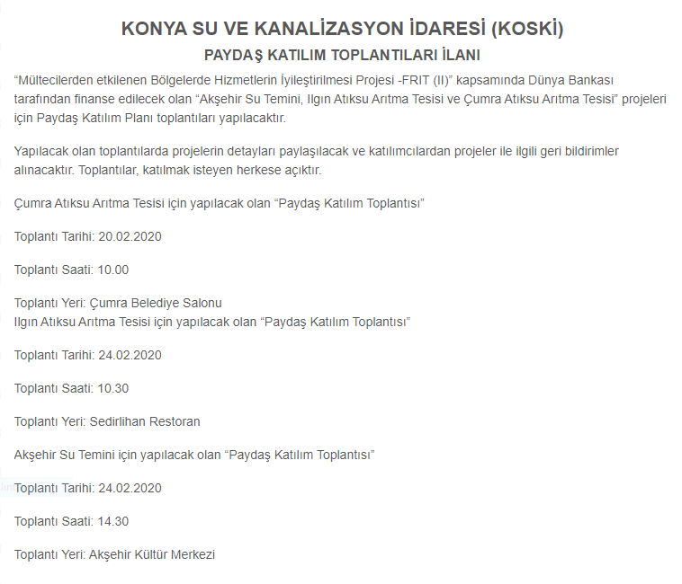

Photographs
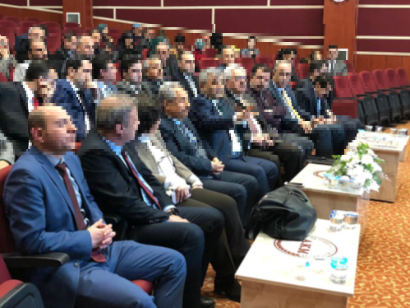
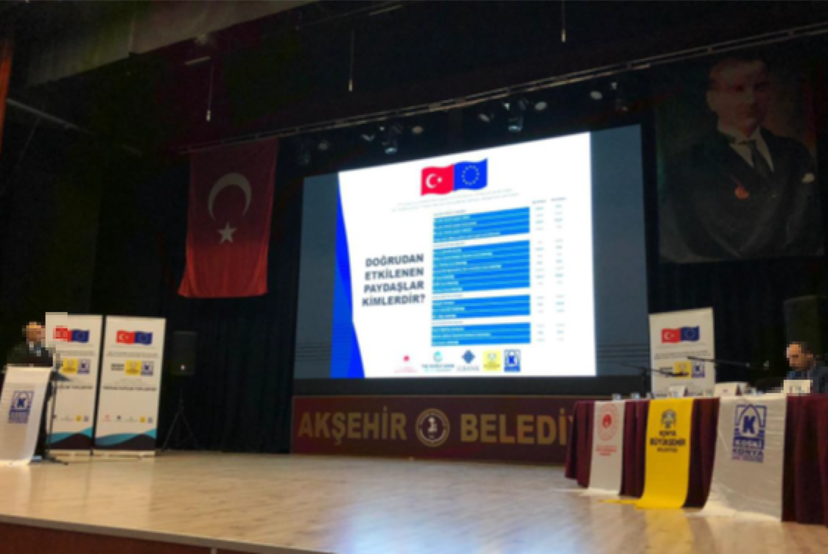

Participant List

Meeting Minutes
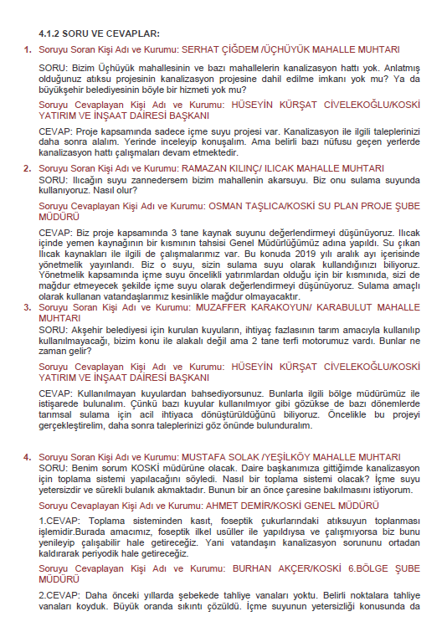

Materials of October 27th, 2021 Dated Meeting
Advertisement
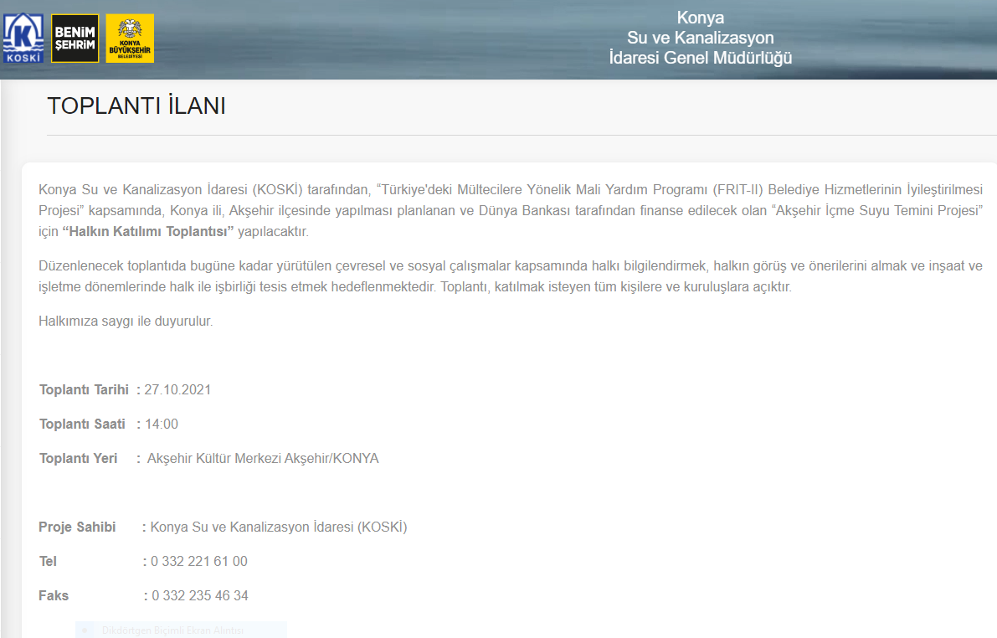

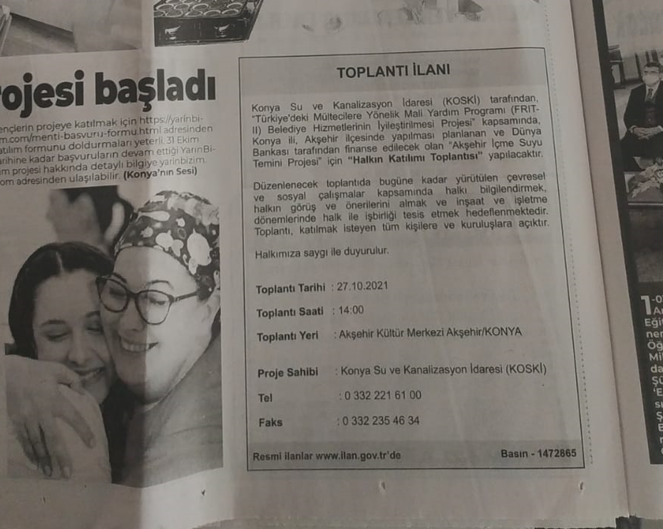
Photographs
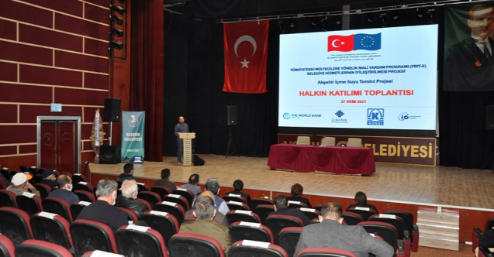
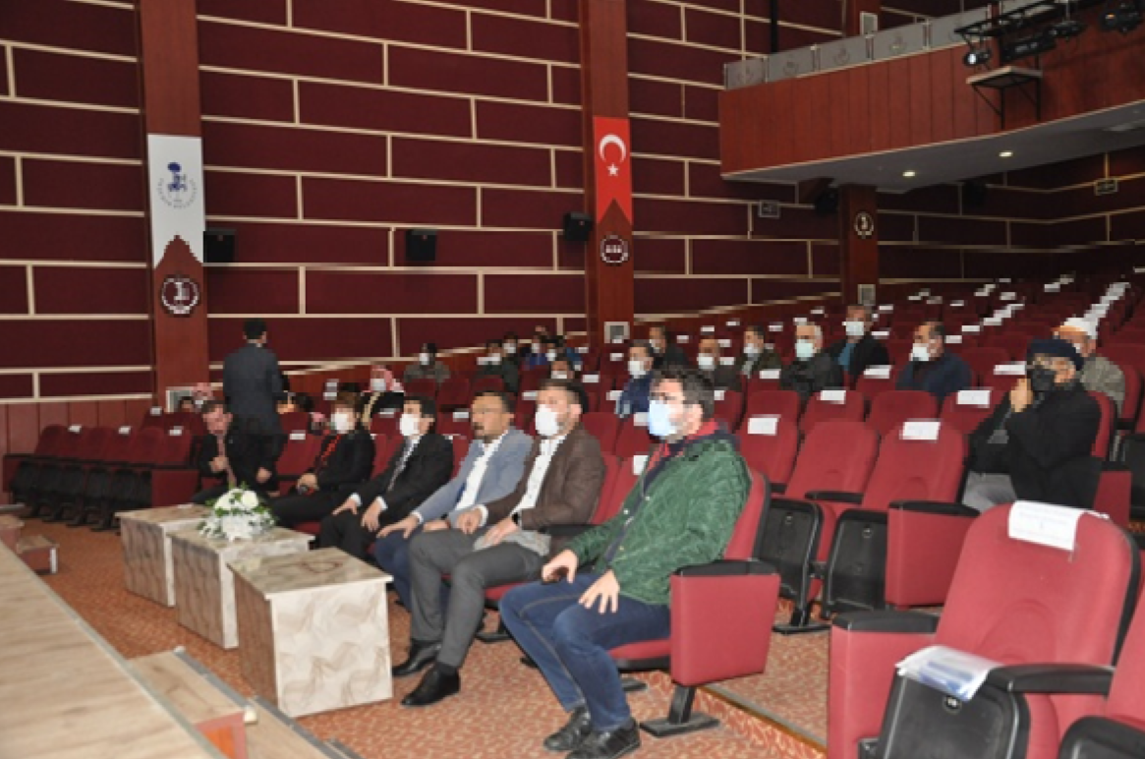

Participant List
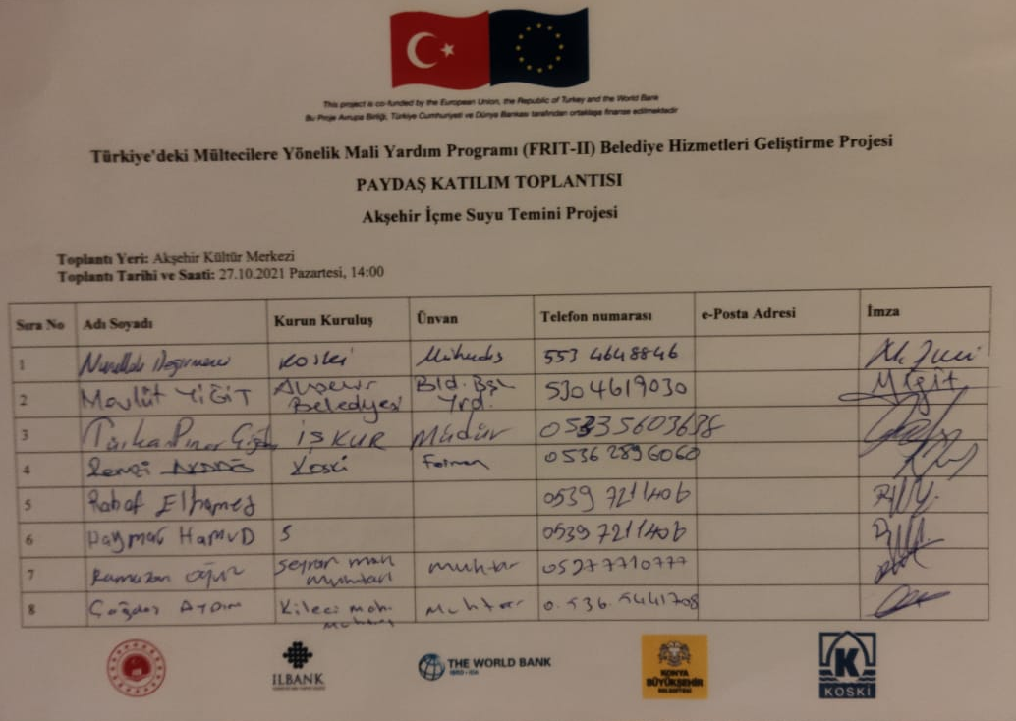
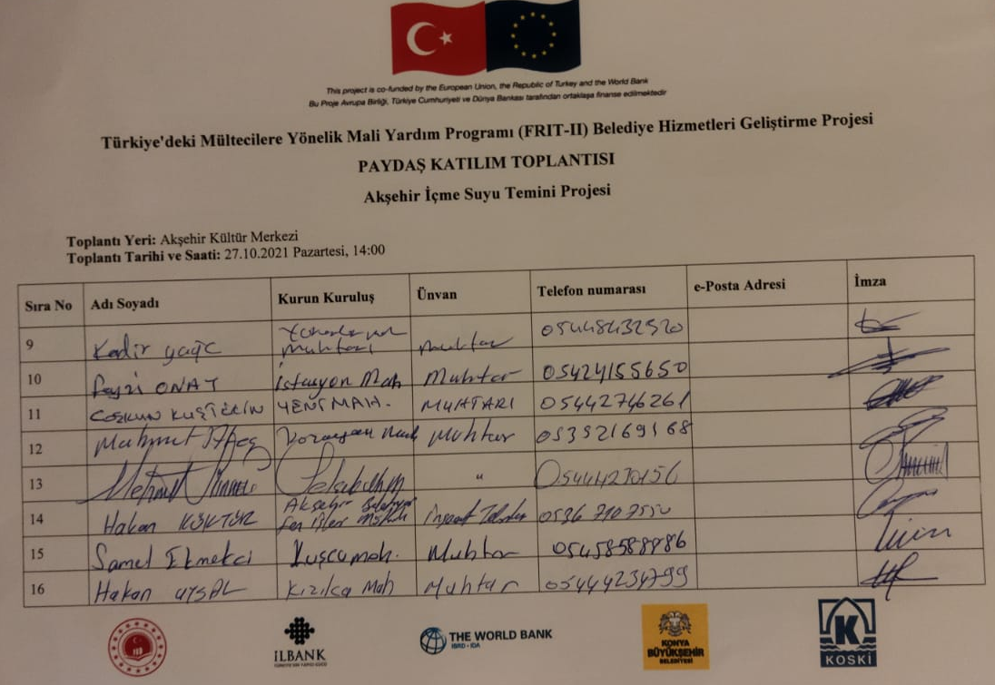
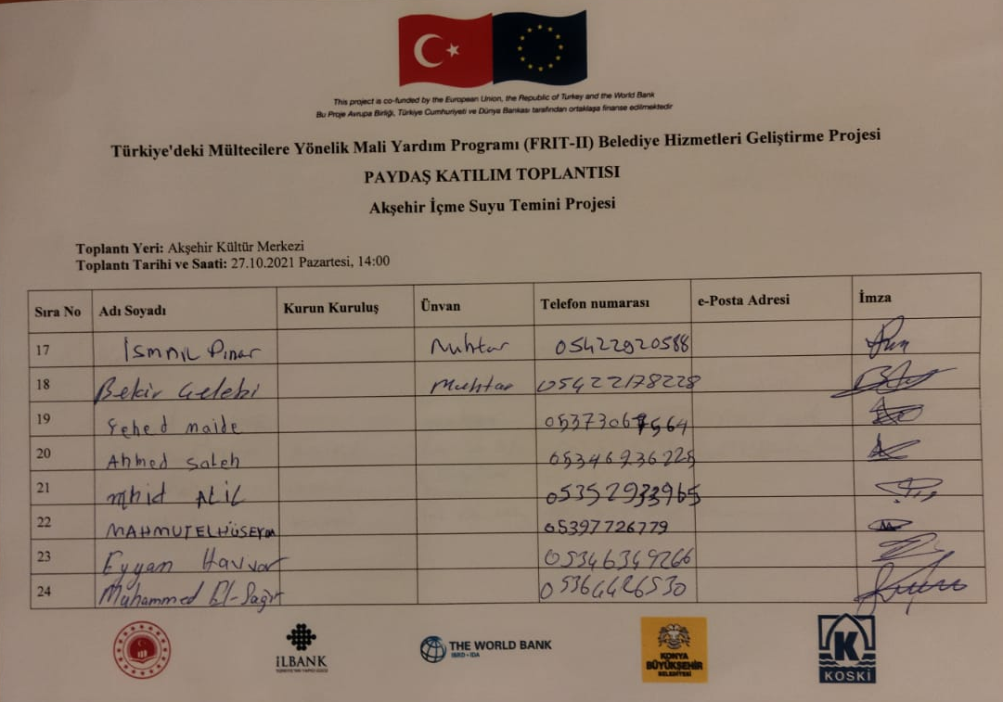
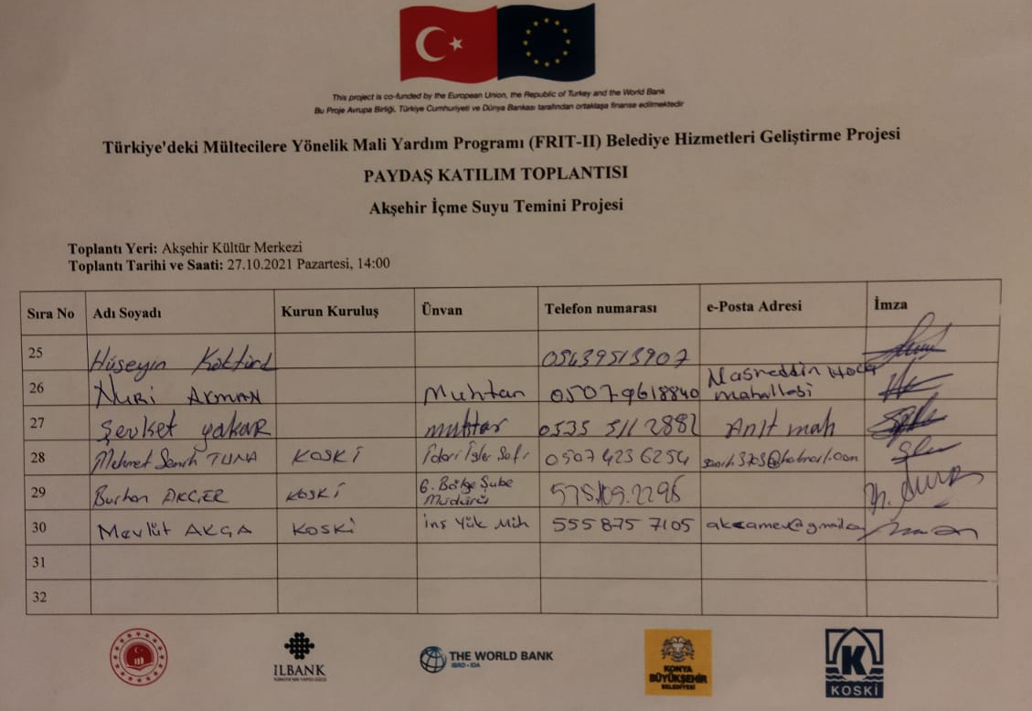

Meeting Minutes
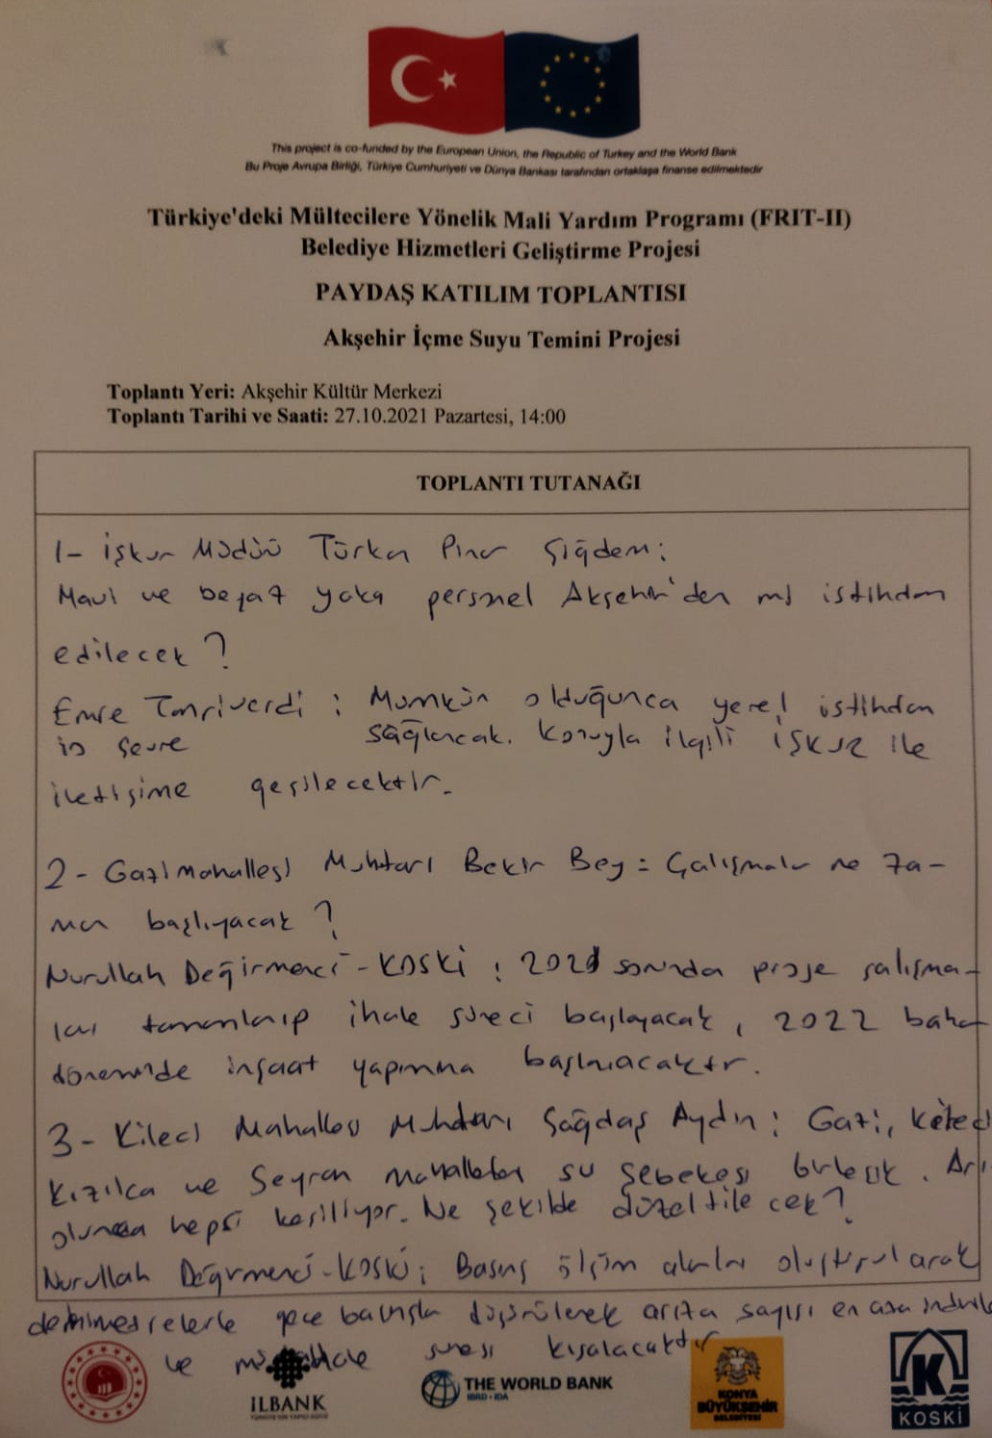
Materials of June 30th, 2022 Dated Meeting
Announcement from KOSKI’s Webpage
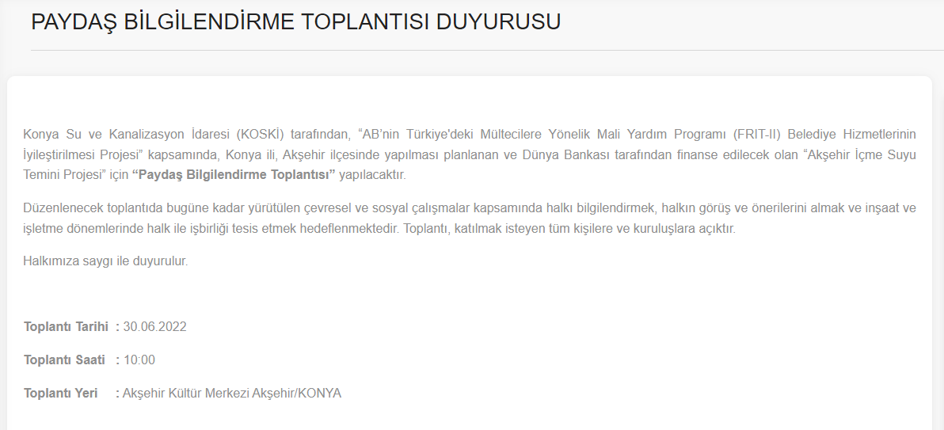
SMS Notification
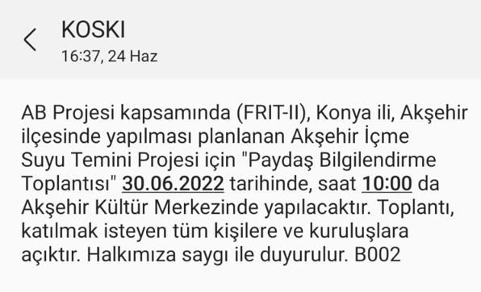

Photographs
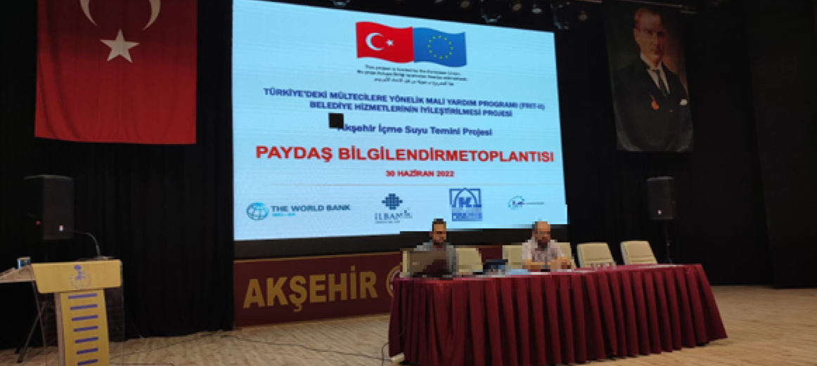
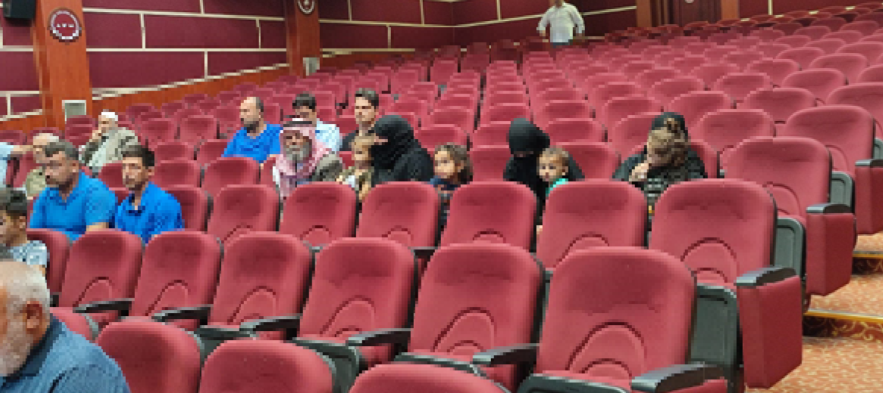

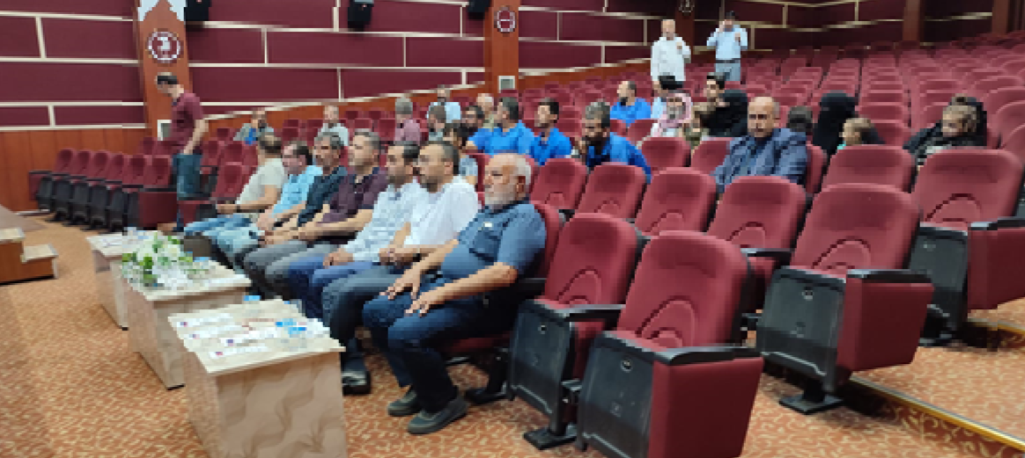
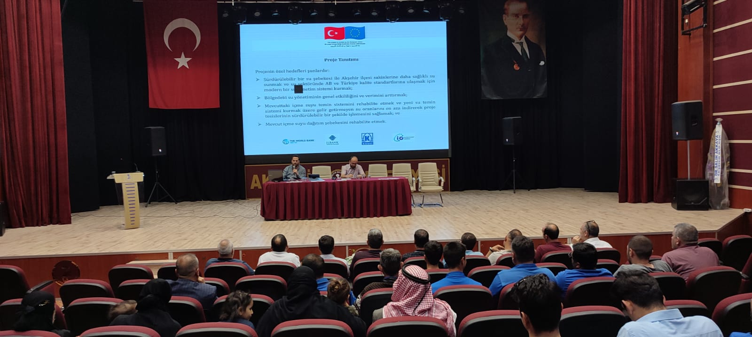
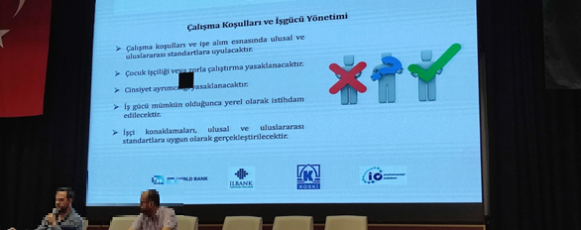
Participant List
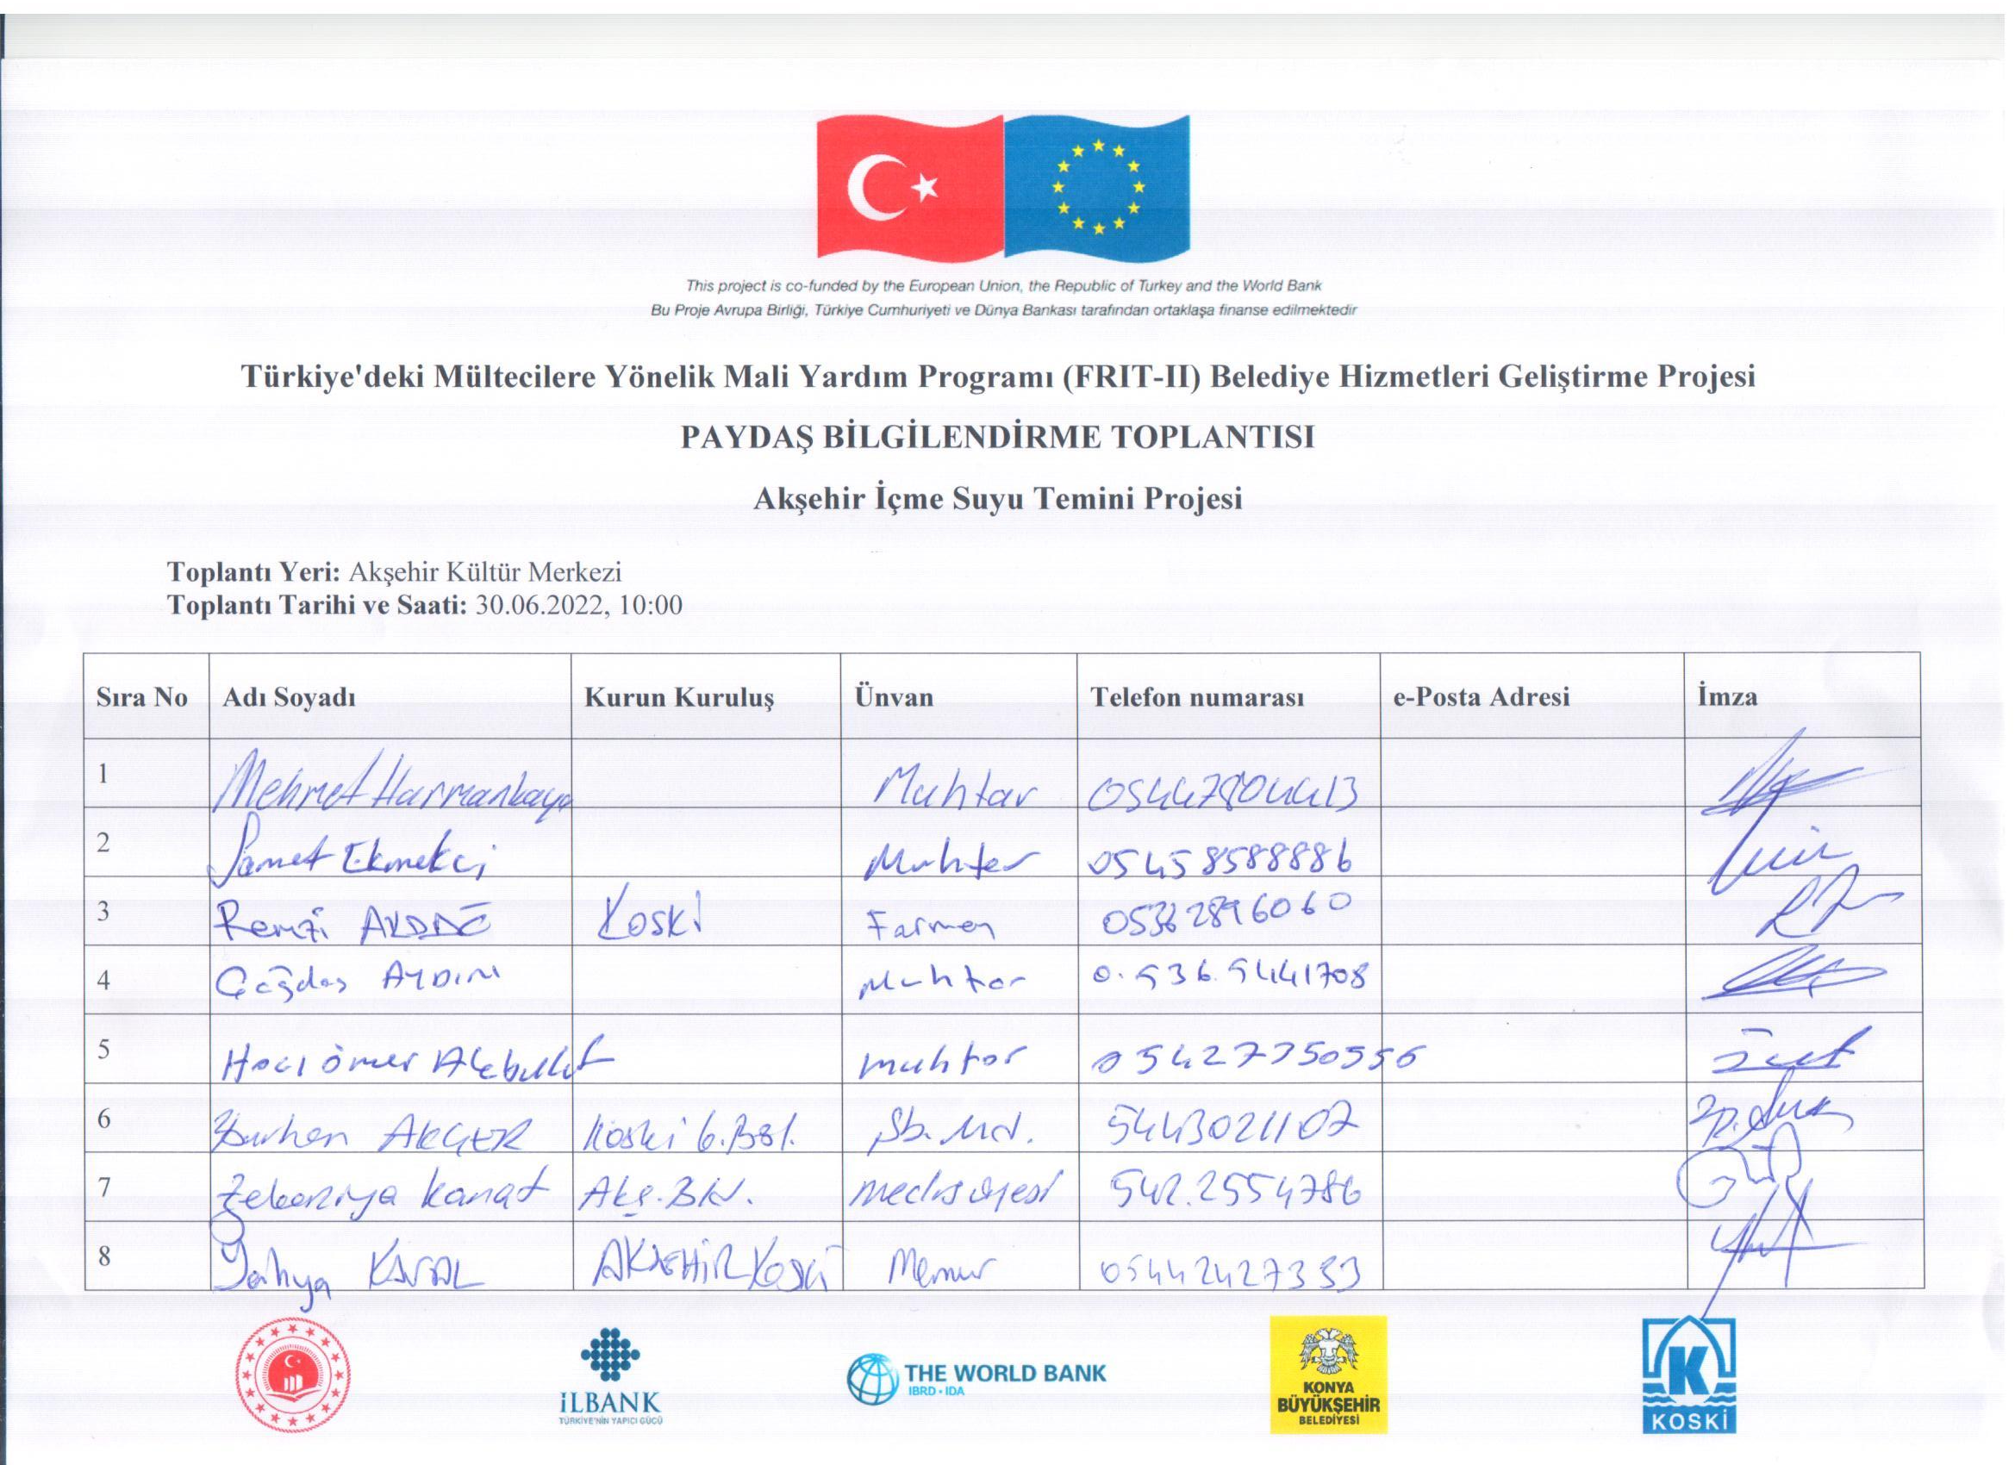
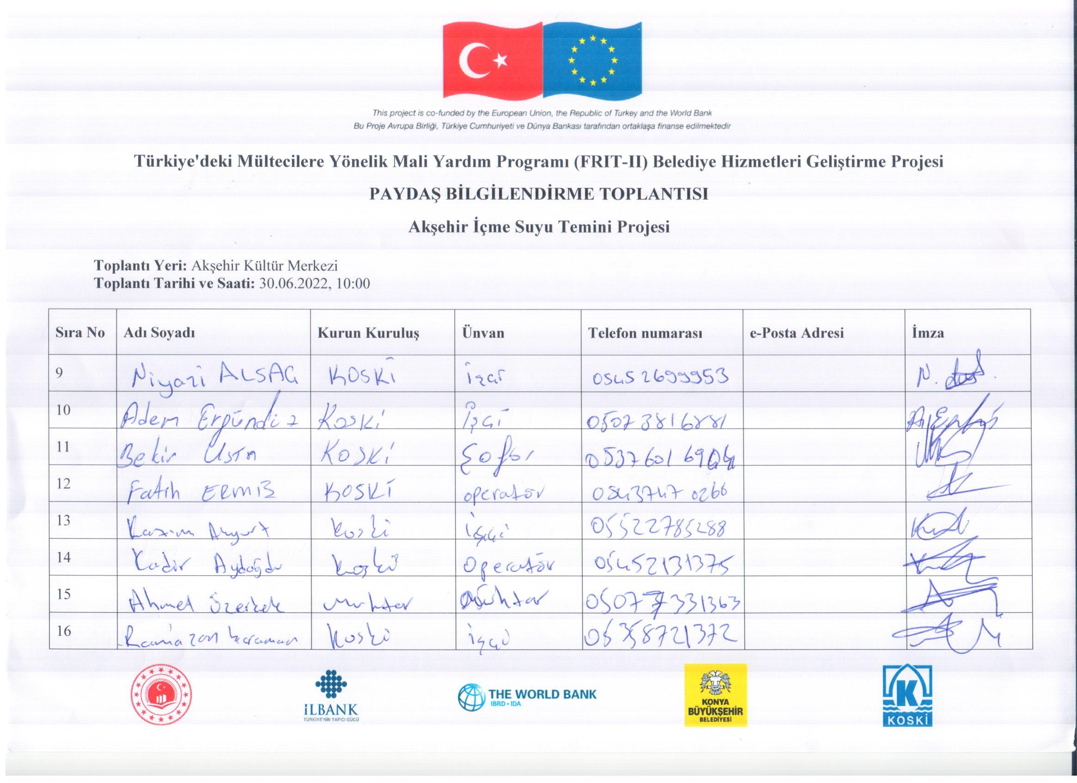
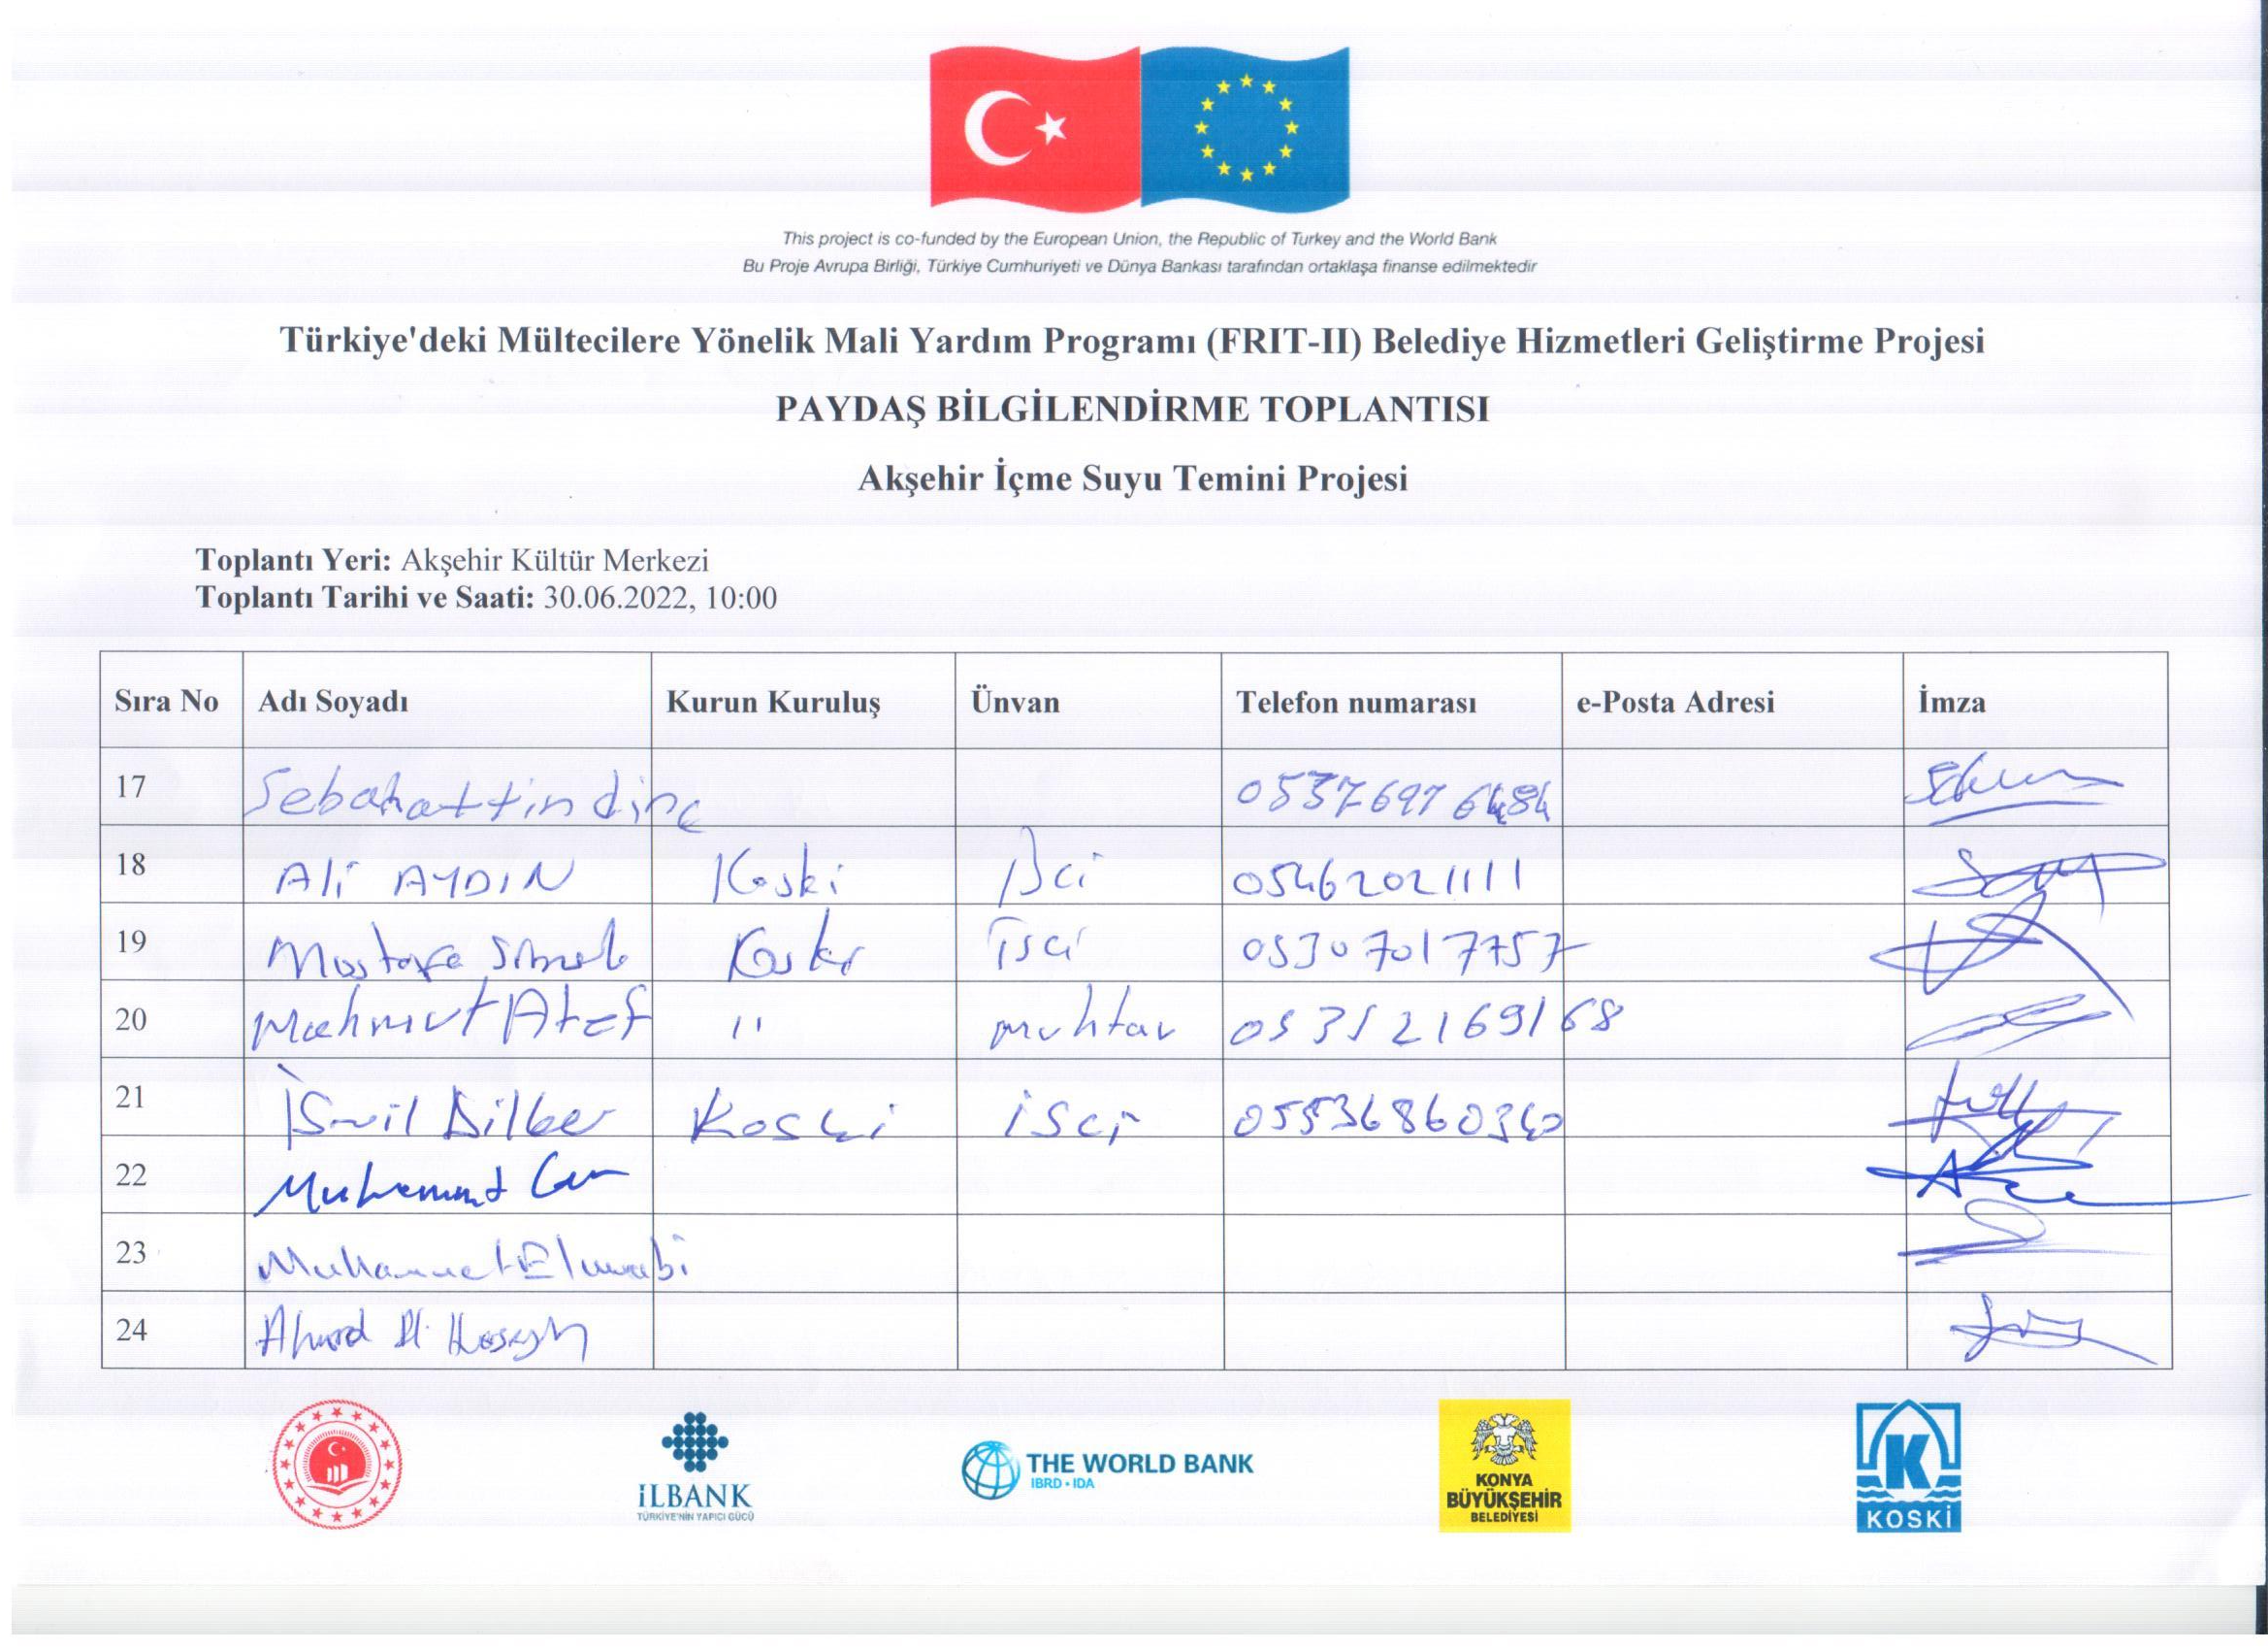
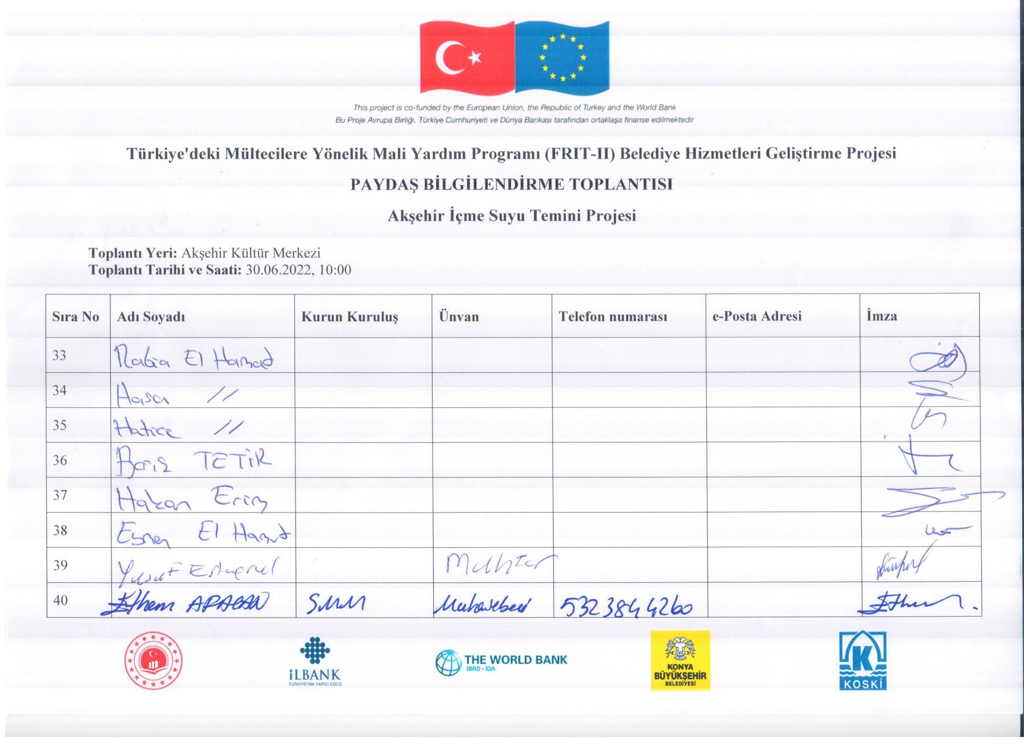

Meeting Minutes
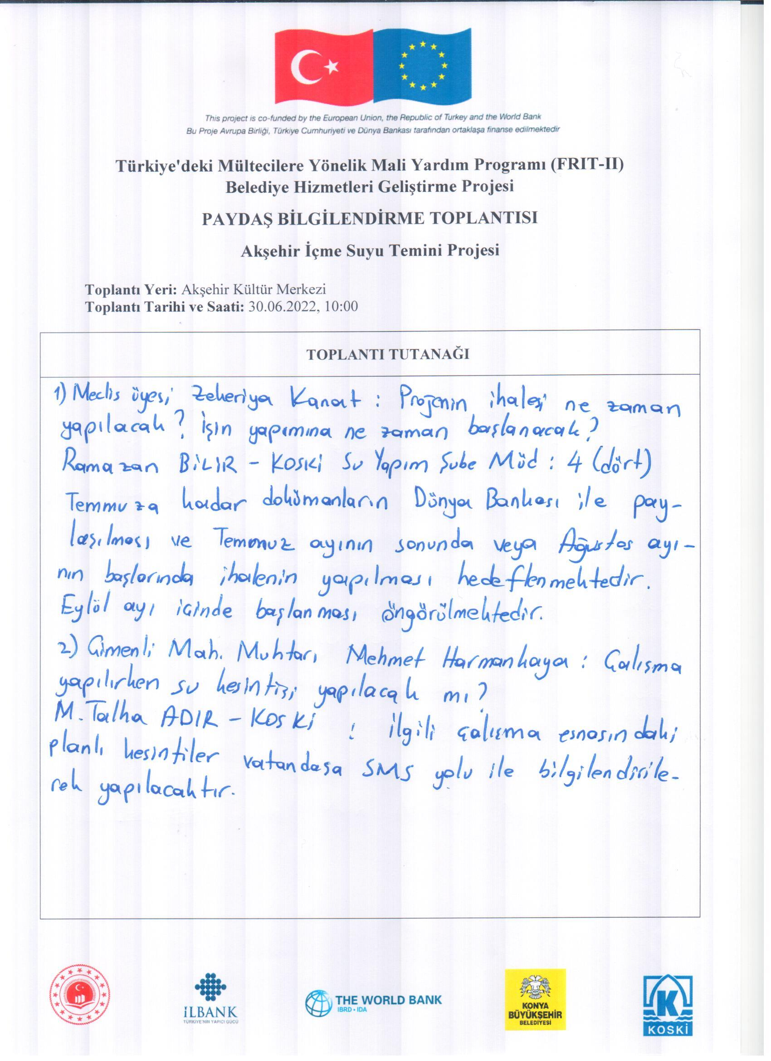
Project Brochure
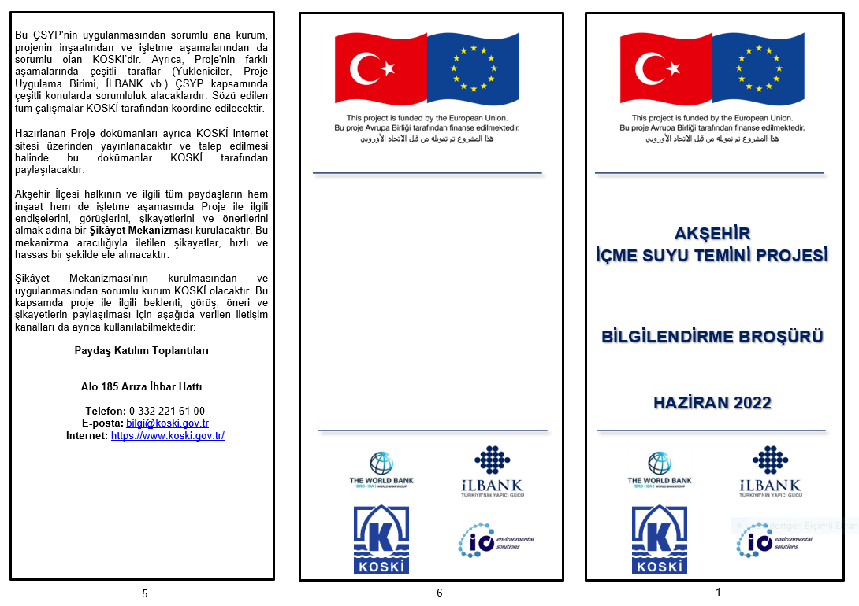
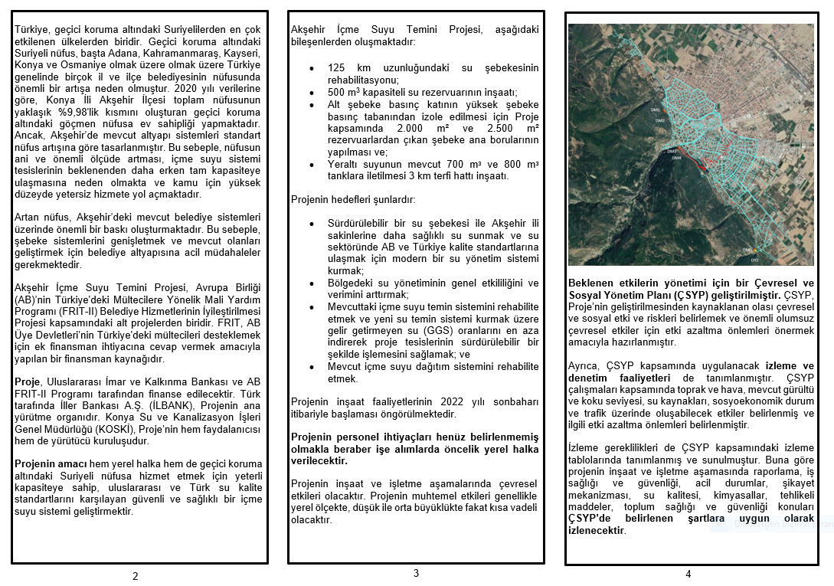
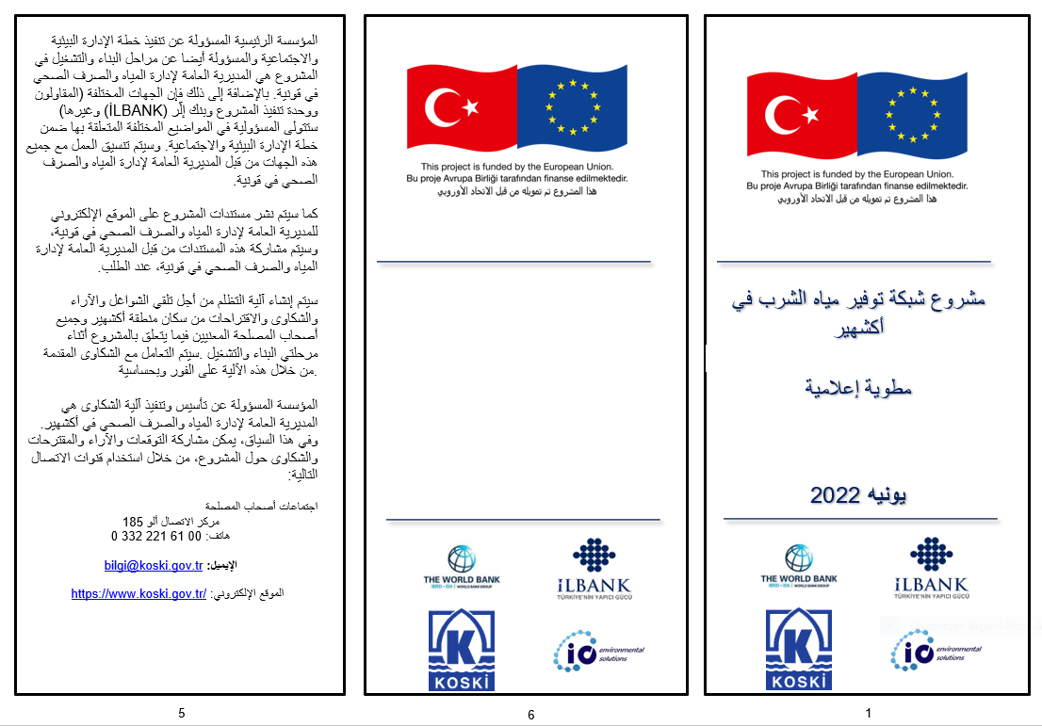

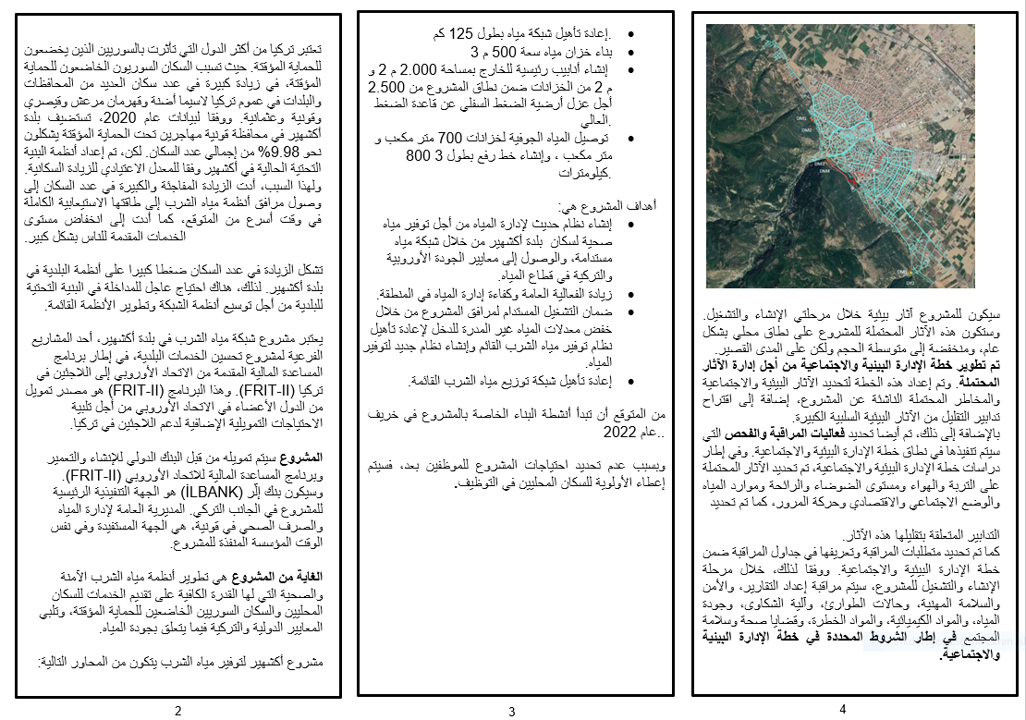

According to DGMM and UNHCR, as of December 2018 there are 3.9 million refugees in Turkey. This total includes Syrians (3.6 million), Afghan (170,000), Iraqis (142,000), Iranians (39,000), Somalis (5,700), and other nationalities (11,700).
Strengthening Municipal Resilience in Response to the Impact of the Syria Crisis in Turkey, 3RP
www.goc.gov.tr
European Commission, October 2018. Technical Assistance to the EU Facility for Refugees in Turkey – Final Report
World Bank ESMAP, December 2012
Population data is provided from TurkStat 2019 data.
https://www.csgb.gov.tr/medias/12262/kanalkazicalismaisgreh.pdf
World Bank, 2020, ESF/Safeguards Interim Note: Covid-19 Considerations in Construction/Civil Works Projects
World Bank, 2020, ESF/Safeguards Interim Note: Covid-19 Considerations in Construction/Civil Works Projects

